Learning about Learning: Piaget, Vygotsky, and Bruner

Many instructors’ dream of imparting important, enduring knowledge while helping students become self-motivated, expert problem-solvers with sophisticated world-views. Most of us often fall short of these dreams in courses crammed with content, classrooms designed for lecturing, and contexts that - sometime quietly and sometimes overtly - support the lecture status quo. At the beginning of our teaching careers, we often dwell on our role as instructor with little regard for what is going on in students’ heads. It is important to remind ourselves that a high quality learning experience depends on a change in student thinking and understanding, and not necessarily on the instructor believing they ‘taught well.’

Constructivism is an educational theory that espouses that learners construct knowledge and meaning from their experiences. Constructivism’s guiding principles are: knowledge is constructed not transmitted, prior knowledge impacts learning, and building knowledge requires effort and purposeful activity.

Social Constructivism espouses that learners needs to arrive at their own version of the truth, and this process will be influenced by their background, culture and embedded worldview. Learners construct shared meaning by having social interactions with other people.

Consider learning something new; you research, you read, you study and get some basic understanding…say maybe 70% understanding, then you try to use your new knowledge to maybe solve a problem…it doesn’t work so well… you find someone else who know more…you have a conversation where you both begin to construct shared meaning and a higher level understanding – this process of social construction is important to get us to a higher level of understanding. Without the social interaction we can’t compare our thinking to others’ thinking or against disciplinary thinking. Fostering these conversations are at the heart of constructivist teaching.
Jean Piaget

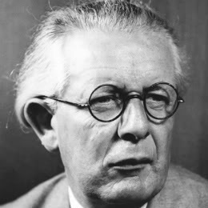
The Swiss educational theorist Jean Piaget (1896-1980) first espoused the idea that learners either assimilate new information into their existing knowledge structures or shift their way of thinking and organizing what they know to accommodate the new information. Sometimes new information can be neatly ‘assimilated’ into students’ existing understanding of the world, and sometimes their worldview needs to shift or ‘accommodate’ the new information. The process of shifting one’s framework of thinking can be a difficult and uncomfortable one.

Piaget conceived that intellectual development occurs in 4 stages:

- Sensorimotor - early life exploration of environment
- Preoperational - increasing language proficiency and interacting with the world in a progressively deeper way – still unable to understand concrete logic and have difficulty mentally manipulating information.
- Concrete Operational - characterized by inductive logical thinking with limited abstraction. Demonstrates beginning abilities to use reverse thinking and generalization.
- Formal Operational - abstract thinking and systematic problem solving thinking becomes the norm.
Piaget originally conceived that people moved into the last stage, Formal Operation, by age 12. There is now considerable evidence that many adults live their entire lives at the Concrete Operational Stage. We can be at different stages at the same time for different domains of knowledge, for instance being at Formal Operation in one domain of knowing and Concrete Operation in another. When our student come to us, they are likely in the Concrete Operational Stage. Learners in the concrete operational stage, when faced with abstraction, creativity, and ambiguity, often react by memorization and are unable to use course material to solve novel problems. These learners will attempt to succeed by rote memorization, partial credit, and repeating courses. They will shy away from open-ended problems and are often unable to learn from their mistakes. If you teach a course that requires higher-level thinking or complex problem solving, and yet some learners claim, “it is all memorization”, they are likely stuck at the Concrete Operational stage.

Lev Vygotsky

Authentic problem solving can give learners the opportunities to use new information and fine-tune their understanding. When learners problem solve with their peers they can often progress more quickly than when they work alone or interact with an expert. Working with peers who are at a similar or slightly higher level of understanding can speed a student’s progress. The positive effect of working through and completing a task that is slightly more challenging than one’s current abilities, and progress that is hastened by the support of fellow learners, has been described by Lev Vygotsky as the Zone of Proximal Development. The ZPD is often characterized as the ‘zone’ within which a student can solve more difficult problems then they could solve alone.

Vygotsky’s ideas have also been used to describe a process that became known as scaffolding, where the instructor can provide appropriate level of instructional challenge and guidance to maximize learners progress on a particular learning task, and fade from the instructional process as student mastery increases.

There are great contrasts between Vygotsky and Piaget’s views. Piaget’s believed that cognitive development must proceed learning, which contrasts Vygotsky’s belief that learning precedes cognitive development. Vygotsky did not see limits on our progress and believed that with the right scaffolding and social interaction that any learner can make substantial learning progress.

Jerome Bruner

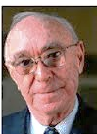
Jerome Bruner is a cognitive psychologist who has made significant contributions to cognitive learning theory.

One of his important contributions was Scaffolding theory that he introduced in the 1950’s. Scaffolding comes from Vygotsky’s theory of an expert assisting a novice. Scaffolds are removable support’s that are provided to the learner as they engage with a new at a task. They can include resources, motivating examples, templates, guides, coaching, and instructor modeling.

Fading describes a process in which the instructors may need to provide more guidance early in the learning process and progressively less as the students’ expertise increases. The concepts of scaffolding and fading are cornerstones of many guided inquiry learning models (POGIL-Process Oriented Guided Inquiry Learning, PBL-Problem Based Learning and others).

Useful Taxonomies: Bloom’s and SOLO

Many educational taxonomies were created so teachers could have a shared language to articulate educational goals. The two most prominent are Bloom’s Taxonomy: Cognitive Domain (1956) and the SOLO taxonomy (1982). Bloom’s work was to build a taxonomy for educational objectives. The SOLO taxonomy in contrast focuses on the structure complexity of student responses, hence the name SOLO – structure of observed learning outcomes. In Bloom’s book – Taxonomy of Educational Objectives: Cognitive Domain (1956) he alluded to the ideas that later led to the SOLO taxonomy development -“knowledge which is organized and related is better learned and retained than knowledge that is specific and isolated (p 35)”

Bloom’s Taxonomy – Cognitive Domain

Revised Blooms – Cognitive Domain
Remembering
Understanding
Applying
Analyzing
Evaluating
Creating
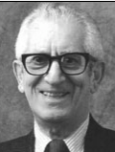
Benjamin Bloom helped develop a taxonomy of educational objectives for the Cognitive domain, to help faculty and students at the University of Chicago graduate school prepare for comprehensive examinations. The cognitive domain taxonomy has since become one of the cornerstones of North American education, as it helps educators use common language around learning goals, and helps individual practitioners articulate the educational possibilities within a particular piece of instruction, course, or program. Since the original taxonomy was created similar taxonomies were created for the Affective and Psychomotor domain.

Anderson and Krathwohl updated Bloom’s Cognitive domain taxonomy in 2011, to address some lingering criticisms of the original taxonomy.

The obvious difference in the revised taxonomy is changing of category descriptor nouns to verbs and the re-positioning of the last two categories, but the really important change was the recognition of how the taxonomy intersects and acts upon different types and levels of knowledge — factual, conceptual, procedural, and metacognitive.

Using Bloom’s

Bloom’s can be effectively used to select test items that test different levels of understand, especially since the different levels can be mapped to various verbs (see table at and of this handout). These verbs can both be used to generate learning objectives and select/create test questions that correspond to Bloom’s different levels.

Criticism of Bloom’s

There has been criticism of the hierarchical notion of the taxonomy that is unfortunately reinforced by the many pyramid like depictions. It is easy to come to the conclusion that students need to move through each level sequentially – for instance remembering some facts before we begin applying them. Obviously, students do need some foundational knowledge to get started, but curricula often focus too long at lower levels (remember, comprehend) before moving to higher levels. This is a mistake. The lower levels are actually parallel and MUST to be undertaken at the same time. It has now been shown that students need to be trying to use the foundational knowledge as they acquire to structure and store knowledge to be most useful for future problem-solving. There is a chicken and egg conundrum here – do I need to teach the basics before I start getting students to solve problems or should I be having them solve problems as they learn the basics.

That said, Bloom's taxonomy (and the revised taxonomy) continues to be a source of inspiration for educators and for developing new teaching strategies.
Blooms Cognitive Domain Verbs
Remembering | Define, describe, draw, find, identify, label, list, match, name, quote, recall, recite, tell, write
Understanding | Classify, compare, conclude, demonstrate, discuss, exemplify, explain, identify, illustrate, interpret, paraphrase, predict, report
Applying | Apply, change, choose, compute, dramatize, implement, interview, prepare, produce, role play, select, show, transfer, use
Analyzing | Analyse, characterize, classify, compare, contrast, debate, deconstruct, deduce, differentiate, discriminate, distinguish, examine, organize, outline, relate, research, separate, structure
Evaluating | Appraise, argue, assess, choose, conclude, critique, decide, evaluate, judge, justify, monitor, predict, prioritize, prove, rank, rate, select
Creating | Compose, construct, create, design, develop, generate, hypothesize, invent, make, perform, plan, produce

SOLO Taxonomy

John Biggs developed the SOLO taxonomy, after he examined student work and identified that the output of student learning displayed similar stages of increasing structural complexity. SOLO is an acronym that stands for Structure of Observed Learning Outcomes. The progression of student learning outcomes can be divided into two distinct stages; a quantitative stage where a students knowledge base is increased and a qualitative stage where there is a deepening of understanding.

There are five stages in the SOLO taxonomy:

Pre-structural: acquire new, unconnected pieces of information.
Unistructural: begin making simple, obvious connections between pieces of information.
Mulitstructural: continue to make connections and begin to be aware of the significance of connections between pieces of information.
Relational: switch from information acquisition to the organization of information to facilitate deepening meaning.
Extended Abstract: begin to recognize and use emergent patterns, and are able to generalize and transfer learning to new situations; students are able to successfully apply abstraction to the understanding of concrete situations.

Uni-structural and Multi-structural constitute the Quantitative phase of learning and Relational and Extend Abstract are the Qualitative phase of learning.

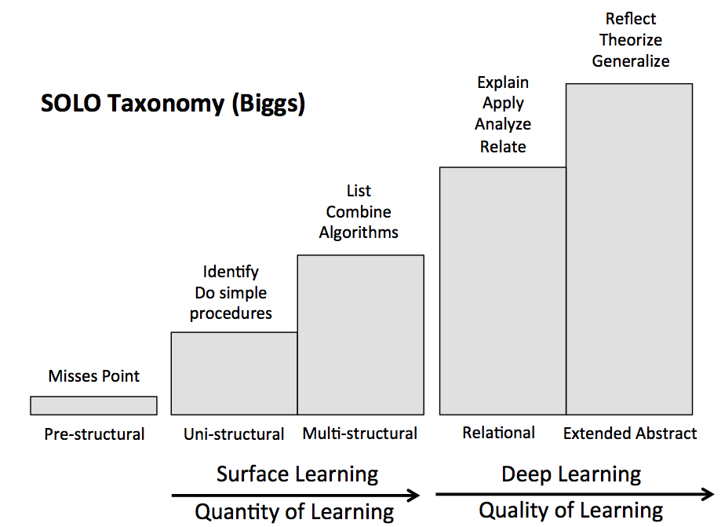

One of the major attractions of the SOLO model is that is suggests a basis for recognizing students progress up the four levels. Thus, there are clear implications for how teachers can use these ideas to develop programs that enable students to enhance the depth of their learning.

Students should be assisted to advance in the following ways:

”Knowing nothing” to Unistructural

Help students 'join the game' with its new rules and its different way of conceptualizing reality.

Unistructural to Multistructural

The teacher needs to concentrate on consolidating and automating the Unistructural knowledge and skills, building a store of knowledge, and encouraging students 'to do more' with their knowledge base.

Multistructural to Relational

Includes understanding or integrating what is known into a coherent system wherein the parts are inter-related. This interrelationship comes about as a result of an ability to form an over viewing principle which can be derived from the information given.
Relational to Extended Abstract

Requires dedicated hard work to master abstract concepts and relationships, and allows the student to derive more generalized principles and transfer understanding to new tasks and situations.

Like Bloom’s SOLO levels can be mapped to verbs. The biggest difference between Bloom’s and Solo are that SOLO is based on the outcomes of learning and Bloom’s is focused on the development of learning outcomes prior to learning events. Another importance difference is that SOLO levels are hierarchical where each level is the foundation upon which higher-level understanding is built.

SOLO Taxonomy Verbs
 | Declarative Knowledge | Functioning Knowledge
Unistructural | Memorize, identify, recite | Count, match, order
Multistructural | Describe, classify | Compute, illustrate
Relational | Compare and contrast, explain, argue, analyse | Apply, construct, translate, solve near problem, predict within same domain
Extended Abstract | Theorize, hypothesize, generalize | Reflect and improve, invent, create, solve unseen problems, extrapolate to unknown domains

