Certificate of Training

Team-Based Learning Institute
May 16 and 18, 2017

Mitra Kiamanesh

Workshop Facilitator

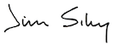
Jim Sibley

