4S Activity Facilitation
Classroom Logistics
“The design of a task is ultimately only as good as its execution and management”
(Roberson and Franchini, 2014, p. 297).
Many people new to TBL worry about facilitating the discussion after simultaneous reporting. Although we all have much to learn about facilitation, the good news is the 4S structure of TBL activities lead discussions that are simpler to facilitate than open general discussions.
Planning an Application Activity

The organization of an effective TBL Application Activity parallels that of any effective teaching activity; it needs a well-thought-out structure with a beginning, middle, and end. There are many frameworks used to describe such structures, but they generally have the same elements grouped in different ways. I will use one of the simpler top-level frameworks to describe structure: Set, Body, Close. Feel free to adapt your personal favourite if you have one.

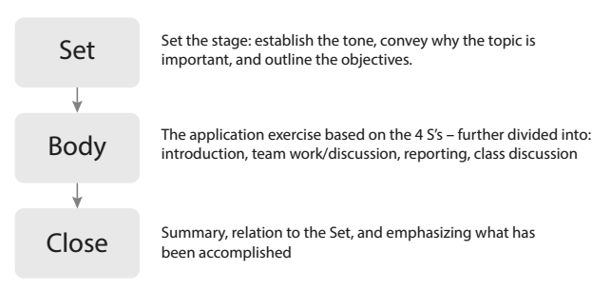

Set, Body, Close is highly adaptable for almost any size group and any duration. It aligns, respectively, with the beginning, middle, and end of an activity or lecture. The Set portion sets the stage and primes the learners for what is to come; most importantly, it establishes the tone, conveys why the topic is important, and outlines the objectives. The Body is the core of the class; in a conventional lecture, this would be where the teacher delivers content, while in a TBL class, this is the Application Activity (including teams working on the exercise as well as the discussion and debriefing that follow). Finally, the Close wraps everything up. It summarizes the class or activity, emphasizes what has been accomplished, and relates the outcomes to the objectives from the Set.

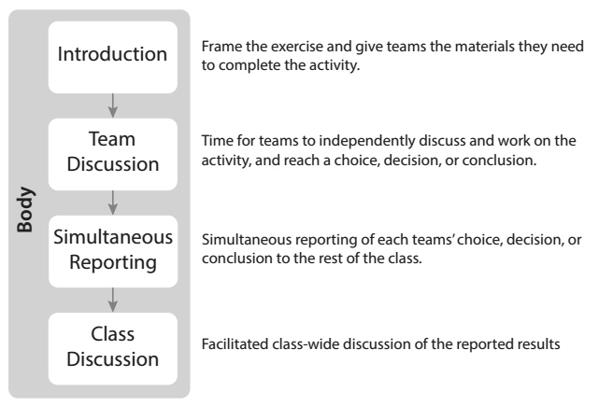
Facilitating simultaneous reporting
First report the patterns you see
The first thing you do, following simultaneous report, is announce the patterns you see...I see mostly A's and C's with a few D's - then you begin asking teams why they made their decision - going team to team and building a reasoned argument together with your students.
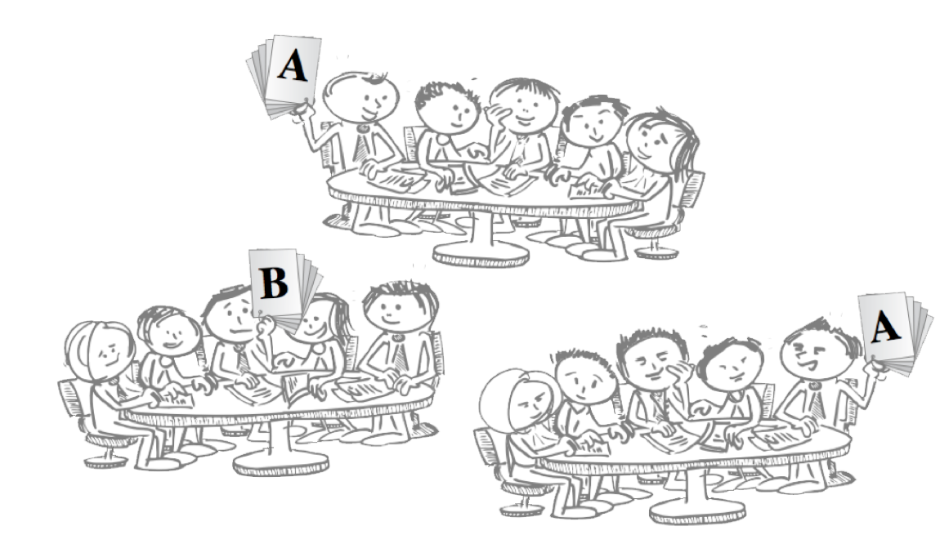
Probe student thinking
When teams commit to their positions and publically report it, the instructor can then facilitate the report by simply going team to team asking “why did your team pick A” going to another team “why did you pick B”. You work the room going side to side and making sure to engage all parts of the room. Try to resist talking to teams next to you. This can become a conversation between the instructor and one team and not a conversation between all teams. One trick is to ask teams across the room to add their two cents. This helps the reporting conversation stay between students and not between instructor and one team of students. You can ask a team to tell you about their team’s deliberations – what did they talk about, how did you decide…What is nice about this is you are only asking them to recount the conversation, not what is the right answer.
Help students build a well considered argument
When discussion energy begins to wane you can begin to ask “why didn’t you pick…” or “was there a second choice that your team considered?”…”why do you think someone might pick that choice?” These are the same kinds of questions that you need to use to play devil’s advocate if all the teams agree.
It can be helpful to remember the components of a well-reasoned argument (Toulin et al, 1984)
- CLAIM is made
- GROUNDS (facts, evidence) are offered
- WARRANT - connects claim to grounds
- BACKING – a theoretical or experimental foundation for warrant is shown
- Appropriate QUALIFIERS are used to temper claim (some, most, many, few)
- Possible REBUTTALS are considered
Remembering the pieces of a well reasoned argument can help you push the students to deeper engagement, analysis. and argumentation.
Closing well – so what has been learned can be reinforced
Another important consideration is to close the discussion well. You want to make sure students get reminded of the important take-aways, the assumptions examined, and the inferences that needed to be made. You can summarize or even better have the students paraphrase a summary of the discussion. Reflective one minute paper can be used to great
effect here. You can simply ask students to quickly individually list the “3 most important points” or “2 remaining concerns” or “a context where it might not be applicable.” A nice finish to this activity is to have teams compile these points into a team consensus worksheet. However you do it, not closing activities well robs them of some of their value.
Read more in Getting Started with Team-Based Learning – page 114-142

