Readiness Assurance Process
Classroom Logistics
The RAP is like any other classroom activity, where preparation can help to make sure the process runs smoothly.

Pre-Class Preparation
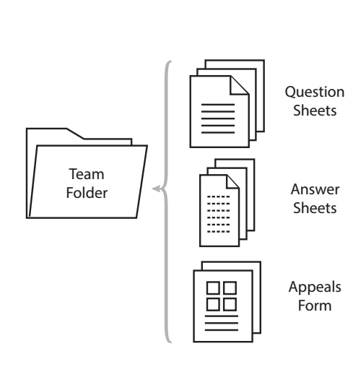
Many teachers use team folders. Team folders are preloaded with the test question sheets, some kind of answer recording forms (maybe Scantron in larger classes), and an appeals form. Folders let you simplify the handling of materials. In large classes, we ask a team representative to come to the front of the class to pick up and drop off their team’s folder, so the teacher remains at the front of the class. Creating these folders for each team not only simplifies getting materials to and from the teams; it sends the important message to your students that you have taken time to be organized.

Timing

The typical RAP takes 50-70 minutes for a 20-question test. In shorter classes, teachers will often shorten the RAP test. For our 50-minute classes, we often give 12-15 questions in 50 minutes; this gives us time to complete the entire five-stage RAP process. Many TBL practitioners now recommend even shorter 10 question RAPs, since student are often eager to get to 4S problem-solving main events.

Class Start

We start by announce there will be a RAP and how much time students will be given for the iRAT and tRAT. A general rule of thumb is three to five minutes for both folder distribution and time for students to get their names on the answer forms, then one minute per question on the iRAT, and slightly longer for tRAT (1.5 minutes per question). How long you need to give is ultimately controlled by the difficulty of the questions. Stray on the side of making questions easier, rather than harder. Hard or tricky questions can quickly burn up student goodwill. Be careful.

The iRAT (Individual Readiness Assurance Test)

To begin the Individual Readiness Assurance Test (iRAT), we ask students to put away any notes or other reading materials. We then ask one representative from each team to come to the front of the class to pick up their team’s folder. Teams are not to open their folders until all teams are reseated. Next, we ask the teams to open their folders, distribute the tests, and begin. While the students are completing the iRAT, we circulate around the room and clarify any difficulties that students may have understanding the questions.

Once the allotted iRAT time has elapsed, students are asked to collect their team’s individual answer sheets and send one representative to the front of the room to exchange the answer sheets for their IF-AT card. Students are reminded to hang on to their question sheets for the team Readiness Assurance Test (tRAT).

Students who are absent on the day of a RAP typically receive a zero for both the iRAT and tRAT unless they have satisfied some other predetermined course requirements. These requirements could be to make plans with the teacher in advance to take the iRAT separately, to provide a medical note in order to be excused from the RAP and have the tests excluded from grading, or to require a signed note from their teammates with permission to share the team score. In this latter case, if a student has been a prepared and consistent contributor to the team, most teammates are happy to share their team score with the absent student.

The tRAT (Team-Readiness Assurance Test)

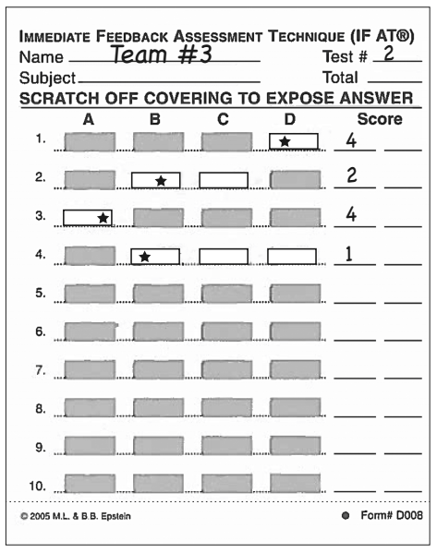
Before starting, we remind students of any decremental scoring scheme we might use with the IF-AT cards. On a four-option IF-AT card (A-D), we often award four points for a correct answer on the first scratch, two points for the second scratch, one point for the third scratch and zero if they needed to scratch all four possible answers. Different teachers use different decremental scales. Whatever scale you use, the important thing is that you are rewarding the students for continuing to discuss the question seriously. Otherwise, after one incorrect scratch, you would just rub the rest off and reveal all the other answers and a valuable learning opportunity would be lost.

During the tRAT, we circulate around the room monitoring the students’ progress. If we notice that a large number of teams are finished before the allotted time is up, we will ask the whole class who needs more time. If only a few teams need more time, then we will often announce that there are perhaps two minutes left (known as the 2 minute rule).

You write the question numbers on the board and ask teams to put check marks beside the question or questions they would like clarified. This is actually a very good option, since some concepts are clarified enough during the tRAT that students do not need further clarification. If you only work from the tally report of the individual tests, you may end up talking about topics that were already resolved during the team test.

Teachers often record the teams’ average iRAT scores and the range of tRAT scores on the chalkboard. This achieves two goals. First, it shows students the value of working as a team, as tRAT scores are usually 10-20% higher than the average iRAT score. Secondly, it motivates teams to perform better than their peers by creating friendly competition.

The Appeal Process

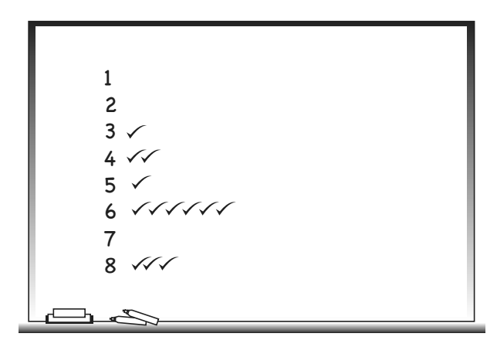
At end of the team test (tRAT), teams are encouraged to appeal questions that they got wrong. Scholarly appeal arguments can be generated by any team and are written on the appeal form included in each team’s folder. The teacher makes it clear that the appeals will only be considered outside of class time and that the results will be announced at the next class. Some student will try to open a conversation about why a particular answer should be considered correct; you can shut the conversation down by simply asking the team to complete that appeals form and you will look at it after class. You need to establish a rule of when appeals are due. Some teachers insist by end of class; other teachers insist by end of day, often submitted by email. One way to ensure that all team members have contributed to the appeal is to have them sign a statement of collaboration at the bottom of the appeal form.

Teacher Clarification/Mini-Lecture

At the end of the testing and appeal phases, teachers respond to items identified in the RAP as still challenging to students. You must not review the test question by question, but only review the questions and concepts that remain problematic for the students. Students like the mini-lecture since they know it won’t be too long and the teacher is talking about something they know they don’t know.

Ending Class Well

Students are asked to place all question sheets and the IF-AT form in their team folder for collection. We often get team members to sign the back of the IF-AT card, as this can simplify requests made by absent students who still want credit. We remind students that all question sheets must be returned or the whole team will receive a penalty, usually a mark of zero. We mark the folders with the number of students in each team; this lets us easily check that all question sheets are returned. A team representative is then asked to bring the team folder to the front of the room.

Read more in Getting Started with Team-Based Learning – page 74-113

