Learning Outcome to 4S Activity Story
Supporting resource for your homework

Define Flood Return Period

This is a very typical content focused, low Bloom’s level learning outcome. Next step is to raise the Bloom’s level (in this case using Bloom’s Cognitive Domain Taxonomy). Lets try that!

Explain Flood Return Period

The change has moved the learning outcome from the lowest Bloom’s level – Remember - to the slightly higher - Understand – level. In the next step, we try to change this learning outcome to be about concrete action rather than just abstract understanding. Lets try that!

Demonstrate understanding of Flood Return Period

This is often the first attempt at making the learning outcome more about concrete action. Unfortunately, it doesn’t provide any information on how the students might “demonstrate understanding”. In the next step, we try again to make it about concrete action but this time so student understanding is put to use in a visible way. Lets try again!

Students will predict the outcome of a situation

This is getting better. Students are using their knowledge of Flood Return Period and applying abstractly to a concrete situation. This is key. You can start to get glimmers of what an activity might look like where students show you that they know (knowledge in the service of action). But what is missing here is discrimination and judgment. Lets add those!

Students will predict the most likely outcome of a specific situation

We now have discrimination and judgment but still a little too open ended to have students make decisions that are easily comparable and drive an intense reporting discussion that examines only the salient issues that need to be considered to make a “good” judgment and decision “in this case”. Constraining the possible outcomes to be considered can help you structure the analysis and discussion so very specific issues are discussed and very specific analysis is done. Lets constrain the possible choices!

Final transformation to 4S activity

Which of these outcomes is most likely given this situation (using your knowledge of flood return period)
- Possible Outcome 1
- Possible Outcome 2
- Possible Outcome 3
- Possible Outcome 4

We have transformed a lower level learning outcome, that at best could be assessed in an examination, into a powerful classroom activity that is structured to lead to a rich, deep reporting discussion.

Final elaboarted version of this 4s activity

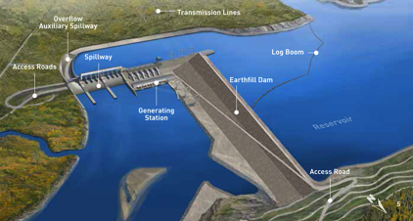

You are head of Engineering for a large dam project on the Yellow river in the Ningxai province of China. The dam is to be located in the Yiling district near the exit of the Ordos Loop section of the river. The dam is to be located at 34°49′46″N 111°20′41″E. The Yellow river is China’s third largest river. The river is characterized by extremely high silt loads, especially in spring floods. The local bedrock is highly fractured gneiss. The dam will be a concrete earthfill hybrid design. You have been asked to determine some of the main design parameters, including safety related question like what flood event return period to build the dam to withstand.

What flood return period would you recommend the dam be designed to withstand?

- once in 50 year flood
- once in 100 year flood
- once in 200 year flood
- once in 500 year flood

Using the 4S structure

Lets examine how to structure problems using the 4S framework so they lead to consistently powerful activities. There are 4 major tenets to consider when structuring a 4S activity.

First, we should use the kinds of questions/problems and problem solving/analysis procedures that disciplinary experts are routinely asked to use/make. Since most disciplines are more about their actions rather than there content. Next we need to make problem about concrete action in a concrete situation with real consequences. This helps make student understanding visible to both the teacher and student. Then we need to think about the kinds of complex analysis that will required of students to analyze/interpret the scenario or problem statement. Finally, we will need to constrain choice to intensify the learning.

Tenet 1: Use Expert-like Disciplinary Problems

A nice feature of this example is that it asks the kind of question an expert would need to make.

“Disciplines are more clearly defined by how those working within the discipline collect, organize, assess, and use information” (Roberson and Franchini, 2014, p. 278)

“If we want our students to become more expert in our disciplines, we need to structure their encounters with content in ways that change what they can do with knowledge.” (Roberson and Franchini, 2014, p. 278)

Tenet 2: Make it about Concrete Action in the real world

Students need to use their understanding (gained in the pre-readings, lectures or previous activities) to make expert-like concrete decisions that will have very concrete consequences. You want to design concrete scenarios where conceptual and abstract understanding helps students make better decisions.

The quality of the problem ultimately controls the effectiveness, energy, and learning outcomes of an activity.

“Students, therefore, need to be required to act frequently in ways that generate consequences that provoke reflection and demonstrate visibly their thinking. The more focused and concrete the action, the more visible will be the thinking and the learning—and the more immediately useful will be the feedback.” (Roberson and Franchini, 2014, p. 276)

“Effective team tasks point students consistently toward making decisions that reveal reasoning and understanding in service of a judgment.” (Roberson and Franchini, 2014, p. 279)

“What we know about the nature of learning is that students gain deeper traction, faster, with course content if their first encounters with it include concrete experiences framed by and informed by the abstractions” (Roberson and Franchini, 2014, p. 296)

Tenet 3: Require complex analysis, discrimination, and judgement

Coming up with a good and defensible solution requires the integration and analysis of many different factors and the weighing of tradeoffs (like cost vs. safety). There are a lot of things for the teams to consider in determining a reasonable course of action and coming up with a reasonable defense for their final decision.

Possible issues that need to be considered:
- How big are the flood events?
- Are changing climate patterns going to affect the size and frequency of flood events?
- What is the difference in cost to design to withstand the different levels of flood events?
- Are there unique landscape or bedrock concerns? How could we mitigate them?
- What are the population patterns downstream?
- How would downstream populations be effected by a failure at different flood levels?
- How do these kind of dams typically fail?
- Can the dam be constructed to fail elegantly and reduced the threat to downstream populations during flood events?

“Scenarios allow you to embed many variables that can be used to introduce multiple concepts, theories and perspectives into students’ discussion, as well as to complicate the task, if desired, through a mix of relevant factors and red herrings.” (Roberson and Franchini, 2014, p. 287)

Tenet 4: Constrain Choice to intensify analysis and discussion

The example at first glance looks a lot like a multiple-choice question and many teachers worry that constraining choice like this will limit the depth of the discussion. It is quite the opposite, constrained choices focuses student energies on analysis of specific issues, which ultimately helps with team to team comparisons that allows students to see how their thinking contrasts other teams. But this would be like saying a murder trial is decided by a two option multiple-choice question. These kinds of constrained choice questions are potent discussion starters. This really becomes clear for all to see during the public reporting of team decisions.

“The function of the collective decision task, therefore, is to place a restrictive frame around the team’s action. This restriction forces the team to evaluate, integrate and, if needed, respectfully discount a team member’s inputs en route to a judgment and a focused decision.” (Roberson and Franchini, 2014, p. 288)

“Tasks that direct students toward a specific choice do not stifle student thinking but concentrate it so that feedback on the task can be directed at specific, anticipated discoveries and realizations.”
(Roberson and Franchini, 2014, p. 290)

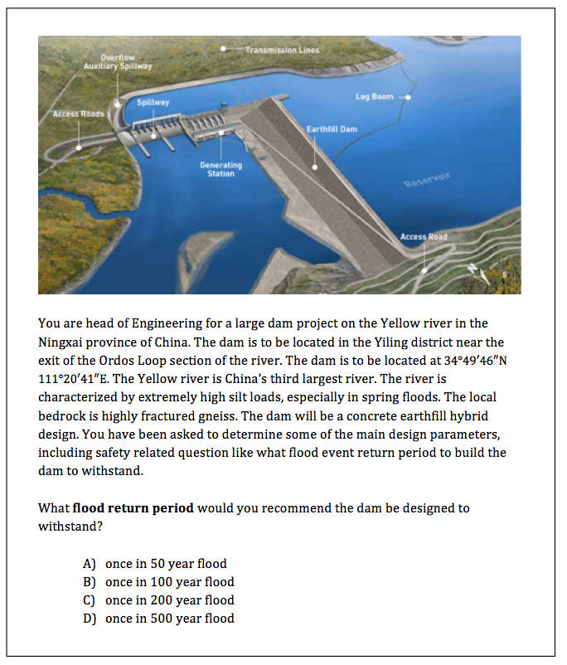
A problem that is significant and interesting to the students – not a toy problem
Multiple reasonable courses of action – some more reasonable than others
Specific question statement - that often uses superlatives like best next step, worst thing to do, most appropriate action, most likely outcome, greatest concern, etc.
Complex scenario to analyze – with relevant information, irrelevant information, missing information, constraints, trade-offs - that require expert-like concrete action

