Building your first TBL Module
Homework Assignment
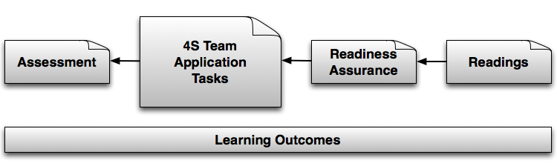

Part One: Design a TBL Module
Your task is to design one TBL module (backwards of course!). Use the following questions to guide your effort.

Define module Learning Outcomes
What will your students will be newly able to do as a result of this module and its activities?
Your answer to this question will be your module learning outcomes.
Write 2-3 outcomes as concrete actions, for example:
- In a political science course, you might want students to become effective at analyzing and assessing the factors that contribute to political corruption.
- In a construction management course, you might want students to become skilled at interpreting drawings, or analyzing a project plan for budgetary purposes.
- In a geology class, you might want students to be able to infer from specific geological landscapes the probable causes and history of their formation.
Support Resources: Writing Learning Outcomes, Bloom’s Taxonomy handout, TBL book p. 18, 116-118

Identify content that will be used in Module
Make a list of the concepts, ideas, principles, perspectives, core facts, and other information that students need in order to be ready to accomplish the learning outcomes. These are normally things that would be covered in the reading assignment.

Build 4S Activities

Now it is time to take those concrete actions described in the learning outcomes and turn them into 4S task/activities. You want to design a sequence of in-class 4-S tasks (at least 3) that your students will do in order to get some practice thinking in this new way and developing their analysis and judgment skills. You might want to scaffold the tasks from simple to more complex. Make sure these are challenging and require more than simple recall of “correct” information. It’s OK if there’s a best or “correct” answer, as long as there’s enough ambiguity, complexity and doubt for deep discussion.

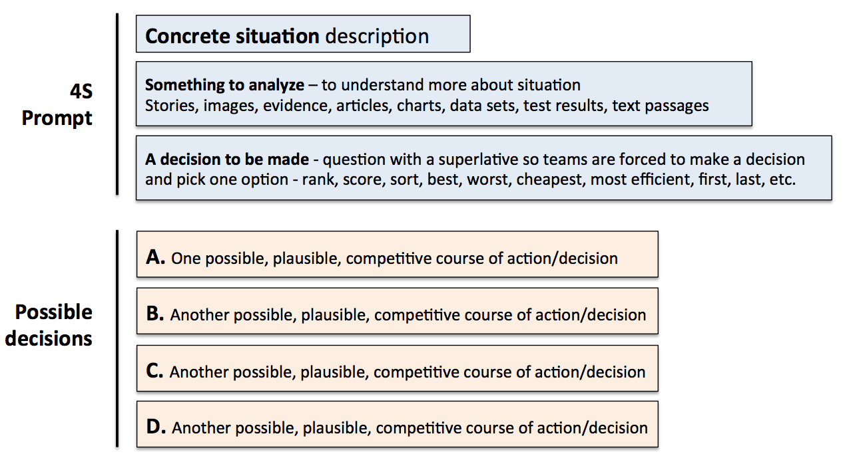

For each activity, create you will need to step-by-step instructions that highlight what students will need to do to complete the task. Write down the actual instructions and prompt/question you will use to direct students through the task.

Support Resources: Creating a Module, Learning Outcome to 4S story, TBL book p.114-142, 186-196

Create Readiness Assurance Test
The Learning Outcomes and 4S tasks create the major shape for the module. Now it is time to identify more specifically what students will need to read (or watch, if you use videos) in order to acquire the resources and tools (information!) needed to begin participating in the activities you have designed. What are the (best) chapters, articles, pages, clips, etc. that convey the targeted ideas? Make a list of these items, which you will eventually give to students as their reading assignment.

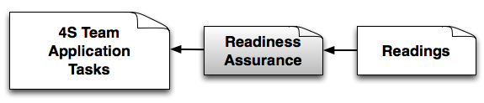

How much is appropriate varies, but keep in mind that you want students to read for basic awareness and understanding, not mastery. The reading needs to be rich enough and long enough to provide starting content for several activities over the length of the module.

Now write 5-10 multiple-choice questions, based on the reading, that focus on your target content. Like the readings, the test is about first exposures and ensuring readiness, not mastery.
- Create some questions at the level of recall and understanding
- Create some questions at the level of application and analysis (comparison, contrast, for example)
- Create a few items that are likely to generate some debate and discussion
Supporting Resources: Writing multiple choice questions, Bloom’s Taxonomy handout, TBL book p. 74-113
- Consider how you will evaluate the learning
How will you know what the students can do at the end of a module and if they have achieved the learning outcomes?

There are many possibilities (select at least one for this assignment):
- Individual assignments
- Traditional individual testing – quiz, midterm, final examinations
- Team analysis worksheets completed as part of 4S task
If you want to use an assignment, write down the actual assignment prompt.

If you are using testing, write down 2-3 of the actual higher-level questions that you will use for your final evaluation.

If you are going to have teams complete a worksheet that highlights their analysis, write down the prompts you will use to instruct students on what you want them to do and record.

Part Two - Prepare a micro-summary of your module
You will use this summary to present your work with your colleagues and get feedback.

- 1-page version of the module (ONE SIDE of ONE SHEET)
- Teammates will read this as a way of getting a picture of what your plans are.
- Please bring 5 copies of this 1-pager. Email Jim Sibley (jim.sibley@ubc.ca) by 7 am Thursday morning if you want copies printed for you.

Your Micro-Summary should include:
- A few action oriented learning outcomes
- List of 2-3 key concepts, ideas or other critical information that students will need to get from the readings and a description of the reading/prep assignment (sources)
- One RAT question
- One in-class 4-S activity
- Description of final assessment strategy
- Any other concern or issue that you would feedback on.

