Designing 4S Tasks
Supporting resource for your homework
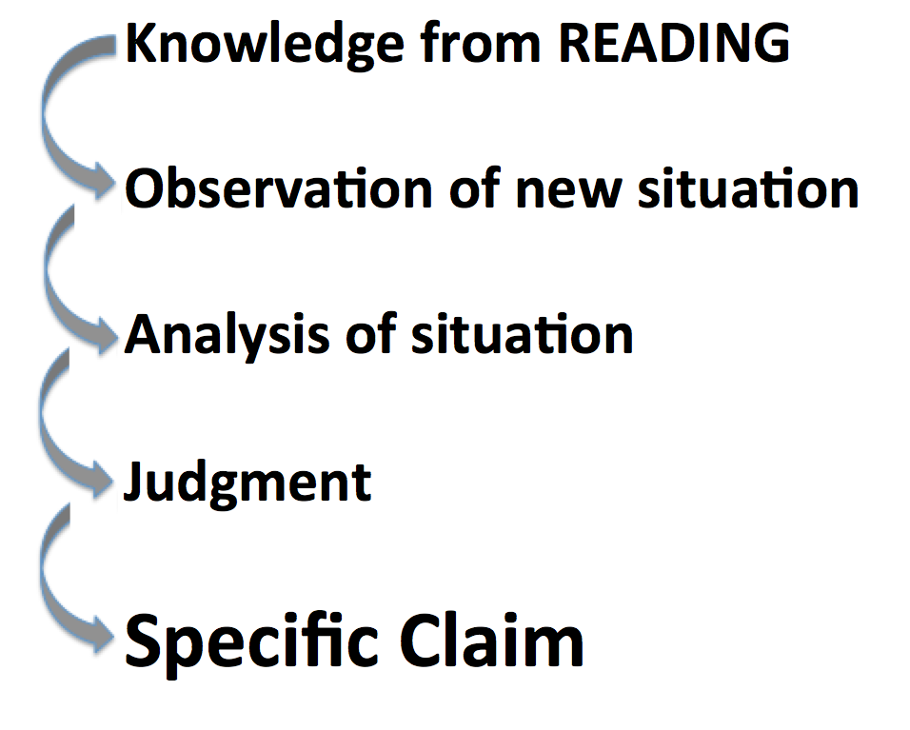
During a 4S Application task, students get to concretely apply what they have abstractly learned from the readings. You want students connecting abstract concepts from the readings with concrete experience during the 4S team Application tasks. Making connections during 4S team tasks is important to consolidate student learning.

Helping students see gaps in their knowledge motivates the students’ look up what they don’t know and then immediately putting that knowledge into action tests and deepens their understanding.

You need to present a scenario that creates the context in which what students “know” abstractly (via their readings) is put to the test when they try to “use” it in concrete, specific case. Your job is to find or, if necessary, fabricate these scenarios.

Typical Structure of 4S question

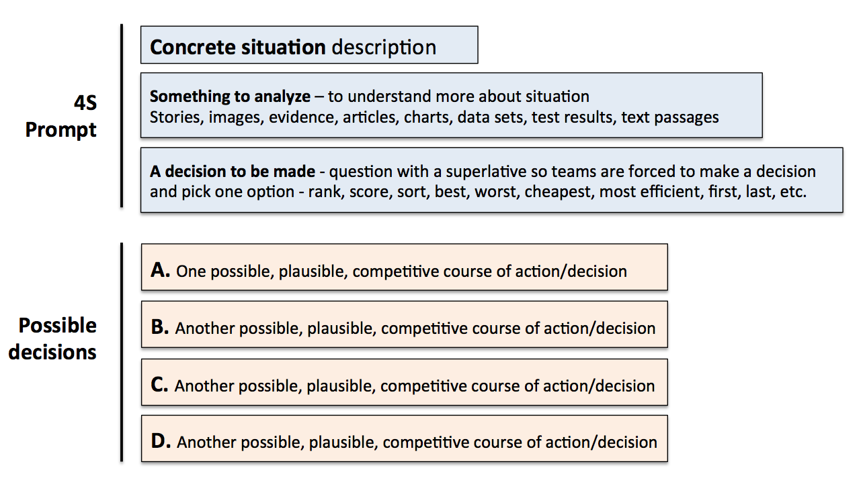

4S Extended Example (from Roberson)

Students in Sociology might “know” Maslow’s hierarchy of human needs, and could score well on a test that asked them to recite and explain it. But now imagine the Application task you give students, based on their initial understanding of Maslow:

You are a social worker and you have been given the case of “Maria from Syria.” Given your understanding of Maslow’s hierarchy, look at these data, make an assessment of her situation, and decide the best way to proceed in interacting with her: “Maria comes from a middle class family (her father was a dentist) in a small town in war-torn Syria. She immigrated with just her two children to Canada 2 years ago, and came to Ontario. She now works long hours at minimum wage as a housekeeper. She recently re-married and currently lives with her abusive, alcoholic husband. One of her children has health problems...etc.”

If the details of the case are rich, it quickly becomes clear to students that Maria’s case is complicated, and that Maslow’s hierarchy, while it is a useful tool to help analyze the situation, does not lead to an easy assessment or judgment.

Example 4S prompts (note the use of superlatives or implied superlatives to force a specific choice)

- A patient comes into emergency with the following symptoms...
  - What is the first thing you would do? And why?
  - What is the first test you would order? And why?
  - What would be the worst thing to do? And why?
- Given 3 possible programs to end homelessness in your city, select the program that is the best and will likely be most strongly supported by local agencies and Civic leaders? (Michaelsen and Sweet)
- What is the most relevant theory that explains the behaviour in the video? (Kubitz and Lightner)
- Which of the following best describes the opportunity cost of coming to class today? (Espey)
- Which of the following should the University do to best increase the quality of Undergraduate education? (Mahler)
- Which sampling scenario would best address this research project? (Mahler)
- Given three valid historical interpretations of the progressive Movement, discern which best describes the Progressives revealed in our manifesto? (Restad)
- In Clarence Page’s op-ed piece “The Problem With Trashing Liberty”’ where does the responsibility for a safe a civil society lie? Which of the following three philosophers (X, Y, and Z) does Clarence Page most agree with on these fronts? (Roberson and Reimers)
- What of the following passage in the Bhagavad Gita best illustrates reflection about the nature of Krishna’s divinity? (Dubois)
- Rank how useful each source is for understanding the fears of the Cold War era. (Restad)
- Which teacher should be nominated for a teaching award? (Croyle and Alfaro)
- Which indicator (from a list of 5 plausible alternatives) is most critical to making a correct diagnosis in this case? (Michaelsen and Sweet)
- If a moving vehicle overloaded this bridge structure, which component would likely fail first?
- You are making a home assessment, which of the following safety hazards would be of greatest concern? (Clark)
- After assessing Mrs. Randall’s dining room what would be your first recommendation to protect her from falls? (Clark)
- What line on this tax form would pose the greatest finical risk due to an IRS audit? (Michaelsen and Sweet)
- Given a set of real data, which of the following advertising claims is least (or most) supportable? (Michaelsen and Sweet)
- You are consulting for a new business owner who wants to open a dry-cleaning store in Norman, Oklahoma. Where would you recommend locating a new dry-cleaning business? (Michaelsen)

4S development process

First, you may need to make your original Learning Outcomes more CONCRETE.

Next, you need to create problem scenarios/situations where students’ factual knowledge (from RAP process) is useful, but maybe insufficient to solve the problem definitively.

Next, when creating these scenarios you want to clarify exactly what do you want students to be doing.
- Evaluate/judge something (object, product, creation, situation)?
- Analyze or diagnose a situation?
- Interpret something (text, artifact, data set)?
- Solve a particular type of messy problem?

Next, identify the concrete information/data sets the students will work with:
- Texts (such as cases, descriptions, excerpts from a textbook, writing samples, etc.)
- Images (visualizations, diagrams, videos, etc.)
- Data (spreadsheets, graphs, charts, etc.)
- Objects (products, specimens, etc.)

Next, you need to pick the format of students’ action:
  - Will they compare?
  - Will they sort?
  - Will they rank?
  - Will they score?
  - Will they choose the best course of action?
  - Will they distill and represent in a written format?

Next, determine how to make student thinking/decisions visible so it can be represented in a simultaneous report. Can their answer be represented with?
  - Colour Voting Cards
  - Single Number
  - Single Letter
  - Single word or phrase
Sometimes this means converting a complex response into a simple response. For example, after a ranking task, ask students to report their #1 choice, rather than their entire ranking scheme. If you’ve asked students to compile a list, ask them to choose the MOST critical item on their list and report it. Every task needs to lead to a moment of sharp differentiation: “I choose this over that.” Getting the students to this moment sets up “WHY?” as the teacher’s entry point for interactions leading to student analysis, reflection, and critical thinking. The simultaneous report naturally lets teams compare their decisions and decision-making process to other teams.

Finally, it is good to develop a facilitation plan for debriefing the 4S Application task, to ensure students learn the most they can from the task. Debriefs always begins by asking ALL teams to simultaneously report their answers/decisions. A good plan provides you with a way to organize the discussion that follows, and direct students into a dialogue with each other.
Instructor: “OK, I see three groups said “B” and two groups said “C.” Let’s start with those of you who said “C.” Please explain to the other students why you chose this answer?
Later: OK, teams who said B, how would you respond to them?
Later still: Nobody chose A. Why did you discount that possibility?

