Writing Learning Outcomes
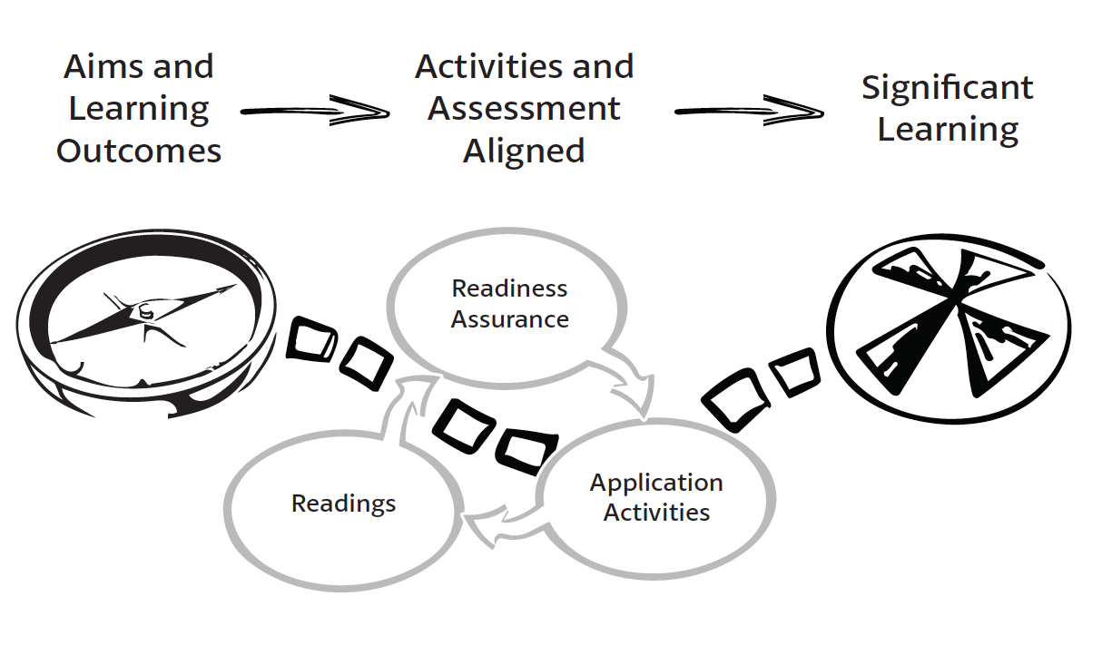
Supporting resource for your homework
Build Your First Simple Learning Outcome
Creating great learning outcomes is a cyclic, iterative process where you revisit and refine as your course design proceeds. You create your first provisional outcomes are then used to build other components of course design – selecting teaching and learning activities and designing assessment materials. As the other components begin to come into focus, you will periodically revisit and refine your initial learning outcomes. At a very simple view – writing a learning outcome can be as simple as attaching a Bloom’s verb to a piece of a piece of content.
Consider: I want students to know about flood return periods, I could simply add the Bloom’s verb “describe” to flood return period.
Describe + Flood Return Period = Learning Outcome
Learning Outcomes are directly focused on student achievement and become more detailed by module end, on exactly what the students will be able to do. Learning Outcomes often contain references to the knowledge, skills, and judgement abilities you want your students to develop. Your initial Learning Outcome statements are often the precursors to ideas for 4S Application tasks.

Learning Outcomes are often much more rigorously constructed then this simple approach. A model known as the ABCD model is often applied.
A – stands for audience – “The student will”
B - stands for behavivour – “write an explanation”
C – stands for condition – “in 30 minutes”
D – stands for degree – “with no mistakes”
For our purpose we can keep the learning outcomes simpler at the beginning.
How to make Learning Outcomes that are good for TBL
When we start thinking about the 4S Application tasks, we want to try to write Learning Outcomes that focus on more concrete actions rather than abstract understanding. We are looking for concrete actions just like a discipline expert takes. Good Learning Outcomes express how experts in your field or discipline would use the course content to solve disciplinary problems. The more concrete you can make the learning outcomes the easier it will be to develop 4S Application tasks from them.
Sample Learning Outcomes for a statistic course: by the end of this course students will be able to use their knowledge of statistical principles to:
- Complete a statistical analysis
- Select an appropriate sampling plan
- Develop a survey instrument and plan to gather information from a specific population
Sample Learning Outcomes for a genetics counselling course: by the end of this course students will be able to use their knowledge of genomics to:
- Interpret genome sequencing data
- Identify genetic markers with greatest risk of disease/abnormality
- Develop counselling plan to work with specific family issues
Sample Learning Outcomes for a business course: by the end of this course students will be able to use their knowledge of marketing principles to…
- Conduct a market analyses
- Evaluate a marketing plan
- Select or Develop marketing techniques to reach specific populations of clients
Sample Learning Outcomes for a history course: by the end of this course students will be able to use their knowledge of early Canadian history to…
- Interpret written accounts of historical events in light of cultural dynamics
- Assess (and estimate) the bias or orientation of a given author
- Develop arguments for current policies or political positions based on historical context

