Readiness Assurance Test – Learning about Learning

1. You have come to believe that students must negotiate a shared understanding of the subject matter to achieve deep learning with understanding. The process of achieving this enhanced level of understanding through dialogue is best described by which educational theory?

- Behaviourism
- Constructivism
- Social Dialogue Theory
- Social Constructivism

2. You notice that some concepts are much easier for students to learn than others. It seems that concepts that can be incorporated into existing frameworks of understanding are simpler for students to grasp. Concepts that require students to modify or abandon their current framework of understanding are more difficult for students to learn. Which educational theory is this observation congruent with?

- Bloom’s Acceptance/Abandonment
- Vygotsky’s Zone of Optimal Development
- Structured Observed Learning Outcomes (SOLO)
- Piaget’s Assimilation/Accommodation

3. You have been using Team-Based Learning in your first year physics seminar for a couple of years. You have begun to notice that some teams don’t deeply discuss their decision rationales often get stuck part way through the problem and as a result don’t do well in the full class discussion. In contrast, teams with more animated and in-depth conversations often successfully complete the problem or at least proceed further into the problems before getting stuck, and they most often do better in whole class discussions. In the successful teams, it seems like the students are helping each other progress, with students helping each other work out a deeper understanding. This process of learners aiding each other’s progress is best described by what educational theory.

- Piaget’s Assimilation/Accommodation Process
- Vygotsky’s Zone of Proximal Development
- SOLO framework of complexity development
- Bloom’s taxonomy of Cognitive Development

4. You have decided to use Team-Based Learning (TBL) in your 2nd year literature course. You are trying to decide how to sequence the activities to help the students best develop a deep understanding of the subject matter.

What educational construct might be most useful in helping you sequence the TBL activities?

- Piaget’s stages of intellectual development
- Bigg’s SOLO taxonomy
- Bloom’s taxonomy in the cognitive domain
- Vygotsky’s scaffolding

Application Activities – Learning about Learning

You have been thinking a lot about how to help your students gain a deeper level of understanding of your subject. Students willing take copious notes and are very willing regurgitate the large amounts of facts back in test and exams, but when it comes to solving novel problems with what they know – the students are often stumped - they can’t seem to apply what they know.

You came across some ideas for a new way to ask probing questions (see the examples below) and are hoping they might up your instructional game and help student to deeper understanding.

Task One

Please examine the question layout below, which comes from the book “Creating Written Test Questions for the Basic and Clinical Sciences.”

Step One: Start by parsing each question and identifying what we want students to actually be doing. Check the readings and pick an appropriate verb(s) from both the Bloom’s verb table and SOLO verb table.

Step Two: Which taxonomy would best explain the progression of the questions and logic behind the layout? Pick one and be ready to describe WHY one of the taxonomies better explains the layout.

- Bloom’s taxonomy
- SOLO taxonomy
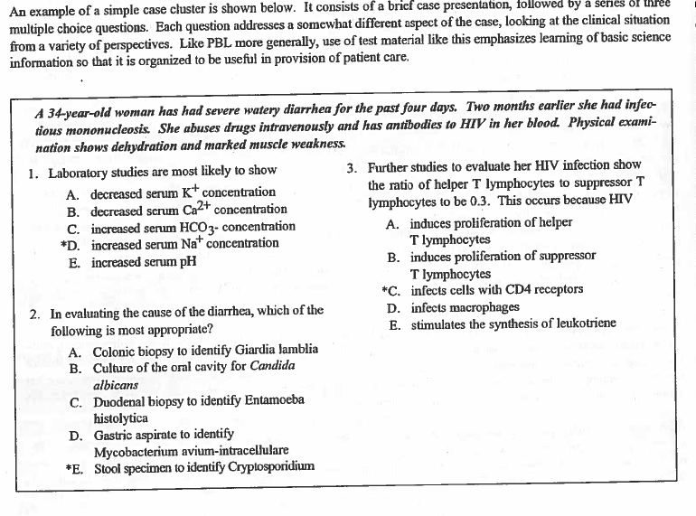

Task Two

Please examine both the question layouts below, which comes from the book “Teaching for Quality Learning at University.”

Step One: Start by parsing each question and identifying what we want students to actually be doing. Check the readings and pick an appropriate verb(s) from both the Bloom’s verb table and SOLO verb table.

Step Two: Which taxonomy would best explain the progression of the questions and logic behind the layout? Pick one and be ready to describe WHY one of the taxonomies better explains the layout.

- Bloom’s taxonomy
- SOLO taxonomy

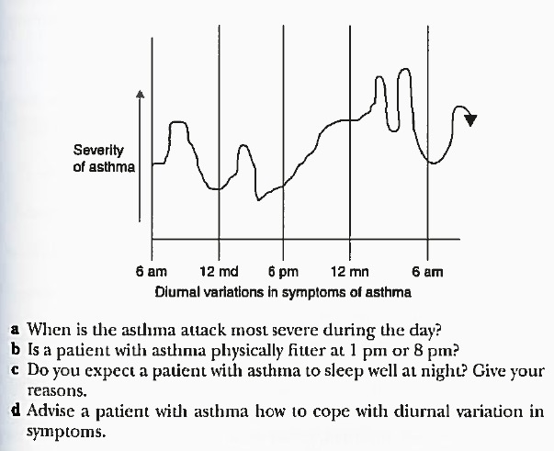
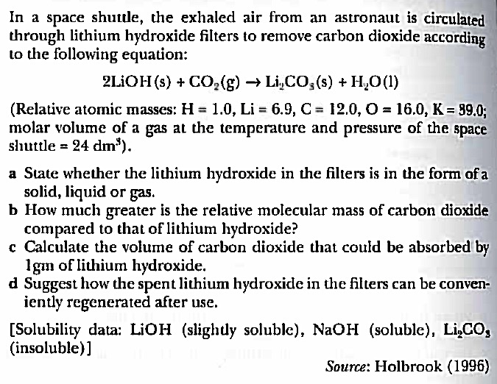

Task Three
A new faculty colleague has come to you seeking help on how to grade student reports. Which taxonomy would you recommended to help guide their assessment of the quality and depth of student work?

Pick one and be ready to describe WHY one of the taxonomies better suited to assess the final quality of student work.

- Bloom’s taxonomy
- SOLO taxonomy

