Creating a TBL module thread
When we first try to envision a TBL module, it can be helpful to imagine the module, as a tapestry of learning. Our first task is to create the threads that the tapestry will ultimately be woven from. A single thread will link a Learning Outcome, to a 4S activity, to Readiness Assurance questions, finally to a reading.
The Learning Outcomes defines where we want student to go, the careful combination of a reading and Readiness Assurance questions get students ready to apply what they abstractly know, and the powerful 4S learning tasks then lets students put their knowledge to work in the concrete world and show us they know.
We design backwards - first by defining the desired Learning Outcomes, then turning our attention to the creation of a 4S task, and finally selecting the readings and creating the Readiness Assurance questions to ready the learners.

Step 1-3: Create Learning Outcome

Step 1: Create a Learning Outcome
Define Flood Return Period
This is a very typical content focused, low Bloom’s level learning outcome.

Step 2: Raise the Bloom’s level of Learning Outcome
Explain Flood Return Period
In this step, we raise the Bloom’s level. See page 6 of this section for different verbs you can substitute to target higher Bloom’s levels. In this example, the change has moved the learning outcome from the lowest Bloom’s level – Remember - to the slightly higher Understand level.

Step 3: Make Learning Outcome about Action
Demonstrate understanding of Flood Return Period
In this step, we change the learning outcome to be about concrete action rather than abstract understanding.
But in this example selecting a verb like “demonstrate”, doesn’t provide any information on how the students might “demonstrate understanding”. It is time to think about how to make student thinking more visible. We do this by imaging a 4S task that will give students the opportunity to use what they know, extend their knowledge, and finally show us they know (achieve Learning Outcome).
We now want to think about our discipline and the kinds of questions experts are routinely asked to make, the kinds of data they work with, the inferences, judgments, and decision they are required to make. These will ultimately be the source of your inspiration of what makes a great 4S task.

Step 4-5: Design 4S Team Tasks

Step 4: Select a 4S question prompt
It is worth remembering we want the question prompt to constrain the decision space, so the reporting discussion is more focused on salient issues. Think about the difference that would occur when we imagine the report conversation for what would be the best thing to do in this situation versus the more diffuse what would you do it this situation?
Combining the identified disciplinary action with the desired Learning Outcome, it is time to go shopping for a 4S question prompt. You want one that contains a superlative (like best above) that will make students analyze, discriminate, and finally report a reasonable choice or course of action. See page 14 of this section for a list of possible 4S prompts.

Step 5: Use template to create 4S question parts
Once we have a question prompt in mind, we can start completing the other pieces of a complete 4S question. It is worth noting that the specific detail you add to the scenario can guide students to analyze the problem a certain way using the provided detail or pointers to data sets. Similarly, the mix of different course of action/decisions possibilities can have students naturally examine the situation from a specific set of perspectives that you have intentionally pointed them towards.
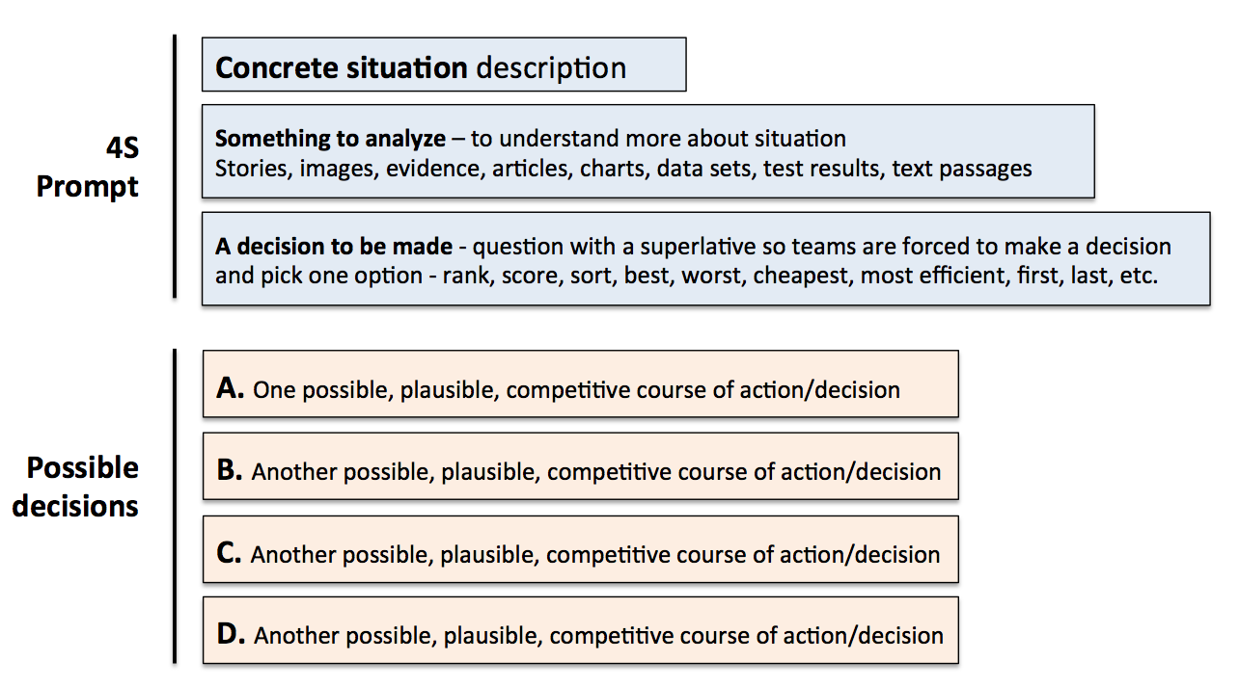

Step 6-8: Design Readiness Assurance Sequence

Step 6: Determine important concepts to test
Looking at the 4S task you have created, it is time to think about what concepts, definitions, and vocabulary the students will need to start their analysis. Make a preliminary list.

Step 7: Select Appropriate Reading
Knowing what concepts, definitions, and vocabulary your students need to get started – find a concise reading that has sufficient detail (not too much) and is at an appropriate reading level to be accessible to your students.

Step 8: Create a variety of Readiness Assurance questions
Time to write a few multiple-choice questions for the Readiness Assurance test. Question should be a mix at mostly Bloom’s levels – remember, know, and some light application. See the Bloom’s section page 6 of this section for suggestions of possible question leaders. Select a few leaders and complete your multiple-choice questions.

Creating Learning Outcomes
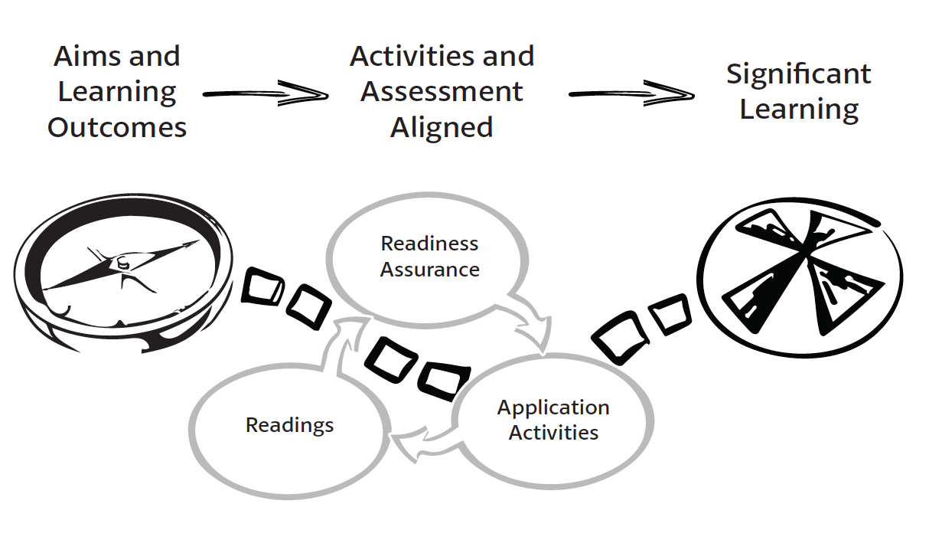
Build Your First Simple Learning Outcome
Creating great learning outcomes is a cyclic, iterative process where you revisit and refine as your course design proceeds. You create your first provisional outcomes are then used to build other components of course design – selecting teaching and learning activities and designing assessment materials. As the other components begin to come into focus, you will periodically revisit and refine your initial learning outcomes. At a very simple view – writing a learning outcome can be as simple as attaching a Bloom’s verb to a piece of a piece of content.
Consider: I want students to know about flood return periods, I could simply add the Bloom’s verb “describe” to flood return period.
Describe + Flood Return Period = Learning Outcome
Learning Outcomes are directly focused on student achievement and become more detailed by module end, on exactly what the students will be able to do. Learning Outcomes often contain references to the knowledge, skills, and judgment abilities you want your students to develop. Your initial Learning Outcome statements are often the precursors to ideas for 4S Application tasks.

Learning Outcomes are often much more rigorously constructed then this simple approach. A model known as the ABCD model is often applied.
A – stands for audience – “The student will”
B - stands for behaviour – “write an explanation”
C – stands for condition – “in 30 minutes”
D – stands for degree – “with no mistakes”
For our purpose we can keep the learning outcomes simpler at the beginning.
How to make Learning Outcomes that are good for TBL
When we start thinking about the 4S Application tasks, we want to try to write Learning Outcomes that focus on more concrete actions rather than abstract understanding. We are looking for concrete actions just like a discipline expert takes. Good Learning Outcomes express how experts in your field or discipline would use the course content to solve disciplinary problems. The more concrete you can make the learning outcomes the easier it will be to develop 4S Application tasks from them.
Sample Learning Outcomes for a statistic course: by the end of this course students will be able to use their knowledge of statistical principles to:
- Complete a statistical analysis
- Select an appropriate sampling plan
- Develop a survey instrument and plan to gather information from a specific population
Sample Learning Outcomes for a genetics counseling course: by the end of this course students will be able to use their knowledge of genomics to:
- Interpret genome sequencing data
- Identify genetic markers with greatest risk of disease/abnormality
- Develop counseling plan to work with specific family issues
Sample Learning Outcomes for a business course: by the end of this course students will be able to use their knowledge of marketing principles to…
- Conduct a market analyses
- Evaluate a marketing plan
- Select or Develop marketing techniques to reach specific populations of clients
Sample Learning Outcomes for a history course: by the end of this course students will be able to use their knowledge of early Canadian history to…
- Interpret written accounts of historical events in light of cultural dynamics
- Assess (and estimate) the bias or orientation of a given author
- Develop arguments for current policies or political positions based on historical context

Bloom’s Taxonomy
Blooms – Cognitive Domain
Remembering
Understanding
Applying
Analyzing
Evaluating
Creating
Benjamin Bloom helped develop the Cognitive domain taxonomy of educational objectives to help educators prepare examinations and other assessment materials that test different levels of knowledge .and understanding.
Bloom’s can be effectively used to create test items that test different levels of understanding, since the different levels can directly be mapped to specific verbs. These verbs can both be used to generate learning objectives and create test questions that correspond to Bloom’s different levels.

Cognitive Domain (lower levels)
Remembering
Verbs: Recalling, defining, recognizing, listing, describing, retrieving, naming
Common Question Leaders:
- What is the definition of….
- What is the name of…
- What is the best description of…
- List the following….
- Why did….?
- How is…?
- Where is…?
- When did … happen?
Understanding
Verbs: Explaining ideas or concepts, interpreting, summarizing, paraphrasing, classifying, explaining, locating, identifying, restating
- Common Question Leaders:
- How would you classify…?
- What facts or ideas best shows….?
- Interpret in your own words…?
- Which statement best supports…?
- How would you summarize…?
- What is the main idea of…?
Applying
Verbs: implementing, carrying out, using, executing, translate, employing, illustrating
Common Question Leaders:
- What is the best first step?
- What is the most significant problem?
- What would be the worst thing to do?
- Would it be a mistake to…?
- What is the most common mistake?
- Which test would you order next?
- What is the most common diagnosis?
- How would you use…?
- How would you solve?
- What is the most logical order?
- What approach would you use..?
- What would result if….?
- What facts would you select to show…?

Some tips for using Bloom’s for TBL

Write a variety of Low-level questions
- What did the text say? (Remembering)
- What did the text mean? (Understanding)
- How could you apply it? (Recognize an example of a concept)

Have a few Low-level questions that invite discussion
- Which statement is most accurate?
- Based on the theory that you read about, what is most likely to happen is we apply X?
- Which of these items best represent the qualities/characteristics of X?

Have one or two Higher-level questions that invite discussion
- Based on what you have read about theory A, which of the strategies listed below has the best chance of success, given the specified conditions (X, Y, Z)?

Gronlund’s Question Prompts
Illustrative knowledge questions
Knowledge of Terminology
- What word means the same as ________?
- Which statement best defines the term ________?
- In this sentence, what is the meaning of the word ________?
Knowledge of Specific Facts
- Where would you find ________?
- Who first discovered ________?
- What is the name of ________?
Knowledge of Conventions
- What is the correct form for ________?
- Which statement indicates correct usage of ________?
- Which of the following rules applies to ________?
Knowledge of Trends and Sequences
- Which of the following best describes the trend of ________?
- Which is the most important cause of ________?
- Which of the following indicates the proper order of ________?
Knowledge of Classifications and Categories
- What are the main types of ________?
- What are the major classifications of ________?
- What are the characteristics of ________?
Knowledge of Criteria
- Which of the following is a criterion for judging ________?
- What is the most important criterion for selecting ________?
- What criteria are used to classify ________?
Knowledge of Methodology
- What method is used for ________?
- What is the best way to ________?
- What would be the first step in making ________?
Knowledge of Principles and Generalizations
- Which statement best expresses the principle of ________?
- Which statement best summarizes the belief that ________?
- Which of the following principles best explains ________?
Knowledge of Theories and Structures
- Which statement is most consistent with the theory of ________?
- Which of the following best describes the structure of ________?
- What evidence best supports the theory of ________?
Illustrative comprehension and application questions
Comprehension Questions
- Which of the following is an example of ________?
- What is the main thought expressed by ________?
- What are the main differences between ________?
- What are the common characteristics of ________?
- Which of the following is another form of ________?
- Which of the following best explains ________?
- Which of the following best summarizes ________?
- Which of the following best illustrates ________?
- What do you predict would happen if ________?
- What trend do you predict in ________?
Application Questions
- Which of the following methods is best for ________?
- What steps should be followed in applying ________?
- Which situation would require the use of ________?
- Which principle would be best for solving ________?
- What procedure is best for improving ________?
- What procedure is best for constructing ________?
- What procedure is best for correcting ________?
- Which of the following is the best plan for ________?
- Which of the following provides the proper sequence for ________?
- What is the most probable effect of ________?
From: How to make Achievement Tests and Assessments - 5th edition by Norman Gronlund

Writing RAP Questions
At the heart of the Readiness Assurance Process is a series of readings and multiple-choice tests that cover the important fundamental knowledge that students will need to know to begin the 4S application activities.
Getting ready to write RAP questions
Once you understand what the culminating student performance will be, you turn your attention to preparing student for first engagement with the content (reading and RAP) and then the progression of 4S activities that leads to that culminating 4S performance.
Identify specific knowledge the students will need to begin effectively engaging with the 4S activities. This is not everything they need to solve every activity but what they require as an entry point to the problem-solving conversation. You do this by mapping back from the 4S application activity to important foundational knowledge that the students will need to be successful. When you are clear on the basic knowledge students need to know, you are then ready to select appropriate student preparation materials and construct RAP questions.
Select appropriate student preparation materials. There is an iterative loop as you select/define/refine the concepts to be initially tested, and then select and refine the preparation materials. For preparation materials, we most often use readings, but videos, lecture recordings, or narrated PowerPoint’s can work well. Over the years we have discovered that less is more with readings. The amount of readings that students will tolerate depends on the particular discipline and institutional context. Our readings are closer to 25 pages for 2 weeks, which is down from our original 75 pages for two weeks. We found that students were spending a short, fixed amount of time completing readings without regard for complexity and length of readings. Remember the Readiness Assurance Process is not trying to be comprehensive. It is just giving students an entry point to the problem-solving conversation.
One aside – when teachers are first introduced to the idea of the flipped classroom, they are often concerned on how to cram their 1 hour lectures into a 10-12 minute videos. This is the wrong way to look at it. The preparation materials are just to get students started. It is not all that students learn in a module, so you need to create a selective subset of your 1 hour of lecture content – focusing of high level themes and must know basic concepts and definitions. Students will be motivated to learn the additional content to solve the exciting 4S team tasks.
Develop a list of important concepts and ideas to test with your RAP questions. The RAP question coverage doesn’t need to be comprehensive, you are providing students the foundational knowledge and understanding they need to begin problem-solving.

Writing MCQ Questions
Multiple-Choice questions have two main parts: the question stem or leader, and the options (which include a correct answer). When beginning to construct a multiple-choice question, write the stem of the question first. A well-constructed stem is a stand-alone question that could be answered without examining the options. The wording of the stem and the verbs it contains determines the overall difficulty of the question.
Multiple-Choice Questions have a reputation for only testing lower level skills like knowledge and recall. In the question example below students are asked the difficult task - to select the citation that is most accurate. All citations have errors and the students are really being asked to “hypothesize” which errors will have the greatest impact on the citations effectiveness. This question is testing at a very high “Blooms” level. Writing questions at higher “Blooms” level is difficult, but NOT impossible.
In your argument, you are citing a number of cases from different courts. This is the first time you cite any of these cases. What is the most accurate citation sentence (use your citation manual)?

            - Wyman v. Newhouse, 93 F.2d 313, 315 (2d Cir. 1937); Henkel Co. v. Degremont, 136 F.R.D. 88, 94 (E.D. Pa. 1991), Willametz v. Susi, 54. F.R.D. 363, 465 (D. Mass. 1972).
            - Henkel Co. v. Degremont, 136 F.R.D. 88, 94 (E.D. Pa. 1991); Willametz v. Susi, 54. F.R.D. 363, 465 (D. Mass. 1972); Wyman v. Newhouse, 93 F.2d 313, 315 (2d Cir. 1937).

            - Willametz v. Susi, 54. F.R.D. 363, 465 (D. Mass. 1972); Henkel Co. v. Degremont, 136 F.R.D. 88, 94 (E.D. Pa. 1991); Wyman v. Newhouse, 93 F.2d 313, 315 (2d Cir. 1937).

            - Wyman v. Newhouse, 93 F.2d 313, 315 (2d Cir. 1937), Willametz v. Susi, 54. F.R.D. 363, 465 (D. Mass. 1972), Henkel Co. v. Degremont, 136 F.R.D. 88, 94 (E.D. Pa. 1991).

Have a peer or colleague review your questions. It can be difficult to see flaws in our own questions, when we have spent hours writing them. A fresh set of eyes can help us catch many errors. There is nothing more uncomfortable then dashing off a set of poorly written questions, rushing to class, and enduring the inevitable student backlash and discontent.

Some Rules for MCQ Question Writing
For good question stems, consider following rules:
- Stems should be stand-alone questions.
- Stems should be grammatically complete.
- Negative stems should be used with caution.
- If a key word appears consistently in the options, try to move it to the stem.
- Word the stem such that one option is indisputably correct.
For creating good options, consider following rules:
- Make sure each incorrect option is plausible but clearly incorrect.
- Make sure that the correct answer (keyed response) is clearly the best.
- Avoid, if possible, using “all of the above”.
- Use “none of the above” with caution.
- Try to keep options similar lengths, since test-wise students will pick the longest option if unsure (too long to be wrong).
- Make sure options are grammatically consistent with the stem (question leader) and use parallelism.
- Make sure that numerical answers are placed in numerical order, either ascending or descending.
Well-constructed multiple-choice questions are not easy to create. But the quality of the multiple-choice questions you use in your Team Test can make or break the tone of your class. Nothing is more uncomfortable than rushing poor questions to the classroom and having to endure the inevitable student backlash. Good questions are absolutely essential to our success, and putting in the effort to write good questions is worth your time and attention.
Spend time reviewing and revising your questions. It can be very helpful to have a colleague look at your questions. When we write them we are often too close to see all the mistakes. Just like good writing is about good editing, good MCQ questions are about reflection and revision

Question Level mix on RAP tests
Write your RAP multiple-choice questions at Bloom’s Remember, Understand, and light Application level of difficulty. This is not about testing all that students will learn in the module, but instead only what they need to begin effectively problem-solving (4S Application Activities). It is important to pitch the RAT at the right level to encourage students to engage deeply but not so difficult that they lose heart.
The test should be a mix of approximately 20% remembering (did you do the readings?), approximately 60% understanding (did you understand what you read?), and finally, 20% application, The application questions can be in the form of “which concept applies to this situation” (are you ready to use what you have read?). To use a book analogy, you want to write these tests more at the table-of-contents level then at the index level.
You can include a few simpler questions that just provide simple accountability that the student has completed the readings. Try to ask about topics that students are likely to interpret incorrectly. Test common misconceptions that might undermine students’ ability to successfully begin problem-solving. You can ask which concept applies to a given situation or scenario. You can focus on the relationship between concepts; this is an efficient way to test two concepts at once.

Designing 4S Tasks
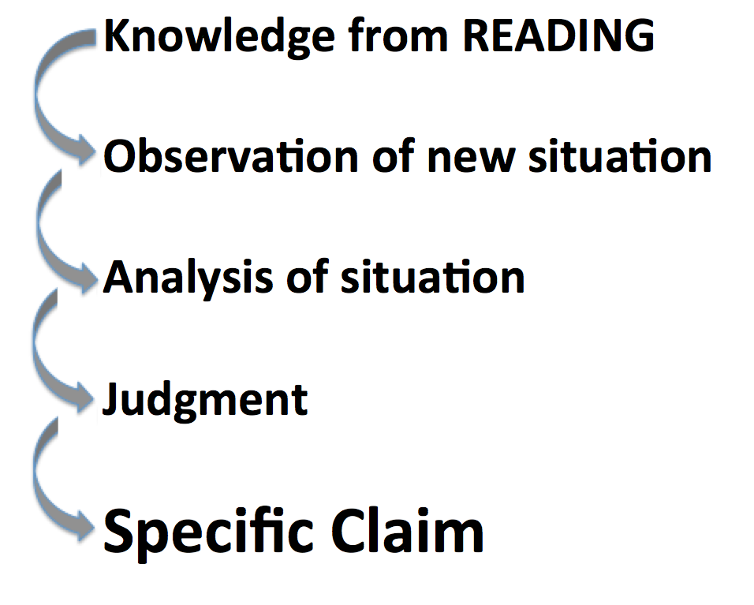
During a 4S Application task, students get to concretely apply what they have abstractly learned from the readings. You want students connecting abstract concepts from the readings with concrete experience during the 4S team Application tasks. Making connections during 4S team tasks is important to consolidate student learning.
Helping students see gaps in their knowledge motivates the students’ look up what they don’t know and then immediately putting that knowledge into action tests and deepens their understanding.
You need to present a scenario that creates the context in which what students “know” abstractly (via their readings) is put to the test when they try to “use” it in concrete, specific case. Your job is to find or, if necessary, fabricate these scenarios.
4S Extended Example (from Roberson)
Students in Sociology might “know” Maslow’s hierarchy of human needs, and could score well on a test that asked them to recite and explain it. But now imagine the Application task you give students, based on their initial understanding of Maslow:
You are a social worker and you have been given the case of “Maria from Syria.” Given your understanding of Maslow’s hierarchy, look at these data, make an assessment of her situation, and decide the best way to proceed in interacting with her: “Maria comes from a middle class family (her father was a dentist) in a small town in war-torn Syria. She immigrated with just her two children to Canada 2 years ago, and came to Ontario. She now works long hours at minimum wage as a housekeeper. She recently re-married and currently lives with her abusive, alcoholic husband. One of her children has health problems...etc.”
If the details of the case are rich, it quickly becomes clear to students that Maria’s case is complicated, and that Maslow’s hierarchy, while it is a useful tool to help analyze the situation, does not lead to an easy assessment or judgment.
Example 4S prompts (superlatives or implied superlatives to force a specific choice)
- A patient comes into emergency with the following symptoms...
  - What is the first thing you would do? And why?
  - What is the first test you would order? And why?
  - What would be the worst thing to do? And why?
- Given 3 possible programs to end homelessness in your city, select the program that is the best and will likely be most strongly supported by local agencies and Civic leaders? (Michaelsen and Sweet)
- What is the most relevant theory that explains the behaviour in the video? (Kubitz and Lightner)
- Which of the following best describes the opportunity cost of coming to class today? (Espey)
- Which of the following should the University do to best increase the quality of Undergraduate education? (Mahler)
- Which sampling scenario would best address this research project? (Mahler)
- Given three valid historical interpretations of the progressive Movement, discern which best describes the Progressives revealed in our manifesto? (Restad)
- In Clarence Page’s op-ed piece “The Problem With Trashing Liberty”’ where does the responsibility for a safe a civil society lie? Which of the following three philosophers (X, Y, and Z) does Clarence Page most agree with on these fronts? (Roberson and Reimers)
- What of the following passage in the Bhagavad Gita best illustrates reflection about the nature of Krishna’s divinity? (Dubois)
- Rank how useful each source is for understanding the fears of the Cold War era. (Restad)
- Which teacher should be nominated for a teaching award? (Croyle and Alfaro)
- Which indicator (from a list of 5 plausible alternatives) is most critical to making a correct diagnosis in this case? (Michaelsen and Sweet)
- If a moving vehicle overloaded this bridge structure, which component would likely fail first?
- You are making a home assessment, which of the following safety hazards would be of greatest concern? (Clark)
- After assessing Mrs. Randall’s dining room what would be your first recommendation to protect her from falls? (Clark)
- What line on this tax form would pose the greatest finical risk due to an IRS audit? (Michaelsen and Sweet)
- Given a set of real data, which of the following advertising claims is least (or most) supportable? (Michaelsen and Sweet)
- You are consulting for a new business owner who wants to open a dry-cleaning store in Norman, Oklahoma. Where would you recommend locating a new dry-cleaning business? (Michaelsen)

Another Pathway Description of 4S development process
First, you may need to make your original Learning Outcomes more CONCRETE.
Next, you need to create problem scenarios/situations where students’ factual knowledge (from RAP process) is useful, but maybe insufficient to solve the problem definitively.
Next, when creating these scenarios you want to clarify exactly what do you want students to be doing.
- Evaluate/judge something (object, product, creation, situation)?
- Analyze or diagnose a situation?
- Interpret something (text, artifact, data set)?
- Solve a particular type of messy problem?
Next, identify the concrete information/data sets the students will work with:
- Texts (such as cases, descriptions, excerpts from a textbook, writing samples, etc.)
- Images (visualizations, diagrams, videos, etc.)
- Data (spreadsheets, graphs, charts, etc.)
- Objects (products, specimens, etc.)
Next, you need to pick the format of students’ action:
  - Will they compare?
  - Will they sort?
  - Will they rank?
  - Will they score?
  - Will they choose the best course of action?
  - Will they distill and represent in a written format?
Next, determine how to make student thinking/decisions visible so it can be represented in a simultaneous report. Can their answer be represented with?
  - Colour Voting Cards
  - Single Number
  - Single Letter
  - Single word or phrase
Sometimes this means converting a complex response into a simple response. For example, after a ranking task, ask students to report their #1 choice, rather than their entire ranking scheme. If you’ve asked students to compile a list, ask them to choose the MOST critical item on their list and report it. Every task needs to lead to a moment of sharp differentiation: “I choose this over that.” Getting the students to this moment sets up “WHY?” as the teacher’s entry point for interactions leading to student analysis, reflection, and critical thinking. The simultaneous report naturally lets teams compare their decisions and decision-making process to other teams.
Finally, it is good to develop a facilitation plan for debriefing the 4S Application task, to ensure students learn the most they can from the task. Debriefs always begins by asking ALL teams to simultaneously report their answers/decisions. A good plan provides you with a way to organize the discussion that follows, and direct students into a dialogue with each other.
Instructor: “OK, I see three groups said “B” and two groups said “C.” Let’s start with those of you who said “C.” Please explain to the other students why you chose this answer?
Later: OK, teams who said B, how would you respond to them?
Later still: Nobody chose A. Why did you discount that possibility?

Learning Outcome to 4S Activity Story
Define Flood Return Period
This is a very typical content focused, low Bloom’s level learning outcome. Next step is to raise the Bloom’s level (in this case using Bloom’s Cognitive Domain Taxonomy).
Explain Flood Return Period
The change has moved the learning outcome from the lowest Bloom’s level – Remember - to the slightly higher - Understand – level. In the next step, we try to change this learning outcome to be about concrete action rather than just abstract understanding.
Demonstrate understanding of Flood Return Period
This is often the first attempt at making the learning outcome more about concrete action. Unfortunately, it doesn’t provide any information on how the students might “demonstrate understanding”. In the next step, we try again to make it about concrete action but this time so student understanding is put to use in a visible way.

Students will predict the outcome of a situation
This is getting better. Students are using their knowledge of Flood Return Period and applying abstractly to a concrete situation. This is key. You can start to get glimmers of what an activity might look like where students show you that they know (knowledge in the service of action). But what is missing here is discrimination and judgment.

Students will predict the most likely outcome of a specific situation
We now have discrimination and judgment but still a little too open ended to have students make decisions that are easily comparable and drive an intense reporting discussion that examines only the salient issues that need to be considered to make a “good” judgment and decision “in this case”. Constraining the possible outcomes to be considered can help you structure the analysis and discussion so very specific issues are discussed and very specific analysis is done. Lets constrain the possible choices!

Final transformation to 4S activity

Which of these outcomes is most likely given this situation (using your knowledge of flood return period)
- Possible Outcome 1
- Possible Outcome 2
- Possible Outcome 3
- Possible Outcome 4

We have transformed a lower level learning outcome, that at best could be assessed in an examination, into a powerful classroom activity that is structured to lead to a rich, deep reporting discussion.

Final elaboarted version of this 4s activity

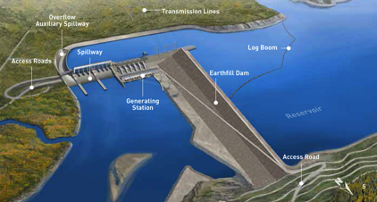

You are head of Engineering for a large dam project on the Yellow river in the Ningxai province of China. The dam is to be located in the Yiling district near the exit of the Ordos Loop section of the river. The dam is to be located at 34°49′46″N 111°20′41″E. The Yellow river is China’s third largest river. The river is characterized by extremely high silt loads, especially in spring floods. The local bedrock is highly fractured gneiss. The dam will be a concrete earthfill hybrid design. You have been asked to determine some of the main design parameters, including safety related question like what flood event return period to build the dam to withstand.

What flood return period would you recommend the dam be designed to withstand?

- once in 50 year flood
- once in 100 year flood
- once in 200 year flood
- once in 500 year flood

Using the 4S structure
Lets examine how to structure problems using the 4S framework so they lead to consistently powerful activities. There are 4 major tenets to consider when structuring a 4S activity.

First, we should use the kinds of questions/problems and problem solving/analysis procedures that disciplinary experts are routinely asked to use/make. Since most disciplines are more about their actions rather than there content. Next we need to make problem about concrete action in a concrete situation with real consequences. This helps make student understanding visible to both the teacher and student. Then we need to think about the kinds of complex analysis that will required of students to analyze/interpret the scenario or problem statement. Finally, we will need to constrain choice to intensify the learning.
Tenet 1: Use Expert-like Disciplinary Problems

A nice feature of this example is that it asks the kind of question an expert would need to make.

“Disciplines are more clearly defined by how those working within the discipline collect, organize, assess, and use information” (Roberson and Franchini, 2014, p. 278)

“If we want our students to become more expert in our disciplines, we need to structure their encounters with content in ways that change what they can do with knowledge.” (Roberson and Franchini, 2014, p. 278)

Tenet 2: Make it about Concrete Action in the real world

Students need to use their understanding (gained in the pre-readings, lectures or previous activities) to make expert-like concrete decisions that will have very concrete consequences. You want to design concrete scenarios where conceptual and abstract understanding helps students make better decisions.

The quality of the problem ultimately controls the effectiveness, energy, and learning outcomes of an activity.

“Students, therefore, need to be required to act frequently in ways that generate consequences that provoke reflection and demonstrate visibly their thinking. The more focused and concrete the action, the more visible will be the thinking and the learning—and the more immediately useful will be the feedback.” (Roberson and Franchini, 2014, p. 276)

“Effective team tasks point students consistently toward making decisions that reveal reasoning and understanding in service of a judgment.” (Roberson and Franchini, 2014, p. 279)

“What we know about the nature of learning is that students gain deeper traction, faster, with course content if their first encounters with it include concrete experiences framed by and informed by the abstractions” (Roberson and Franchini, 2014, p. 296)

Tenet 3: Require complex analysis, discrimination, and judgement

Coming up with a good and defensible solution requires the integration and analysis of many different factors and the weighing of tradeoffs (like cost vs. safety). There are a lot of things for the teams to consider in determining a reasonable course of action and coming up with a reasonable defense for their final decision.

Possible issues that need to be considered:
- How big are the flood events?
- Are changing climate patterns going to affect the size and frequency of flood events?
- What is the difference in cost to design to withstand the different levels of flood events?
- Are there unique landscape or bedrock concerns? How could we mitigate them?
- What are the population patterns downstream?
- How would downstream populations be effected by a failure at different flood levels?
- How do these kind of dams typically fail?
- Can the dam be constructed to fail elegantly and reduced the threat to downstream populations during flood events?

“Scenarios allow you to embed many variables that can be used to introduce multiple concepts, theories and perspectives into students’ discussion, as well as to complicate the task, if desired, through a mix of relevant factors and red herrings.” (Roberson and Franchini, 2014, p. 287)

Tenet 4: Constrain Choice to intensify analysis and discussion

The example at first glance looks a lot like a multiple-choice question and many teachers worry that constraining choice like this will limit the depth of the discussion. It is quite the opposite, constrained choices focuses student energies on analysis of specific issues, which ultimately helps with team to team comparisons that allows students to see how their thinking contrasts other teams. But this would be like saying a murder trial is decided by a two option multiple-choice question. These kinds of constrained choice questions are potent discussion starters. This really becomes clear for all to see during the public reporting of team decisions.

“The function of the collective decision task, therefore, is to place a restrictive frame around the team’s action. This restriction forces the team to evaluate, integrate and, if needed, respectfully discount a team member’s inputs en route to a judgment and a focused decision.” (Roberson and Franchini, 2014, p. 288)

“Tasks that direct students toward a specific choice do not stifle student thinking but concentrate it so that feedback on the task can be directed at specific, anticipated discoveries and realizations.”
(Roberson and Franchini, 2014, p. 290)

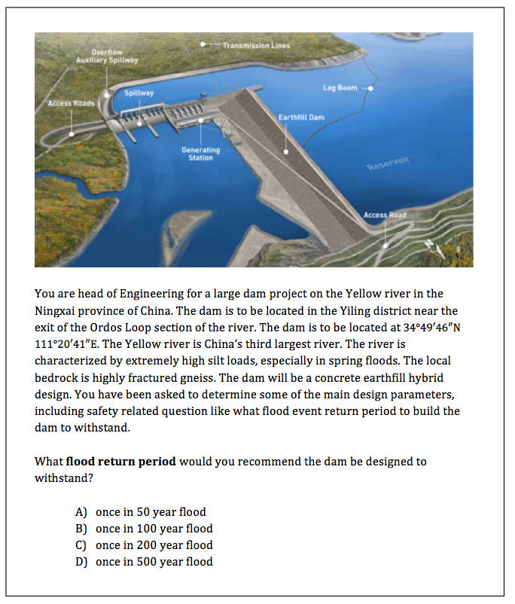
A problem that is significant and interesting to the students – not a toy problem
Multiple reasonable courses of action – some more reasonable than others
Specific question statement - that often uses superlatives like best next step, worst thing to do, most appropriate action, most likely outcome, greatest concern, etc.
Complex scenario to analyze – with relevant information, irrelevant information, missing information, constraints, trade-offs - that require expert-like concrete action

