Reflection – NIC TBL Institute June 2017
General: Control of Parking Lot questions better – established ground rules early - had big post-its (1 foot by 1 foot) for parking lot questions, didn’t go down many rabbit holes – group just didn’t ask as many questions
Morning Day 1
Team formation – good, had 9 nurses in 21 participants….used all nurses at front of line, then score on Michealsen’s group belief questionnaire
iRAT/tRAT/Appeal – good, used Balan’s scorecards for recording iRAT
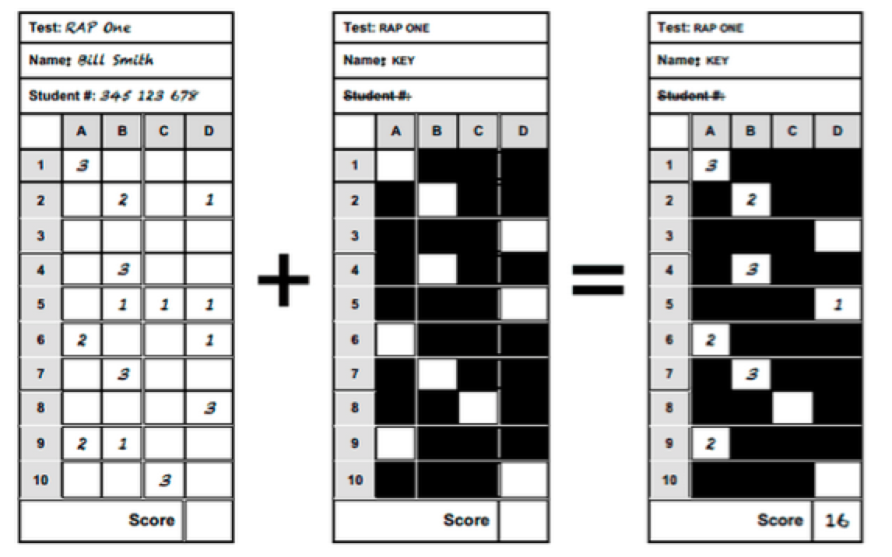
Three new 4S activities really help people consolidate the pieces of TBL, especially their understanding of the 4S’s.

First 4S activity based on new video generated great discussion about each of the 4S’s. Will fix distorted voice in video
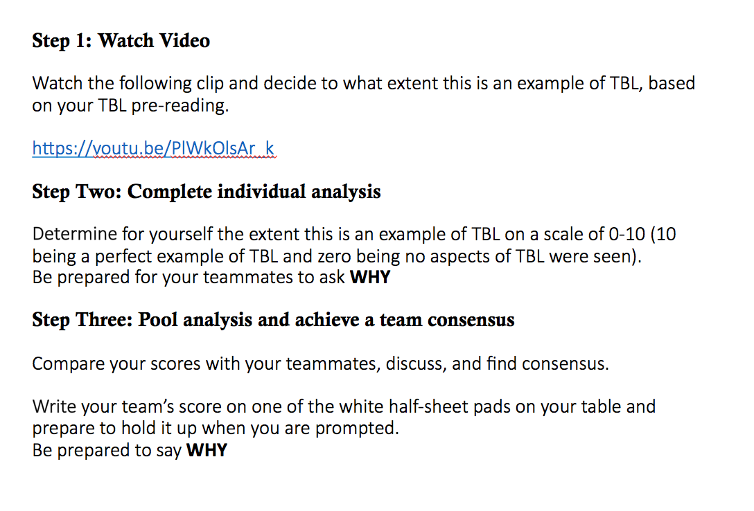
Second 4S activity (rewritten passive voice) created nice opportunity to reinforce how specific choice really focuses analysis and generates better discussion.
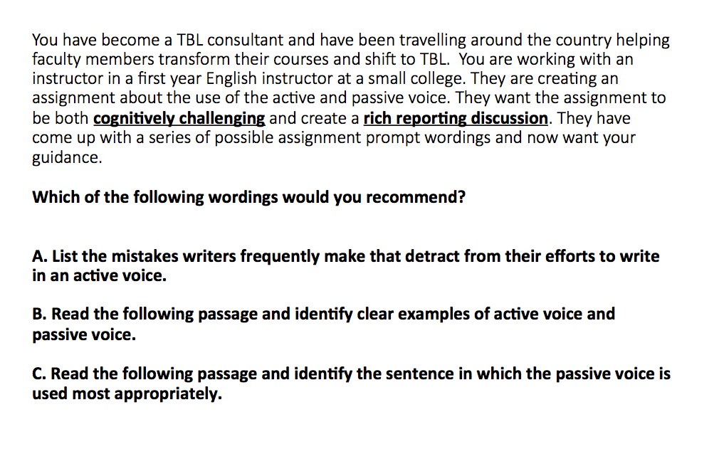
Third 4S activity - Roberson 6 different actions to recommend in response to listsrev posting, didn’t work that well. People found the wording of the prompt confusing and were not sure what to do.
- Need to Revise
Segment from 11:15 to noon to consolidate and reinforce team formation, RAP, 4S and TBL framework worked really well. This was missing from May iteration and was needed.
- PowerPoint Attached, maybe add 4S activities (at end of this document)
Afternoon Day 1
New segment – Introduce writing LO’s > Individual work using each participants personal course material > table talk
New segment – Introduce designing 4S’s > Individual work > table talk
New segment – Introduce writing MCQ’s > Individual work > table talk
This all worked very well….although group struggled a bit with MCQ’s
Homework tasking – good
This configuration of afternoon felt like quite an improvement
- PowerPoint Attached
Morning Day 2
Feedback circles – great as usual
Post feedback circle reflection should NOT be announced as…do this and get coffee….nobody reflected…and just went for coffee
Peer Evaluation section and peer evaluation council before lunch – good as usual…might do a slide on one rubric row – say attendance with specific commentaries for each level, so people can see assigning marks/levels is based on mostly observation and not judgments
Afternoon Day 2
Did chunking card sort…then handed out Teaching at its Best TOC…this remains the weakest part of the 2 days. I don’t think it brought clarity to people. I wonder is this should just be replaced with a longer whole course overview.
4S activities (Put you TBL knowledge to work) worked well, but wonder if they should be incorporated into end of Day 1 morning during consolidation section.
Warning label, last words, close – worked well
Possible Adds to Day 1 Morning (moved from afternoon of Day 2)
