APSC Examination Protocol Suggestions

Centre for Instructional Support 2019 W2 Examination Period

# General

These suggestions and protocols will help us do the best we can. There are legitimate academic integrity concerns with online final examinations and we only have partial solutions. This document reflects our current plans and understandings.

If you have specified in your syllabus that there will be a final exam and now choose to not have a final exam and only use past assessments for computing final grade, this decision should be made in polite consultation with students. If a particular student feels they have been negatively impacted by this late change in syllabi and course expectations, they may have cause for appeal.

**Note:** Associate Dean, Carol Jaeger has provided APSC faculty with detailed guidance on this subject in her 22mar2020 document – **APSC Resources for Instructors for Modifications to Syllabi and Exams.**

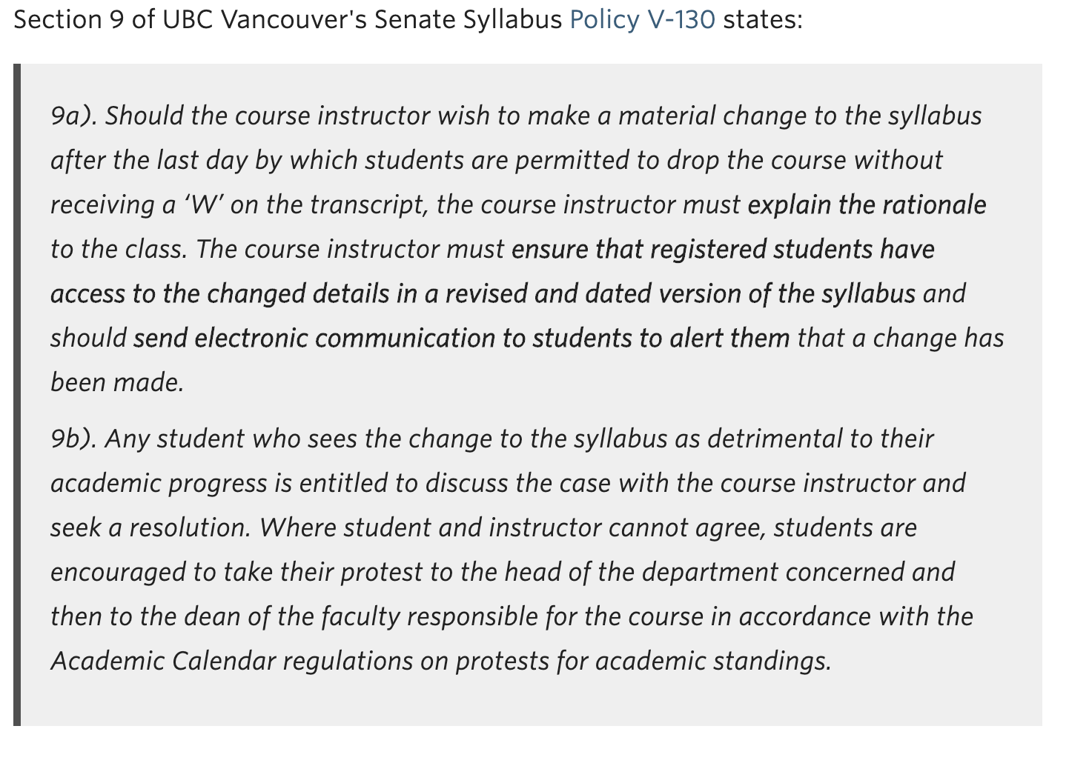

If you choose to have a final exam, have it during the normal, officially scheduled time on the paper-based schedule. And if there is any way to make your final exam multiple-choice do it, or at least make a portion of it MCQ. Our options for academic integrity control for MCQ tests are good. These controls are discussed in Proctorio section below. The duration of online exams should be lengthened slightly to allow for technical glitches and challenges.

If your examinations are highly dependent on handwritten calculation questions there are limited options for them and they don’t include good academic integrity controls like Proctorio. The “best” solution we have identified is described in “Examinations that require hand writing and drawing” section below. Pete Ostafichuk has provided an excellent novel way to incorporate high level calculation question in multiple-choice format that is also described in this section.

The Faculty of Applied Science has prepared an Academic Integrity pledge for students to sign (agree to electronically). The pledge is modelled on the Faculty of Science pledge that was recently developed. We have built on their work and have created an Academic Integrity Pledge for Applied Science. This will improve academic integrity compliance, but it is not any kind of magic bullet. These kinds of pledges have been shown to reduce Academic Integrity violations at schools where they have been used, but some students still will cheat and collude. Our suggested text is below in “Academic Integrity Pledge” section. It can be incorporated as a multiple-choice question into beginning of every online exam or be added into your course as a separate quiz. The Centre for Instructional Support can help you with this.

# APSC Academic Integrity Pledge

I affirm that I will not give or receive any unauthorized help on this examination, that all work will be my own, and that I will abide by University of British Columbia policies and any special rules for conduct set out by the examiner.

I understand that any violation of University rules or those set out by the examiner will be investigated as a case of academic misconduct, and the usual consequences and penalties as set out in the UBC Academic Calendar will apply.

The rules that apply to this exam are as follows:

[instructor to enter details here – e.g. work alone, no calculator, how work will be shown, etc. as applicable)]

[  ] I agree to the APSC Integrity Pledge  
[  ] I understand that violation of the pledge will result in an academic misconduct investigation  
Type your name here [                                             ] in place of a signature.

# 

# **Possibility One: Use Canvas Quizzes for Final Examination**

You should try develop your final exam in the Canvas Quiz tool. There are many question types available in Canvas quiz tool, they include:

* **Multiple Choice**
* **True/False**
* **Fill in the Blank**: Enter your question text, then define all possible correct answers for the blank. Students will see the question followed by a small text box to type their answer.
* **Fill in Multiple Blanks**: Enter your question, specifying where each blank should go. Then define the possible correct answer for each blank (define widely, including mis-spellings) . Students must type correct answers into text boxes at each blank.
* **Multiple Answers**: This question will show a checkbox next to each answer, and the student must select ALL the answers you mark as correct. These question are all or none marks - no part marks.
* **Multiple Dropdowns**: Enter your question, specifying where each dropdown should go. Then define possible answers for each dropdown, with one correct answer per dropdown.
* **Matching**: Build pairs of matching values. Students will see values on the left and have to select the matching value on the right from a dropdown. Multiple rows can have the same answer, and you can add additional distractors to the right side.
* **Numerical Answer**
* **Simple Formula Question**: Enter your question, build a formula, and generate a set of possible answer combinations. Students will see the question with a randomly selected set of variables filled in and have to type the correct numerical answer.
* **Essay Question**: Students will be given a text field to compose their answer. This option provides a live word count as students are typing. You can include guidance in the question stem of how long and detailed the answer should be – “Suggested Answer Length 50 to 100 words”
* **File Upload Question**: Students will be able to upload a file for their answer.

Once you have built your exam in Canvas, you can enable Proctorio on the quiz settings page. You can then adjust the Proctorio settings (they go from slightly creepy to really creepy – UBC legal has approved its use). There are recommendations on Proctorio settings later in this document, and explanations of the various settings and what student difficulties can be anticipated with different settings.

# Securing Canvas Quizzes with Proctorio

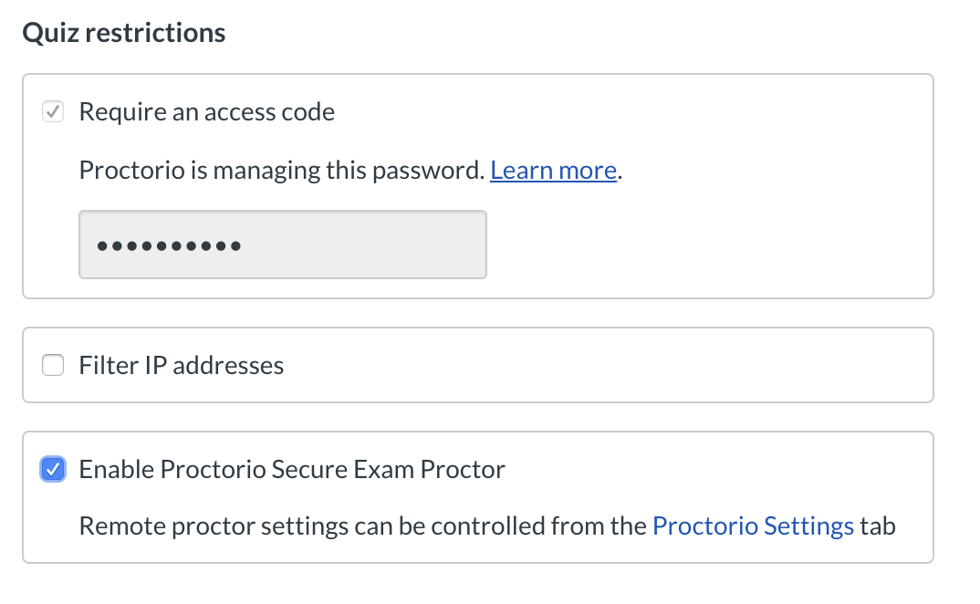First you need to add “**Secure Exam Proctor**” to your Canvas course from the settings page. Then you create a new quiz you get the option of enabling Proctorio in the Quiz Restrictions section of quiz settings page. To use Proctorio both you and your students must use the Chrome web browser and install the Chrome Proctorio extension.

Proctorio places some significant requirements on students (install Chrome and Proctorio extension, enable/have a webcam and potentially a microphone, have a quiet, private place to write). Students may not reasonably be able to meet these new requirements , we need to make alternative arrangements for these students. We need to be very accommodating with enforcing these new rules on engagement – no prejudice. We need to be careful to treat all students fairly.

To get student comfortable with Proctorio and identify students that require alternate arrangements, we suggest a **practice quiz using Proctorio**. The Centre for Instructional Support can copy this Proctorio Practice quiz into your course. Just request at [learning@apsc.ubc.ca](mailto:learning@apsc.ubc.ca). This practice quiz is also used to get instructors comfortable. The Practice report from Proctorio can be used to coach students away from any suspicious behaviour observed on the system in the context of a no-stakes/low-stakes assessment (e.g. students can be notified that the system flagged unusual eye movement) so they can address that before a high-stakes assessment.

The Proctorio Practice quiz guides students through the installation of Chrome and the extension. The instruction provide link to download Chrome and the extension and instructions on how to install them.

Once student have installed Chrome and the extension they the can complete at a minimum 3-question quiz

1. Did you successful install Chrome?
2. Did you successful install Chrome Proctorio Extension?
3. Did Proctorio work for you?

I would be good practice for instructors to create their own version of the Proctorio Practice quiz (i.e., not for marks) with similar questions to what students will get on the real exams. The reason is to give students a chance to also get used to writing the exam on Canvas with a different question style they might have otherwise seen, and to be able to flag and correct suspicious behaviours on the practice quiz, rather than having that come out on the high-stakes exam.

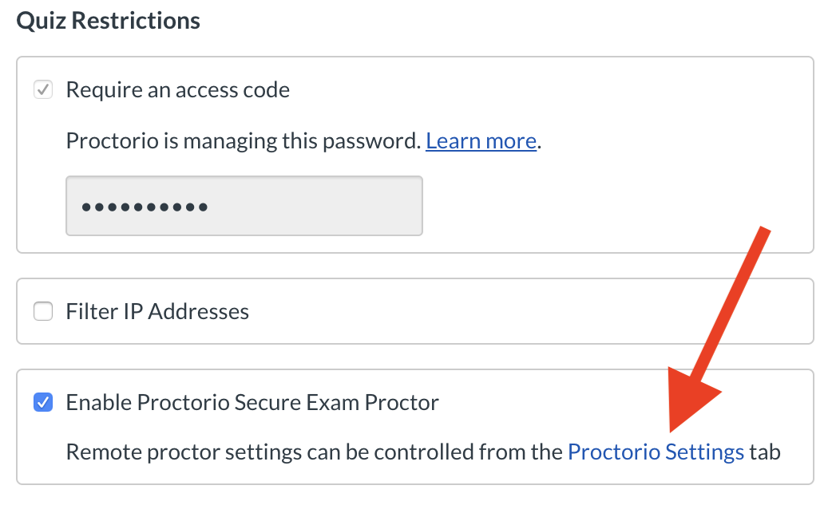

If students have difficulty with the Proctorio Practice quiz they should contact their program Assistant (or their designate). If issue is more technical the Program Assistant can then contact the Centre for Instructional Support (learning@apsc.ubc.ca). We will need to monitor the results and reach out to non-complying students to make suitable alternate arrangements. We must sell the importance of this Proctorio Practice quiz to student as a way to reduce stress and anxiety come final examination day.

Here are our current Proctorio Settings recommendations (you can access these settings from the Canvas Quiz settings page).

**Recording Options**

[Video Recording] Yes

[Audio Recording] Yes

[Record Screen] Yes

[Record Web Traffic] Yes

[Record Room] No

**Lock Down Options**

[Force Full Screen] Yes

[Only One Screen] Yes

[No New Tabs] Yes

[Close Open Tabs] Yes

[Disable Printing] Yes

[Disable Clipboard] Yes

[Block Downloads] Yes

[Clear Cache] Yes

[Disable Right Clicks] Yes

**[Prevent Re-entry] No**

**Verification Options**

[Verify Video] Yes

[Verify Audio] Yes

[Verify Desktop] Yes

[Verify ID] Instructor Preference – most don’t use

[Verify Signature] No

**In-Quiz Tools**

[Basic Calculator] No – cumbersome, not very good

[Whiteboard] No – cumbersome, not very good

**Proctorio Frame Metrics**

Set to low or mid points – Proctorio collects more information than settings suggest, setting control amount of detail in reports. More severe settings will trigger more alarms. You are able to freely change these settings after the assessment and the resulting suspicion levels reported by Proctorio will be automatically updated.

Computer Based Abnormalities

[Navigating Away] Yes

[Keystrokes] Yes

[Copy and Paste] Yes

[Browser Resize] Yes

[Mouse Movement] No

[Scrolling] No

[Clicking] No

Environmental Abnormalities

[Audio Levels] Yes

[Head and Eye Movement] Yes

[Leaving the Room] Yes

[Multi-Face] Yes

Technical Abnormalities

[Exam Duration] No

[Start Times] No

[End Times] No

[Exam Collusion] Yes

There is UBC Proctorio advice at <https://keepteaching.ubc.ca/assignments-assessments/#proctored> (Proctorio advice is near bottom of page). Proctorio automatically runs a brief tutorial highlight the key features when you first access your results. This is done directly in Canvas using the actual data from your course assessment.

# Adjusted Exam Durations

Typically, other campus units with more Proctorio experience extend the examination window by 25 total minutes - add 10 minutes to start of examination (to get student going) and 15 minutes to end of examination (to navigate any technical difficulties). The exact exam duration should only be extended to include the 15-minute end time addition. Students can arrive early online, get into Proctorio controlled quiz, and start early (in pre-exam 10-minute window) - the quiz duration will be the same for all students– start 10 minutes early, finish 10 minutes early.

# Working with Proctorio Results

After the quiz has completed, a detailed Proctorio report is available via a gradebook link in Canvas. Proctorio automatically runs a brief tutorial highlight the key features when you first access your results. This is done directly in Canvas using the actual data from your course assessment. This is worth watching!

# Real Time Chat Support during Examination Starts

On examination day at examination start-ups the Centre for Instructional support will provide live chat support for students as Proctorio-enabled exam are beginning.

The Centre for Instructional Support will set up and host a real-time Proctorio exam start-up support chat (details – TBA). Both Sauder and Pharmacy, who have more experience with Proctorio, use this live chat mechanism to help support students. This kind of chat support has been lightly accessed by students in other faculties – most requests are for Proctorio access code – which means student doesn’t have Proctorio extension installed, there have been a few cases of needing to quit and restart Chrome, and only one case of needing to reinstall Chrome.

We are currently reviewing the examination schedule and doing staff planning to have enough people in place to support the students as multiple exams launch.

# Please Ask for Help

Make use of the services at the Centre for Instructional Support. They can help you build the Canvas quizzes and double-check your Proctorio settings before high-stakes tests.

Contact us by sending an email to learning@apsc.ubc.ca

# 

# Early APSC User Feedback

*• I found it really helpful to have the video and screen recorded.  I was able to flag the student looking away from the screen in a suspicious way, and to match that with how they were progressing through the exam.*

* *One student who lost connection to the system in the middle of the quiz.  I was able to see in the Proctorio records that the student was warned by Proctorio before the quiz that he didn’t have enough free space, but he dismissed the warning and attempted the quiz anyway.  He stopped complaining about the system being buggy after I shared that information with him, and he said he’d fix the issue for the final.*
* *A few students got “kicked out” due to a drop in WiFi, accidentally quitting browser, and twice the system just kicked them out (we are not sure why yet). A simple restart of the browser got them back in and there was no lost data that we've seen so far (still early)*

*• Issues with the student ID card and facial recognition- especially for the females getting flagged for wrong ID due to no-make and glasses vs make-up and no-glasses on their ID card*

* *Stable internet connections are key (this is why we set “re-entry” allowed – otherwise a momentary drop in connectivity would end student’s exam. With re-entry allowed they can reload the page and come back in – much simpler and less stressful for everyone.*
* *Difficult to find quiet place to complete exam, when all family members are home.*
* *Difficulty with slow VPN speeds in some parts of China.*
* *Students in other time zones complain about writing tests in middle of the night*

# 

**Note:** one way that student can get themselves in difficulty is not ever completing Proctorio practice quiz and not retaking it close to exam date. This Practice Quiz is not a do it once and forget it. In as short as a week or two, Chrome updates can break a student’s computer’s readiness. Student need to be encouraged to re-take practice Proctorio quiz close to exam time.

# **Examinations that require hand writing and drawing**

Your first goals should be to try to minimize the number of handwritten questions on your examination. There is little we can do the maintain good academic integrity in this situation. The Academic Integrity pledge will help, but will not prevent some students from cheating and colluding.

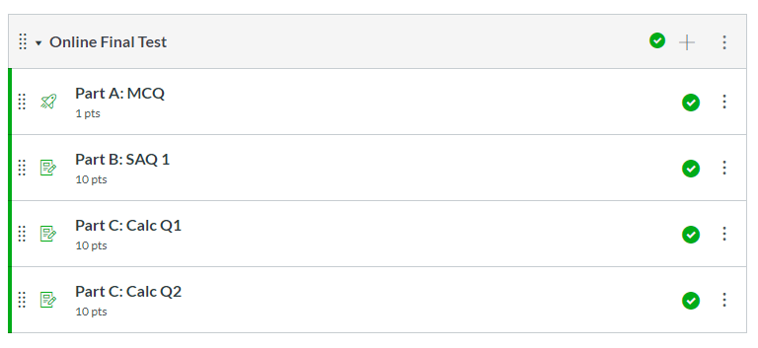If you decide you must include traditional handwritten calculation questions, you can collect hand-written submissions by having students take pictures of their final work with their phones or iPads and submitting these files in Canvas. We have identified what we believe to be optimal process. We do this by creating separate assignment drop-box for each question submission (so a few long questions would be better than many short questions). This might sound complicated but there is an advantage when you are marking. You can then use SpeedGrader and it will give you sequential access to each student image submission for a particular question. For instance, this would let you mark all question 2 at the same time, this will be better for grading consistency. If we were to collect images as file upload question, the quiz results download as nested folder, and it is cumbersome to mark and move back and forth between student submissions. We are currently testing this approach to ensure it is both reasonable on students and does not overwhelm the Canvas server.

Canvas Quiz

3 Assignment

Drop Boxes

Another clever solution is to modify questions involving calculations, sketches, or non-text answers to preserve high-level thinking while allowing simple text responses (thanks to Pete Ostafichuk for this idea and example):

1. Take what you would normally include as a hand-written question.
2. Create a sample solution to that question, but to insert common errors students might make.  (Not calculator button-pressing errors, but conceptual errors.)
3. Include the sample solution as an image or screenshot on Canvas and ask students to identify the errors that were made. Ideally, students should also suggest what should have been done instead.

A traditional calculation problem might look like this:

2 m/s

r = 5 cm

A polished sphere of 5 cm radius is placed in a uniform flow of air moving at 2 m/s to the right. Estimate the drag force vector acting on the sphere. Use ρair = 1.2 kg/m3 and μair = 1.8 × 10-5 Pa∙s. Show all of your work, and draw a box around your final answer.

A reformatted question that maintains—or possibly enhances—the level of student thinking assessed, but simplifies answers to short text phrases, could look as shown on the next page.

(continued)

2 m/s

**Problem:** A polished sphere of 5 cm radius is placed into a uniform flow of air moving at 2 m/s to the right. Estimate the drag force vector acting on the sphere. Use ρair = 1.2 kg/m3 and μair = 1.8 × 10-5 Pa∙s.

**Your classmate’s solution:**

1. Find Reynolds number, 
2. From Figure 1 (page 100) the most conservative CD curve uses ε/D = 0.0125
3. From Figure 1 using ε/D = 0.0125, CD = 0.4
4. Calculate drag from CD



1. Drag opposes motion; the sphere is pushed to the left by a force of 0.03 N drag force.

r = 5 cm

Consider the problem below. Imagine a classmate has prepared the solution that follows, but that they have made some errors in their work. **Your task is to identify and correct the errors. There are at least four errors in the sample solution. In the answer box provided, list each error on a new line with the following:**

1. The line number of the solution were the error is located,
2. A brief description of what is wrong with what your classmate has done, and
3. A brief description of what they should do instead in order to correct the error.

Notes: (1) treat each step in the solution independently and do not propagate corrections to following steps, and (2) you do not need to check any calculations; all errors should be obvious without a calculator.

Type answer here:

# Tips for using this format

If using this format, some ideas to consider:

* make sure it is clear students should not propagate corrections from earlier steps (i.e., students should focus on each line of the solution independently, and assume all prior work is correct when considering that line),
* be explicit whether or not you want students to recheck any calculations, look up values, etc.,
* consider indicating how many errors are in the mock solution or how many errors students should identify,
* consider basing the errors in the mock solution on common errors you see students make,
* consider awarding marks based on how significant the error is (i.e., trivial errors carry less mark weight than major conceptual errors), and
* consider that very few (if any) students will spot all errors; I usually give 100% for students who correctly identify a subset of all errors.

An alternative to this format to further emphasize high-level judgement and evaluation, and to further streamline marking, is to ask student to identify only the 2 or 3 most significant errors. You would need to clarify what you mean by “most significant” but this could include the errors that most significantly impact the final conclusions, or that most significantly demonstrate a lack of understanding of the concepts, etc. In this way, students first need to identify all errors they can and then they need to rank them by significance. In marking, part of the mark is based on how significant the error they identify is.

# Please Ask for Help

Make use of the services at the Centre for Instructional Support. They can help you build the Canvas quizzes and double-check your Proctorio settings before high-stakes tests.

Contact us by sending an email to learning@apsc.ubc.ca

# Frequently Asked Questions

**How can I ensure that the submitted image of hand-written work is the students own work?**

Unfortunately, we can’t. The best we can do is remind students about academic integrity expectations by using the academic integrity pledge. You probably should create the exam questions thinking of exam is open book.

**I want to use custom settings with Proctorio. Who should I discuss these with?**

The settings you will use depend on your examination and your preferences. Contact us and we can discuss the various options and the outcomes of different Proctorio settings. Contact us at [learning@apsc.ubc.ca](mailto:learning@apsc.ubc.ca) to discuss your particular needs.

**Can I use Proctorio without Canvas?**

Proctorio is only available inside Canvas at UBC. It wraps around existing Canvas quizzes

**Is there a cost for using Proctorio?**

Central administration has made Proctorio free for all UBC courses for the duration of this event.

**Can student use any web browser to access a Proctorio Quiz?**

Proctorio ONLY works with Google Chrome.

**What should I do if a student is having trouble accessing the Proctorio Quiz and is asking for an access code.**

This typical is the result of the student not having the Proctorio Chrome extension installed. Direct them to install the Proctorio Chrome extension (<https://chrome.google.com/webstore/detail/proctorio/fpmapakogndmenjcfoajifaaonnkpkei>)

**I have student who usually write at the Accessibility office. How do I now handle them?**

The accessibility office is quickly building protocols and guidelines for instructors to properly handle these students. There guidance document should be available shortly (18mar2020)

**What if none of these options work for me?**

Contact Jim Sibley at the Centre for Instructional Support (jim.sibley@ubc.ca). Maybe we can work out an alternative option that will work for you.

# Frequently Asked Questions - from UBC keepteaching.ca

**How does Proctorio support taking remote exams?**

Proctorio helps preserve exam integrity by:

* Recording students' video, audio, screen, and/or keyboard activity during an exam
* Restricting what students can do on their computers during an exam (e.g., accessing other applications, websites, and browser windows/tabs)
* Proctorio’s algorithms analyze behavior within the recordings and flag potential issues for review. You have the final say on whether any flagged activity constitutes actual misconduct.

**What do students need to use Proctorio?**

To take a Proctorio exam, students must have:

* A desktop or laptop computer (mobile devices will not work)
* Chrome web browser with Proctorio Chrome extension installed on their computer
* A working webcam (if you plan to record video) and microphone (if you plan to record audio)

**Are Proctorio recordings stored in Canada?**

Yes. All Proctorio encrypted recordings are stored at Amazon Web Services in Montreal.

**Who outside UBC can see the Proctorio recordings?**

No one. While the recordings are scanned by Proctorio's algorithms, the footage is only available to the appropriate users at UBC. No person at Proctorio can access the encrypted recordings. Any UBC instructors or teaching assistants doing Proctorio reviews should ensure they are in a fully private space to further protect student privacy.

**How do I address student concerns about using Proctorio?**

Students can be reassured by explicitly stating:

* Proctorio is necessary to make sure the exam experience is fair for everyone. If you engage with the exam honestly, you do not need to worry about the recording, even if something unusual or unexpected happens during your exam (e.g., a loud noise).
* Proctorio only runs when you're in an exam in your Chrome browser (you will see a shield icon in the browser when it’s active). There is no separate program collecting your data and no data collection once you leave your exam.
* No person is watching you during the recording and only your course instructor and/or teaching assistant will review the recording afterward. Proctorio’s role is limited to: a) providing temporary data storage for your video and b) running its automated algorithms to flag any moments in your video for review.
* An automated flag on your recording does not mean your instructor or teaching assistant will automatically assume you cheated or that you will receive a grade deduction. Human interpretation of the flags is essential; your instructor and/or TAs make the final call.
* Additionally, giving students a no-stakes practice exam (that you can also take) allows everyone to get familiar with the Proctorio experience, before being in a high-pressure, high-stakes situation.

**How can I help my students prepare for Proctorio exams?**

* Make sure students have access to a desktop or laptop computer (mobile devices will not work), have installed the Chrome web browser with Proctorio Chrome extension, and have a webcam and microphone available.
* Encourage students to arrange a space to take the exam ahead of time in a private, quiet, well-lit location with access to a reliable Internet connection.
* Be explicit restrictions around what is and isn’t allowed during the exam.
* Give students an extra time to take the exam to allow for the room scan that happens at the start of the exam, as well as any technical issues. This can mean broadening the window of when the exam is available for students to start in Canvas and/or the time limit you give them for the actual exam.

**How do I review Proctorio recordings?**

Since Proctorio can only be enabled on Canvas Quizzes, you will use Canvas to access the results within each quiz’s Proctorio Gradebook. You'll get a quick colour indicator to show if any exams should be reviewed further and where potential issues in each flagged exam occurred.

**Do teaching assistants have access to review Proctorio recordings?**

Yes. Most teaching assistants have access to Proctorio recordings, since this is based on their role in Canvas. If you have a TA who is unable to access Proctorio, please contact UBC support.

**Does a flagged exam in Proctorio always mean the student has cheated?**

**NO**. Proctorio’s algorithms look for potentially suspicious parts of recordings that should be reviewed by the instructional team. Sometimes, these will be false flags (e.g., a loud noise). You also have a say in how sensitive Proctorio’s algorithms are to recorded student behaviours, and you can adjust these settings at any time.

**Students are asking me about an exam access code, what do I tell them?**

Your Proctorio-enabled exam will not require an access code. If students are being prompted for one, please ensure they are:

* Using the latest version of the Chrome web browser
* Have installed the Proctorio Chrome extension
* If this doesn’t resolve the issue, contact Proctorio support (proctorio.com/support)

**What technical support is available for students?**

Proctorio provides a support page specifically for test-takers. Additionally, Proctorio support can be reached:

* During an exam: by clicking the shield icon in the web browser, then clicking Live Chat
* Outside an exam: by connecting via phone (1-866-948-9087) or email ([support@proctorio.com](mailto:support@proctorio.com))

**Remember the Support you have:**

The **Centre for Instructional Support** can help you activate your Canvas course shell, post materials, create assignment drop-boxes, teach you how to simply record PowerPoint voiceovers, or plan and conduct synchronous online classes using tools like Zoom and Collaborate Ultra which is integrated with Canvas. Contact us at [learning@apsc.ubc.ca](mailto:learning@apsc.ubc.ca) for help.

**LT Hub** provides campus level central support. Any instructor can call (604.827.4775) or email (lt.hub@ubc.ca.

A new campus-wide web resource is being created at **https://keepteaching.ubc.ca/.** It is currently up and available with instructions and content being updated daily.