Guide to Teaching
for New Faculty
in applied Science

This document represents my current guidance and advice. As campus procedures and systems are renewed, some aspects of the guide may become outdated and inaccurate. Please help us keep the guide current and accurate, by sending your suggestions, feedback, and corrections to learning@apsc.ubc.ca

Thank you to Carrie Hunter for her thoughtful extensive feedback and edits that made this so much better!

Jim Sibley
Centre for Instructional Support
University of British Columbia
December 2022

There are NO restrictions on the use of this book. Attribution is not required. All graphics are originals and copyright free.
Please feel free to extract, chop, hack, mutilate, revise, reuse, and redistribute to suit your own educational needs.

Contents
Introduction 1
Welcome to UBC 1
Centre for Instructional Support 2
First Steps 5
Teaching your first course 5
Course Improvements 8
Becoming a Great Teacher 33
Some foundational education ideas 33
Rigorous course design 46
Logistics Advice 54
Become familiar with Canvas 54
Working with Teaching Assistants 56
Find your support network 58
Rhythm of the academic year 60
Campus Supports 64
Getting Students Help 64
UBC Policies related to Instruction 67
Frequently Asked Questions 68
UBC Glossary 72
Ask for Help 78
Invitation from CIS 78
Works Cited 80

Guide to Teaching
for New Faculty

Introduction
This guide will help you get started teaching in the Faculty of Applied Science at the University of British Columbia (UBC). It provides an introduction to both teaching and course design as well as procedures and services that can help you be successful at UBC.

Welcome to UBC
The University of British Columbia is located on the traditional and unceded territories of the Musqueam, Squamish, Tsleil-Waututh, and Okanagan nations. The University was established in 1908 and has a current (2022) student population of 65,000 and over 16,000 faculty and staff on two campuses in Vancouver and Kelowna. There are 8 Faculties at the Okanagan campus (UBCO) and 12 Faculties at the larger Vancouver campus (UBCV). UBC has a large population of international students; they come from over 143 countries and comprise 27% of the total student population.
UBC is a large research-focused public institution with a typical central governance model: President, Vice Presidents, Board of Governors, Senate, and Provost.
The Board of Governors (BoG) is responsible for the management, administration, and control of the property, revenue, business, and affairs of the University. The BoG has the responsibility of approving new faculty appointments, but in day-to-day business, the Provost actually approves appointments, then the BoG reviews and accepts the approvals recommended by the Provost.
University Senate’s are typically responsible for academic topics and issues that affect the University community. We have two Senates (UBCV and UBCO) that set policy for awarding degrees, establishing new programs, curriculum changes, admission requirements, academic scheduling, appeal and adjudication processes, and educational policy.
The Faculty of Applied Science at UBCV is comprised of a large number of professional programs, including Nursing (NURS), Architecture and Landscape Architecture (SALA), Community and Regional Planning (SCARP), and 14 Engineering programs. In 2019, there were 468 students in Nursing, 300 students in SALA, 106 students in SCARP, and 7,772 students enrolled in the various Engineering programs.
Each department and school has local admin support staff that oversee local HR, finance, scheduling, and student services. The Applied Science Dean’s office provides central administration and helps support the schools and departments. You can find out more about Applied Science on our website - apsc.ubc.ca

Centre for Instructional Support
A major message in this guide is that the Centre for Instructional Support (CIS) is here to help you. It is Applied Science’s own no-cost faculty teaching support unit that can help you with many aspects of your teaching, including improving your teaching skills and helping you use campus learning technologies effectively. You are encouraged to contact CIS at any time at learning@apsc.ubc.ca or visit the website at cis.apsc.ubc.ca
At the end of this guide is a helpful alphabetized glossary to get you started, including concise explanations of different UBC acronyms, terminology, procedures, services, and systems.

CTLT
Another good place to start is the Centre for Teaching, Learning, and Technology (CTLT). They provide an extensive array of free professional development opportunities for UBC faculty.
They have a yearly faculty orientation workshop series and an ongoing teaching development program specifically for new faculty. As your teaching practices develops, you can attend their free workshops and seminars to learn more about different aspects of teaching.
They can also provide very helpful 1 on 1 consultations of a wide range of teaching topics.
You can learn more on their website - ctlt.ubc.ca

First Steps

Teaching your first course
Designing and delivering your first university course can be a daunting task, especially when few of us have had any formal teacher training.

Keep it Simple
You can keep it simple for your first few semesters. A well-organized lecture course will be well received by students and more achievable. A lecture course will meet student expectations and students will appreciate that your course has a similar structure to many of their other courses.
Start by trying to get copies of last year's course materials - syllabus, lecture slides, assignments and exams. If time is short, just quickly revise these materials and proceed with teaching the course using these revised materials. As you teach the course, you can update slide decks as you go, but keep looking and thinking about the things you might like to change for next year, consider:
- Course well-organized?
- Lecture slides clear and not overcrowded?
- Canvas site thoughtfully organized?
- Assignment formatting consistent and clear?
- Announcements and messages timely and clearly written?
- Syllabus complete with important dates and policies clearly outlined?
Be as organized as possible, and strive for improved organization each year. A sub-optimally organized course impacts student grades and their experience. As you become more comfortable with teaching, you may want to explore different course design options and teaching approaches. The good news is a well-organized lecture course can be a great base to build on and incrementally incorporate better instructional practices. The progressive improvements are often small, but can ultimately lead to a great course with clear objectives, engaging classes punctuated with great activities, interesting and rigorous assignments, and tests and exams that are both fair and challenging.
In his excellent book Small Teaching, James Lang suggests some valuable insights in how to incrementally improve your course with small tweaks along the way. His book is very compelling in the way it connects recent insights in the Science of Learning with small adjustments you can easily make in your courses that can lead to dramatic improvements in student learning. I would recommend borrowing a copy from the Centre for Instructional Support if you want to learn more.
Course organization and teaching approaches can be represented on a continuum, with no ideal place to be: you balance your comfort, needs, and responsibilities, with your student's needs. The goal is to find a mode of instruction that is most effective for you and your students.

Great First Day
A great first day can set the tone for an entire semester. There are some things you can do to start strong and a few things you want to avoid. Spend more time than usual getting your materials ready and practicing your words. You want to be as scintillating and engaging as you can be. You want to get students excited about taking your course.
DO NOT read the syllabus to the students, encourage them to read it on their own time. Reading the syllabus to the students is a real energy killer and can set up in the students' minds that “I am just going to sit and listen for the rest of the semester.”
If you expect student engagement to be the norm all semester, you should start right off with some activities or at least some engaging questioning. A caution about questioning - ask your first question and then wait the students out - DO NOT answer your own question just because you are uncomfortable with the length of the silence. If you answer your own first question - the students then know for the rest of the semester they just need to wait you out. How you approach asking your first question can set the standard for the rest of the semester.
It is worth visiting the classroom a few days before class and trying out the projector and microphone to better ensure a smooth first day. Technology issues are very infrequent these days but do occasionally occur. They may not be caused by you, but students can unfairly judge you if you spend the start of class fumbling with the classroom technology.
In your first class, highlight your professional experience and credentials, and put on a professional air on the first day to establish yourself as an authority in the student's mind. Later in the semester, you can get more casual as you get to know your students.
It is worth discussing some positive student expectations. You can acknowledge that life happens and people will sometimes arrive late - ask that latecomers get seated and settled quietly out of respect for their fellow learners. Similarly, ask them not to pack up early and begin talking and potentially disturbing the students around them that are still listening and trying to learn.
It can be worthwhile to assign the first assignment during the opening class or at least send them home with some reading to do. This helps send the message that you mean business, since “they are never ready until you get them started” (Wankat & Oreovicz, 2015).
For those of you who like checklists, here is a first-day checklist:
- Do a thoughtful Land Acknowledgement
- Introduce Yourself and Teaching Assistants
- Showcase Canvas site - highlight how to find things
- Give your students a reason to read the syllabus (no stakes quiz?)
- Teach them something on the first day!

Course Improvements

How Much Content?
As a new faculty member, you are most likely given an existing course to teach. There can be both explicit and implicit expectations about the content that will be covered and how your course needs to relate to other courses in your program. Academia is in love with its content and it is very unusual for a course to not have enough material! The long-held belief is that more content is better (Weimer, 2002). It is unfortunate that this content overload pushes students to surface learning strategies like memorizing, regurgitating, and forgetting. This is sometimes called “academic bulimia” with a binge-and-purge approach to learning (Weimer, 2002). It can be hard for a junior faculty member to say no to covering “all the content” when that is the local norm, but you may eventually realize that the students are not learning “all the content” and may want to reconsider the amount of content that your course covers. It is worth thinking about - is my teaching about me covering the content or is it about my students learning the content? This is a difficult issue with faculty recognizing that they don’t have time to teach students everything they need to know.
There have been some interesting studies (Russel et al, 1984) on the effect of low-density versus high-density lectures on the amount of student learning (density in this case refers to concepts presented per minute). They found that LOWER LECTURE DENSITY leads to MORE LEARNING (as measured by exam performance). So, maybe you don’t need to cover all the content, but you may need to create the conditions where students want to learn all the content. Maybe we can use the content to promote learning rather than just covering the content.
A typical progression as a faculty member gains experience in teaching is to slowly winnow the content down to the most important concepts and free up some class time to embed some activities to help students deepen their understanding by actually working with the content.

First Changes
Let's consider a semester or two after you have begun teaching and you now have a well-organized and delivered course. What are the next steps to making your course even better and better?
There are a number of areas you can consider for incrementally improving your courses.
- Refine your Syllabus
- Plan your classes more intentionally
- Punctuate your lectures with activities
- Build better learning outcomes
- Make assignments more meaningful and rigorous
- Improve tests and examinations
- Consider advanced pedagogies

Syllabus
Every time you make improvements and changes to your course you will need to revise the syllabus. Revision should happen anytime you update course outcomes, change the order of modules and topics, add major classroom activities, and add, delete or extensively revise assignments and other deliverables.
The syllabus is your opportunity to inform your students about your vision for the course ahead; what the course will focus on, why things are important, where you will take them during the course, what you hope they will learn along the way, and what you will do to help them learn.
There is UBC policy and requirements for what information must to be included in every syllabus. There is a helpful template you can use to create a syllabus that has all the right information and is compliant with UBC policy - https://curriculum.ok.ubc.ca/syllabusGenerator

Class Planning
A little intention can go a long way to improving your classes. Your lectures can be easily improved by developing and using a lesson plan (Godolphin, 2004). A lesson plan is a roadmap that lets the instructor clarify their intentions for how the class will unfold and what they hope students take away from each class. It subtly shifts focus from your content coverage, to what you need to do to support student learning, and what you want students to do and take away from your class.
There are typically three main parts to a simple lesson template; setting the stage (SET), main performance (BODY), and the takeaways (CLOSE). In practice a lesson might unfold like this:
SET - establish at beginning of sessions what you are going to cover, describe why you think it is important for students to know this, and then describe how you expect students to ultimately be able to use their knowledge.
BODY - you present course content and weave in activities while trying to limit the amount of content and continually monitor student learning and engagement and help them distinguishing the need to know from the nice to know. In the main body, you want to vary the stimuli by using activities, questioning, changes in voice and eye contact, using silences well, and periodically incorporating media like video, audio, and news stories.
CLOSE - summarize what was covered, highlight important takeaways, revisit SET (what you wanted to cover and why you thought it was important) and do not present any new information. Students often remember the last thing said, not necessarily the most important takeaways. Be careful here.
Sequencing Content in the Body
It is worth thinking about how to most effectively sequence the content within your body of your lesson. We often need to fight our intuition here that tells us we need to first introduce students to the details and theory and only then show them how it fits together and how it works in the real world (often using case studies and examples). The best approach is in fact opposite to this and is often called “concrete to concept.” With this approach, you first provide real world examples and application problems where students see real world applications and can give it a try and even fail to solve problems! What ends up happening here is you prime the students to be asking specific questions and have them looking for specific insights. You are helping the students organize their learning and start to develop mental models where the concepts and abstraction you teach can actually be more powerfully organized for future application. When you start with the theories and abstractions the students have no organizing model for the new information, so they can end up storing each piece of information separately which leaves them at a significant disadvantage when they try to use it later for problem solving.
USE CONCRETE to CONCEPT
The best approach is “concrete-to-concept” teaching organization. With the concrete-to-concept approach, the learning sequence begins with examples and application activities and then followed by teaching the theoretical content.
Roberson and Franchini (2014) describe these first application problem attempts as a naïve task. Naïve tasks forces students to grapple with concepts before background theories and abstraction are fully presented, this induces students to more actively listen, and has them looking for specific insights and answers that will help them with the kinds of judgments and decisions they know they will need to be able to make.

Punctuate Lectures with Activities
Many instructors start in simple lecture mode and then progress to punctuated lectures where activities are embedded to help emphasize important points, let students try to apply their knowledge, or just change the pace to maintain students’ attention.
EMBED ACTIVITIES IN YOUR LECTURES
One of the great values of classroom activities is both you and your students can get timely feedback on learning progress. In a traditional classroom, most class time is spent on information transmission and low-level cognitive processes, while out-of-class assignments ask students to engage in higher-level thinking on their own. When activities are embedded in the classroom teaching, opportunities for peer teaching and timely feedback provide support to the student engaging in these higher cognitive functions.
Starting small with only a few classroom activities will help you learn to manage them and see their value. The following two simple activities are excellent ones to try first.
The first is the one-minute paper. This activity focuses on the last few minutes of class. It can be as simple as asking students to pull out a sheet of paper to write down two important things they learned and two things they still have questions about. This is a nice addition to a class since, in the last few minutes, students are often beginning to disengage as they start to pack up.
The one-minute papers are collected as students leave the class. If grades are assigned, they are typically just for handing in something. Your post-class review might just involve you flipping through the student papers and look for consistent themes. These themes can be used, quite effectively, to start the next class in a nice way that connects to the last class.
When I asked at the end of the last class what you learned, you listed - X, Y, and Z and when I asked what question remained these two were consistently mentioned…Let me spend a couple of minutes answering those two questions
Another quick activity that can take as little as a minute or two is called think-pair-share. It can easily be added during the transition between existing lecture segments in your class. You simply pose a question (typically an application-level question), ask students to think for a few moments (you specify how long), and then ask students to turn to someone beside them and discuss their answers together. Once student pairs and trios have had sufficient time to discuss, you then call the class back together and get different pairs to recount their discussions and share their answers.
Both these activities above come from the classic book – Classroom Assessment Techniques. In spite of being almost 30-years-old, the book by Tom Angelo and Patricia Cross remains the classic for picking and planning classroom activities. Many new and revised books have appeared, but this classic has endured because of its unique helpful organization that lets you easily selected activities of different complexity and that target different kinds of learning. The activities are presented as simple to follow recipes with a number of supporting case studies so you can better imagine how the activity will fit into your own classroom teaching experience. You can borrow a copy of this book and others from the Centre for Instructional Support.

Objectives and Outcomes
When you inherit an existing course, you might find that its existing syllabus has a long list of content-focused objectives - students will know this… students will understand that… These content-focused objectives often read more like a list of topics to cover rather than what you want students to ultimately do.
The first change you might consider is clarifying for yourself the difference between your content topics and your learning outcomes. Describing your outcomes in terms of what students will be able to demonstrate as a result of their learning helps us remember that, ultimately, we will need to measure that student learning in our student assessments, and we will be able to ensure our assessments align without outcomes.
The next challenge is to transform content-focused objectives into student learning outcomes. You probably want your students to do more than just know something.
To help you with this, it is important to introduce Bloom’s Taxonomy here to help you learn how to write better learning outcomes.
WRITE LEARNING OUTCOMES USING BLOOM’S TAXONOMY
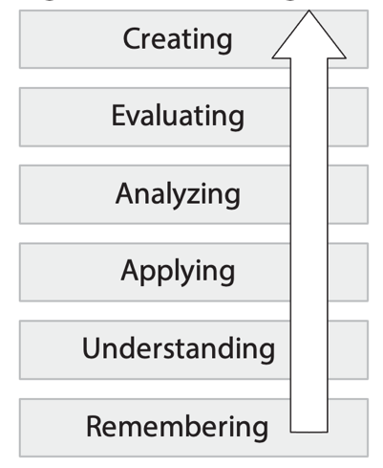
Benjamin Bloom developed an important taxonomy of educational objectives in three domains - Cognitive, Affective, and Psychomotor. These taxonomies have since become one of the cornerstones of university teaching, as they help educators use common language around learning goals and outcome statements, and helps us articulate the range of possible educational goals within a particular piece of instruction, course, or program. Bloom’s Cognitive Domain is the favourite in most university teaching. There are six levels in Bloom’s Cognitive Domain; Remembering, Understanding, Applying, Analyzing, Evaluating, and Creating.
As in this diagram, the levels are often presented as hierarchical. It is hierarchal in complexity of thinking, but misses the iterative loops back and forth across levels to achieve real knowing. Learners sometimes need to fail at applying something to be motivated to want to know more about it.
Bloom’s taxonomy includes lists of verbs that help you identify exactly what the student will be able to do, and at what cognitive level, with their new content knowledge and understanding. For example, you want them to know principle X. How will you assess their knowledge? What does ‘knowing’ mean in this discipline and at this level? Does it mean students will define the principle (remembering)? Will students be asked to paraphrase or explain the principle, perhaps with illustrations (Understanding)? Perhaps you expect them to know the principle well enough to interpret it or apply it in different contexts (Applying)? Do you have an upper-level course where you expect students to really grapple with the principle by critiquing it and differentiating it from others (Analyzing)? Perhaps you teach a graduate course that requires students to demonstrate the ability to create novel concepts and you will require them to assess various principles, judge their validity or even develop new principles that improve upon existing principles (Create)? Here is a handy table of different verbs (Barton, 2007) and their relation to the different Bloom’s levels.
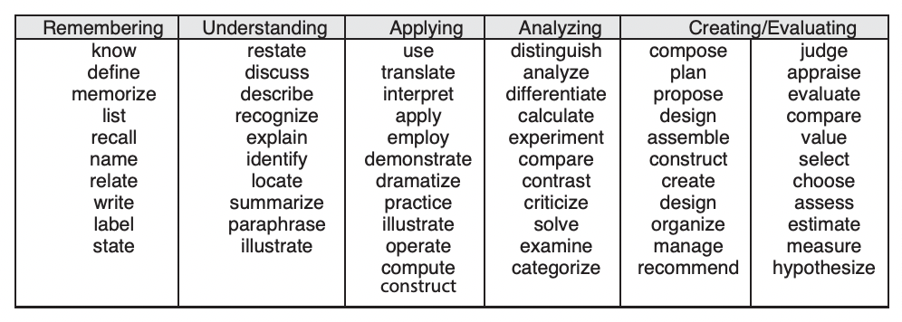
Here are a few simple examples that show how to use verbs to invoke different Bloom’s levels in a learning outcome statement:
- Define a concept (Remembering level)
- List the parts (Remembering level)
- Describe the function of… (Understanding level)
- Compare different approaches to… (Analyzing level)
- Select the best plan (Evaluating level)
- Predict the outcome (Creating/Evaluating level)
Here are some specific examples from Gronlund’s excellent book (2000) on writing instructional objectives:
- Select and justify the procedures used in testing.
(Creating/Evaluating level)
- Identify and describe the concepts and principles involved. (Understanding level)
- Explain the interaction using psychological concepts.
(Understanding level)
- Demonstrate the correct procedure for a wheelchair transfer
(Applying level)

Assignments
You may want to take a bit of time and rewrite some of your learning outcomes so they are more helpful in designing assignments and examinations. What you are trying to do is make learning more visible and therefore more measurable. Take, for instance, “students will know” - how are they going to demonstrate to you that they know? Looking at the Bloom’s table you can see - list, label, define, and other verbs - could be used to see if students know. So, you could rewrite the learning outcome from using know to another Remembering level verb.
Now that you have student-centred, demonstrable learning outcomes, you can use them to help you develop assignments and student assessments that measure student learning. When reflecting and aligned with learning outcomes, student assessment becomes fair and valid. Assess students on what you’ve told them they will have to be able to demonstrate.
ALIGN STUDENT ASSESSMENTS WITH DESIRED LEARNING OUTCOMES
Here are a few guidelines for developing good assignments:
- Make sure there is a progression of assignments (both in scale and focus) spread across the entire semester.
- Assess key and representative aspects of the course, and not necessarily every aspect.
- Make the value of the assessment is commensurate with the effort and time invested.
- Consider developing rubrics to clearly communicate to students both your expectations and the standards for grading.
- Carefully format your assignments for a consistent look. Use similar headings. Use consistent language.
Here are a few guidelines for using and delivering assignments:
- Motivate students by illustrating the real-world relevance, for instance, by describing a story, case or application. This also adds the complexity that allows for the exploration of various perspectives and higher-order thinking.
For example, a calculation-based assignment that requires the production of a poster suitable for the general public allows you to assess outcomes related to communication and knowing your audience.
- Create model answers and marking guides to help you and your TA be more consistent in your grading.
- Consider the timing of assignments so that students aren’t over-burdened all at one time.
Once you have created all your assignments revisit the learning outcomes to ensure that the different assignments do actually cover the complete range of desired course learning outcomes.
MAKE ASSESSMENTS TRANSPERENT RELIABLE AND VALID

A good assessment should be transparent, valid, reliable.
- An assessment is considered transparent when students can easily understand both the task required and the criteria by which the assignment will be judged.
- An assessment is considered valid when it measures important characteristics of student learning. There can be a tendency to measure things because they are easy to measure, not because they are important indicators of student learning.
- An assessment is considered reliable when different assessors come to similar conclusions about the quality of a particular student’s performance. Using rubrics can really help with reliability.
Different assessments have different marking workload implications; we are constantly balancing instructor effort with the quality of feedback to students. Some very effective assessment practices can be used in small group settings, but cannot be scaled to large classroom settings while keeping instructor workload anywhere near reasonable.
And remember, feedback from assignments can also be used in a formative way by students to guide their future learning efforts as it can help them assess their progress toward achieving the course learning outcomes. It can also help them select appropriate study material, practices and skills that they might need to practice and review to be successful in subsequent assignments and examinations

Consider using Rubrics
An excellent way to add power and clarity to an assignment is to build a rubric. So, what is a rubric? - “Rubrics articulate fundamental criteria for the related learning outcomes and include performance descriptors demonstrating progressively more sophisticated levels of attainment.” (AAC&U, 2022) What this really mean is rubrics are tables composed of column and rows. Column headings describing what different levels of performance. A row for each criterion with a text commentary in each column that describes the specific level of attainment. You can get a better understanding of what a rubric is by looking at some good examples. An excellent place to start is the “VALUE rubrics”. Just google this and you will have 16 good examples built for the University classroom.
There are many advantages to building rubrics – when you are writing the commentaries you think deeply about the things you look for in a piece of student that you use to discriminate between levels of performance. You also, sometime uncover criterion that you were not aware that you find important and hope to see in student work. There is a wonderful transparency when you share these rubrics with students at the beginning of an assignment – it gives them a clear idea of what is expected, what they can do to generate excellent work and how their will be assessed.
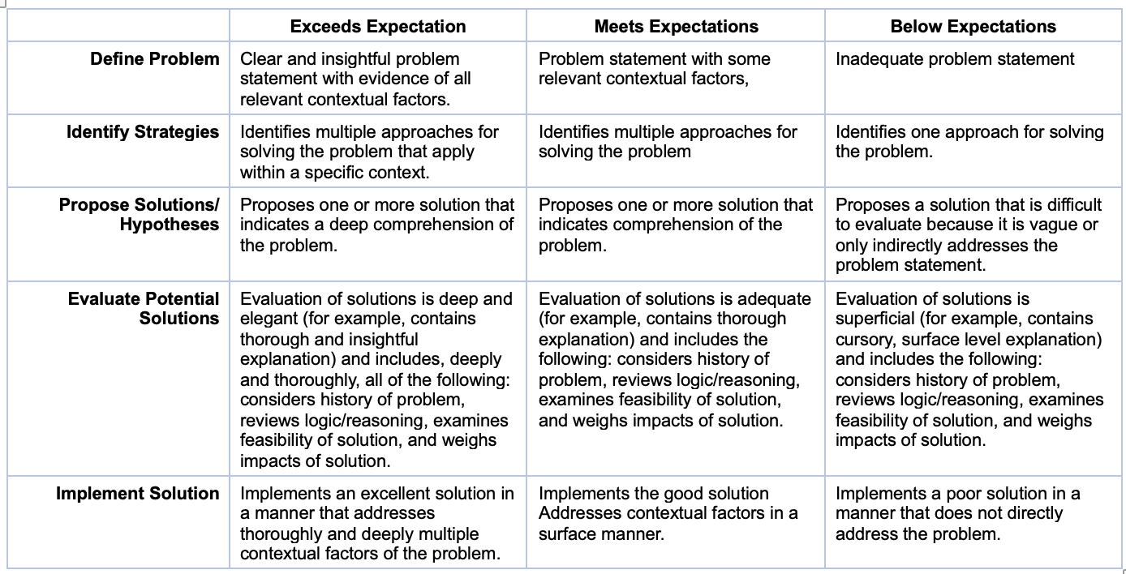
Rubric – Problem-Solving Example

Tests and Examinations
If you are lucky, you can get tests and examinations from the previous course instructor. You can also talk with the previous instructor and find out if you can get access to performance stats for previous exam takers. With access to these statistics, you can potentially identify specific questions that need revision and ensure the test was written at an appropriate length and difficulty. If you can’t get statistics, you can ask the previous instructor for at least the grade distribution for the last time the exam was offered.
If you need to draft an exam from scratch, here are a few suggestions to get you started. You want to create an exam template using the course learning outcomes and the list of topics you covered in the course. You also can use Bloom's Taxonomy to map your question coverage for different topics and learning outcomes.
USE LEARNING OUTCOMES AND TOPICS
TO CREATE AN EXAM TEMPLATE
Here is an example of the thinking that could be used to develop a reasonable examination plan:
You are assessing the first three modules of a course and every module had four major topics (12 topics across 3 modules). For each topic, you will ask two REMEMBER level questions and one UNDERSTAND level question. For each module, you will ask three UNDERSTAND questions that integrate multiple topics and one APPLICATION question.
3 questions per topic, 12 topics = 36 questions
4 questions per module, 3 modules = 12 questions
This would add up to a 48-question exam that focuses on Bloom’s lower three levels.
Make sure to test your exam - get your TA to try it. We often write questions that seem so clear to us but are easily misinterpreted by others. The TA should also be able to give you an estimate of the exam's reasonability for length and difficulty. Make sure the examination is of similar difficulty to assignments and activities from the semester. Resist the urge to build an exam that is the student's opportunity to “put it all together”. If you have only asked students to memorize and regurgitate all semester - asking them to apply, analyze, and synthesize on the last high-stakes exam is unfair. Doing this can generate some justifiable angst and anger from your students.
Making Peer Feedback Work
It is an attractive idea to have students grade each other’s work. Research has shown peer learning and assessment is educationally powerful, but it does have some problems, especially in the way it is often conceived. Linda Nilson in her insightful paper - Improving Student Peer Feedback - has a solution to this conundrum. She posits, that the typical problem is with the kinds of questions we are asking students to use when they review other students’ work.
Students grow by both providing and receiving feedback from each other. However, students must be asked to provide the right kind of feedback, if the exercises are going to have its strongest impact. A student with poor writing skills, for instance, is not well positioned to give writing feedback to a student with superior writing skills. But each student is an expert on how they read, understand and interpret other people’s writing. Nilson proposes the following sort of questions as guides for providing feedback.

- What do you think is the thesis of the paper? Paraphrase it below.
- Put stars around the sentence that you believe is the thesis sentence?
- List the main points made by paper.
- In each paragraph, underline the topic sentence.
- Highlight any passage you had to read more than once to understand.
- Bracket sentences that you find particularly strong or effective.
- Put checkmark next to lines having spelling, grammar or punctuation errors.
The real power of these kinds of questions is the amount of attention to the work it requires of the assessor, skimming and cursory reading will be insufficient. This kind of assessment work require keen attention and focus. This really turns peer assessment into a very powerful piece of learning for the assessor and at same time can provide valuable feedback for writer.

Advanced Pedagogies
Eventually, some instructors will be looking for even better student learning achievement. They often then begin to consider more advanced pedagogies like Team-Based Learning (Michelsen et al, 2004; Sibley and Ostafichuk, 2014), the Flipped Classroom (Talbert, 2017), Case-Based Learning (Erskine et al, 2003, 2005, 2019), or Problem-Based Learning (Barrows, 1998; Duch et al, 2001). The interest in advanced pedagogies intensifies when instructors' focus shifts from what they are teaching to what are students’ learning. Advanced pedagogies may be implemented in some cases with small shifts in the structure of a course. In other cases, a more substantial reassessment and redevelopment would be called for. Often, they also have a bumpy transition period as instructors and students adapt to new processes and expectations. Why would you do this? The outcomes for everyone (teacher and students) can be extraordinary, more enjoyable, and sometimes downright fun! But perhaps most importantly, advanced pedagogies that focus on student learning are associated with improved student learning and student experience.
EXPERIMENT WITH ADVANCED
STUDENT-CENTRED PEDAGOGIES

Many instructors who have adopted advanced pedagogies become enthusiasts for their chosen pedagogy and often talk of being reinvigorated about their teaching and looking forward to going to class.
In these learner-centred advanced pedagogies, the instructor’s role shifts from teacher/expert to designer and facilitator of precisely crafted student learning events. Students do not always willingly embrace these new methods after years of passively letting teachers tell them what to know and when to know it. In time, most if not almost all, students come to value these enhanced learning experiences that are possible with theses advanced pedagogies.
FLIPPED CLASSROOM
The flipped classroom has seen widespread implementation in recent years, not only because its active learning improves student outcomes, but also because it usually requires little transformation of the course or the instructor’s role.
PROBLEM BASED LEARNING
It is an approach in which students learn by working in groups to solve an open-ended problem. The problem drives the motivation and the learning. Often a tutor is used to facilitate the conversation, but the responsibility for learning lies with the students. Problem-Based Learning was popularized by McMaster and Maastricht.
TEAM-BASED LEARNING
It is an active, structured form of small group learning, that can be applied to large classes. Student accountability is achieved through the specific structured processes, including pre-class preparation, readiness assurance testing, problem-solving activities, and immediate feedback. Team-Based Learning was developed at the University of Oklahoma Business School.
UBC Applied Science has considerable expertise with Team-Based Learning. TBL has been in use in Engineering since 2004. Dr. Peter Ostafichuk (Mechanical Engineering) is the local TBL expert, having used TBL in dozens of course sessions. He and Jim Sibley wrote Getting Started with Team-Based Learning, which still remains the best introductory text to the TBL method.
CASE-BASED LEARNING
It engages students in solving problems using specific scenarios that resemble or typically are real-world examples. This method has intense interaction between participants as they build their knowledge and work together as a group to examine the case. The instructor's role is that of a facilitator. Case-Based Learning was popularized by Harvard and the Western Universities Ivey Business School
GUIDED INQUIRY
It is a type of inquiry-based learning where a teacher provides scaffolding to guide the students through their inquiries. They do this by providing students with a structured process to examine a problem. It allows learners to make sense of multiple sources of information, figure things out on their own, and solve complex problems. There are various forms of guided inquiry like POGIL and Peer Instruction is a favourite of many Science programs around the world.
Using Groups and Teams well
There are a few considerations to make sure you are using teams most effectively in your courses. It is worth thinking about the difference between a team and a group, how to form teams, and what is the optimal team size for my application.
CONSIDER HOW TO FORM STRONG TEAMS
A group is distinctly different than a team. A group can be thought of as an ad hoc temporary set of students whereas a team is a group that has been together long enough to form a cohesive unit. The good thing about a cohesive team is they often have worked through the Forming/Storming/Norming stages of Tuckman’s team development model and have moved to the Performing stage (Tuckman, 1965). They understand each other’s strength and weakness and often have found ways to work together well towards the common goal.
There are 3 common ways that you can initially create teams.
Instructor Formed (criterion-based)
This has been shown to be the best team formation method. You carefully distribute a diversity of assets into each team - for instance - each team has someone with work experience, speaks a second language, is good at statistics. You decide on the important diversity to have in each team. You can do a short survey in Canvas and then use a nested sort in Excel to load students into diverse teams.

Randomly Formed
This is the simplest strategy where you can randomize the student rooster and build random teams. There are tools in Canvas to help you create random teams.
Student Selected (only in selected circumstances)
Another option is to have students pick their own teams. Some instructors choose this method hoping to appease students who rebel against other formation strategies. You can actually create more work down the road as these teams are more often lacking a diversity of skills and are more a “social entity” (Brickell et al, 1994). There are situations, especially in senior capstone experiences, where team selection and commitment to a project of interest overrides the consistently better outcomes from other team formation methods.
Which method is right for you?
Brickell et al. (1994) did an extensive study of team formation methods and subsequent outcomes. They found that in the long term that instructor formed (criterion-based) team performed the best, followed by randomly formed teams, and trailing far back in performance student selected teams. If time precludes you from forming criterion based teams, randomly selected teams is a good alternative.
What is the best team size?
This depends on how long the team will be together and the amount of work that needs to be done. Another important consideration is what you are asking the teams to do - a courtroom jury needs to be big but writing a paper together with 12 people would be untenable. You should also consider if the focus of the team is on discussion alone, decision making, processes or building a product.
Product-based team work is often difficult for student teams when students have different time management approaches (last minute versus getting done early), different expectations (you want an A, I want a C) and different skill levels (I always have to redo their sloppy work). Teams need to be smaller for product-based work and there often needs to be individual accountability for the different inputs to the team product. It can be a good idea to divide up the work so it is easier for students to assign portions of the work to each team member. It is a good idea to keep these teams on the small side (3-4). In larger teams, ‘social loafing’ may occur where some students contribute less due to a perceived lack of accountability.
Process focused team work actually needs larger teams to have enough intellectual capital to work successfully with complex decisions and make difficult judgements. In the PBL world, the optimal team size is 6-8, and in TBL, the best team size is 5-7, with a team of 6 being optimal (Thompson et al, 2015).

Becoming a Great Teacher
A lot of becoming a great teacher is about learning how to design great learning experiences for your students. Understanding some key fundamental educational ideas can help you design the best possible learning experiences for your students. This section draws heavily from my decades of experience running the Centre for Instructional Support and helping scores of faculty with their teaching.
It has been an exciting time in education with advancements in cognitive and neuroscience helping us understand better than ever before the science of learning. If you want a more comprehensive overview of the science of learning, I would suggest How Learning Works: 7 Research-Based Principles for Smart Teaching written by Ambrose et al (2010).

Some foundational education ideas
At some point in your career, you will be asked to design a new course or extensively renew an existing course. The following educational ideas are some of my favorites that I have found useful over the years. These different ideas and models may help you see new patterns of how people learn and help you design more powerful learning experiences for your students. Which ideas and models resonate can depend on the current stage in your development as a teacher. Some models helped me early in my understanding of the learning experience and other models helped later in my development. A model that resonates with you right now can sometimes help you imagine, think, and design different possibilities for reimagining and enhancing the student learning experience.
USE LEARNING THEORY TO GUIDE YOUR COURSE AND INSTRUCTIONAL IMPROVEMENTS

Constructivism
Helping you imagine what learning is
The guiding principles of constructivism are:
- knowledge is constructed, not transmitted
- prior knowledge impacts learning
- building knowledge from information requires effort and purposeful activity.
Students bring their understanding of the world around them to the educational process. As teachers, we need to understand the mental models that our students use to perceive the world. Understanding our learners better is a good starting point for meaningful instruction.
Many educators believe that knowledge cannot be transmitted; only information can be transmitted. When we instructors transmit information to our students, we must also create opportunities for our students to individually create meaning from the information. The students need opportunities to actively work with the new information in meaningful ways to turn it into knowledge. Real, authentic problem solving can give students the opportunities to use new information and fine-tune their understanding.
Scaffolding and Fading
An idea to support novice learners
As students are struggling to create meaning from new information you can speed their progress by using scaffolding, where you provide enhanced early support and more extensive guidance when students are first learning. Then we can fade these scaffolds from the learning process as student mastery increases. Scaffolds should fade over time, as too much scaffolding can later actually impair performance as student mastery increases.

Kolb’s Learning Inventory and Cycle
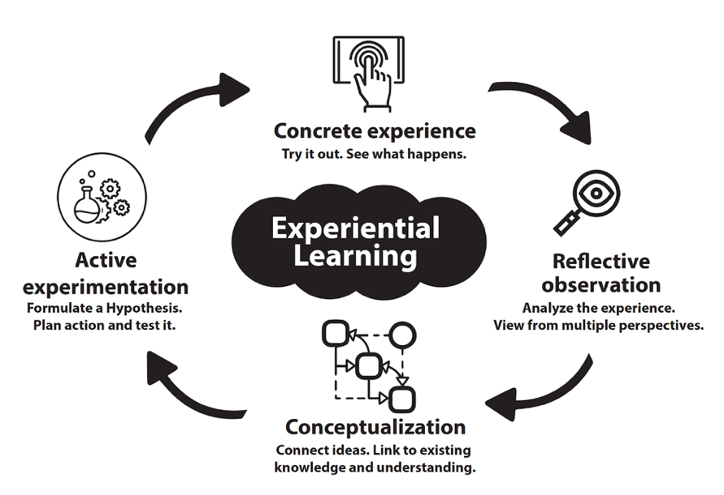
A helpful way to imagine a complete learning experience
Kolb’s helps us with categorizing learners on two continuums; the first continuum categorizes how a learner prefers to approach a task and the second continuum, how a learner prefers to engage in a task.
The “approach to task” continuum ranges from learners who prefer to build plans (active experimentation) to learners who prefer to reflect on an experience (reflective observation). The “engage in the task” continuum ranges from learners who prefer to do first (concrete experience) to learners who prefer to think first (abstract conceptualization).
The real power comes when we use this inventory information to help student cycle through both “approaches to task” and preference for “engaging with task”. Learners need to “cycle” through the four dimensions to develop a deep, enduring understanding. You want to design instruction so students are forced to move around the cycle no matter their initial location on the continuum. If you were to design a learning experience using the Kolb Cycle, you might give learners a “concrete experience”, then have them review and “reflect” on that experience, then have them learn and “abstract” meaning from that experience, and finally refine their new understandings and then “actively plan” for a new experience.

Perry’s Model of Intellectual Development
A model to better understand typical student struggles
The Perry model (Perry, 1968, 1999; Thoma, 1993) describes typical stages undergraduate students move through during their intellectual development. You can use this idea of stages to design activities and assignments that are more appropriate for students' current level of intellectual development and provide the correct amount and type of challenge to nudge them into their next stage of intellectual development. The model has been simplified here into 4 major stages
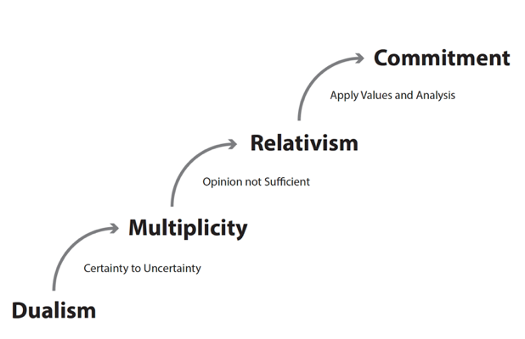
Dualism Stage - typically where students begin. Knowledge is certain (Black/White, Right/Wrong) and authority is the source of truth.
Transition - begins when certainty yields to ambiguity, and learners begin to recognize other points of view exist.
Multiplicity Stage - Learners then enter an uncomfortable period where right/wrong and black/white isn’t sufficient to understand the world around them. Students in this stage can be combative with instructors as they cling to their dualist view. They often hate that uncertainty exists and that truth is subjective. They believe the instructor just doesn’t know the “right” answer and often set out to find a “real” expert. At this stage, you might expect student comments like “it is just your opinion” or “your marking is subjective”.
Transition - learners begins to recognize mere opinion is insufficient.
Relativism Stage - In time, students begin to have a more relativistic view. They recognize that uncertainty does exist but also recognize that some positions and opinions are better than others.
Transition - begins when students start to recognize that mere opinion is insufficient and they need to make justification for their choices and use specific criteria to help evaluate different positions.
Commitment Stage - If and when students achieve this ultimate stage, they are able to weigh the evidence and commit to a reasonable position. They accept that reasonable, defendable choices may require analysis of imperfect or incomplete data.

Fixed and Growth Mindsets
Helping students know themselves better
A mindset is the view you have of yourself as a learner. Your mindset affects how you approach learning and how you respond to difficult challenges.
Mindsets fall into two categories: a fixed mindset or a growth mindset. People with a fixed mindset believe the talent myth – that people have a fixed amount of talent and can’t do much to change it – so you better accept it. People with a fixed mindset mistakenly believe that their talent should see them through and they shouldn’t have to work hard to succeed. They also often respond to failure quite poorly.
In contrast, people with a growth mindset believe that intelligence is not fixed and hard work and perseverance is the key to increasing intelligence and getting better. People with a growth mindset understand that hard work, difficult challenges, and failure are essential parts of learning.
The good news is a growth mindset can be learned. You can help students moved towards a growth mindset by having them recognize when they react to a learning situation in a fixed mindset kind of way. Once students recognize their fixed mindset reaction, you can help them see they have a choice in how to proceed. It is as simple as encouraging growth mindset actions, like:
- Asking teacher for help more often
- Being more diligent in their study habits
- Understanding expertise is earned not gifted to a select few
- Accepting, persevering, and learning from failure
If you are interested in learning more about mindset, I would recommend reading Carol Dweck’s excellent book – Mindsets: The new psychology of success (2006).

SOLO Taxonomy
A useful model to imagine the progression of learning
The SOLO (Structured Observed Learning Outcomes taxonomy (Biggs, 2011) is an interesting and describes learning as a progression of four levels.
- Working with 1 idea
- Working with multiple ideas
- Making connections between ideas, and
- Extending ideas and seeing new patterns
First reading about this taxonomy was eye opening for me, as I realized that deep learning is all about patterns – developing mental maps, seeing and using connections between ideas, and organizing knowledge as you are learning it. The taxonomy describes the learning progression of learning levels as starting with working with one idea, then multiple ideas, then learning connections between ideas, and, then finally extending the ideas and seeing new patterns. The levels are known as Unistructural, Multistructural, Relational, and Extended Abstract. There is also a division between the first two levels (unistructural, multistructural) in what is known as the surface learning category and the last two levels (relational, extended abstract) which represent the deep learning category.
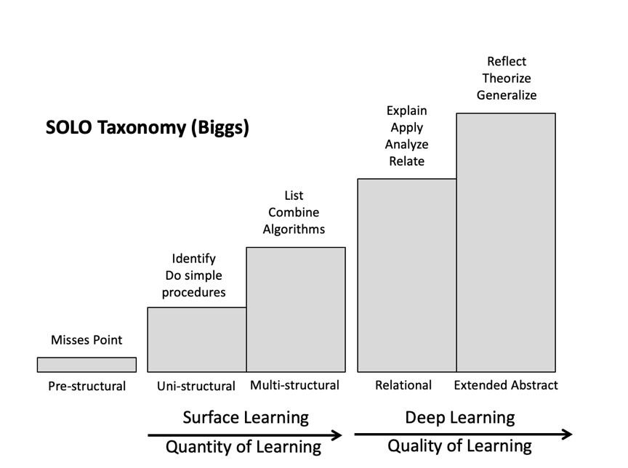
Unistructural - One aspect of a task is picked up or understood serially, and there is no relationship between facts or ideas. Responses and questions require the knowledge or use of only one piece of given information, fact, or idea, obtained directly from the problem. This stage can be characterized by the gathering of facts.
Multistructural - Two or more aspects of a task are picked up or understood serially, but are not interrelated. With an increase in quantity, Multistructural responses use more than one piece of the given information.
Relational - Several ideas or concepts are integrated into a larger coherent structure. This is the start of the Deep Learning Category and constitutes a change of quality of thinking that is cognitively more challenging than surface learning. This stage can also be characterized by the gathering of more complex facts and the application of multi-fact algorithms.
Extended Abstract – A collection of related ideas is both integrated and extended to a higher level of abstraction. The highest level of the SOLO taxonomy, Extended Abstract, requires the respondent to go beyond the given information, knowledge, or ideas and deduce a more general rule or proof that applies to all cases. In this latter case, the learner is forced to think beyond the given and bring in related prior knowledge, ideas, or information in order to create an answer, prediction, or hypothesis that extends the given to a wider range of situations.
Thinking about learning from a SOLO perspective
Another aspect of SOLO that can help you imagine student learning is thinking about the types of complexity that evolve at each SOLO level. There are three aspects that evolve: capacity, relationship, and structure.
Capacity to deal with multiple concepts
Each subsequent level of the SOLO taxonomy increases the learners cognitive load and the demands on their working memory. At the surface - Unistructural and Multistructural - levels, a learner need only encode the given information and may use simple recall strategies to provide an answer. At the deeper - Relational or Extended Abstract - levels, a learner needs to think not only about more things at once, but also how those objects inter-relate.
Ability to see relationships between ideas
Each subsequent level of the SOLO taxonomy increases the learner's ability to see, use, and create relationships between concepts and ideas. Unistructural responses involve thinking only in terms of singular concepts with no relationships between concepts. At the Multistructural level, even though many more concepts are involved, there is still little attention to the relationships between these concepts. At the Relational level, the student begins to identify and mostly use the described relationship between ideas. At the final Extended Abstract level, the student starts to see/create relationships between ideas to respond to new situations that are not simply understood with existing knowledge and thinking.
Ability to see important patterns of knowledge
Each subsequent level of the SOLO taxonomy increases the learners ability to see and use patterns in knowledge to solve problems. A Unistructural response requires students to apply only one piece of information in order to link the question to the answer. A Multistructural response requires students to apply several different pieces of information at once often in an algorithmic way. Relational responses identify and make use of underlying conceptual structures and relationships between concepts, and the Extended Abstract requires the student to see new patterns and create structures that generalize situations not yet experienced or that go beyond the given information.

Critical Thinking
Discounting some folklore about open-ended questions
For developing critical thinking skills, the use of open-ended questions is often suggested. The problem with this piece of Critical Thinking folklore is that disciplinary novices can often take classroom open-ended question discussions in tangential and non-productive directions. This can create real facilitation challenges for teachers to keep the discussion focused on salient issues and concepts ensuring that students take away the most important concepts and ideas. One way to productively focus the student's thinking is to frame questions more intentionally by using specific, explicit choices while giving students broad autonomy on how they arrive at choosing one of those specific choices” (Roberson and Sibley, 2019). All you need to do is carefully frame and constrain your activity prompts to force students to discriminate between competitive options and make specific choices. Making students choose a specific choice from a list of plausible, reasonable options, allows you to focus their thinking and analysis, guide them towards important insights, and develop their discrimination and judgement skills.
Consider the difference between - what would you do? and what would be the best thing to do first? With - what would you do? - you would have to accept pretty much anything a student says - could be doing nothing, something trivial, or something wrong. What would be the best thing to do first? makes the activity much more interesting. Students would now need to discriminate between options, make a specific decision, and build an argument to make their case that their particular choice is the best and should be done first.

Retrieval Practice
Moving knowledge in and out of memory to aid learning
Retrieval practice is the process of having students retrieve things they are trying to learn from memory. It turns out that you can accelerate student retention of knowledge. You can do this by providing opportunities for them to periodically retrieve knowledge from memory.
My first encounter with retrieval practice was review a pre-class video where the instructor had embedded retrieval questions so the video would periodically pause and require the student to answer a simple question before proceeding. I smugly passed judgement on the questions thinking that I could easily write more challenging question to assess their learning – but I had missed the point – the questions were about learning not assessment. The instructor was simply making use of the retrieval effect deepen student learning. Every time the student moved a concept in and out of memory, they were strengthening their long-term ability to remember it.
The research into retrieval efficacy has highlighted how powerful this effect (sometimes called the testing effect) can be and clearly shows the failure of the student favourite of serial restudy (i.e., re-reading of course notes) when compared to the substantial gains from studying using retrieval via self-testing.
The good news is that it is simple to add retrieval practice to your existing classes. James Lang, in his wonderful book Small Teaching: Everyday Lessons from the Science of Learning, has devoted a whole chapter to the retrieval effect and provides some small, simple strategies to use it in your courses.

Spaced and Interleaved Practice
Helping make practice count
You can use spaced practice and interleaving of topics to create a more powerful learning experience for students. Spacing simply refers to spacing retrieval/practice opportunities out over time. Interleaving refers to periodically switching between different topics during a practice sequence.
It is worth considering the differences between spaced practice and massed practice. When trying to learn something new we sometimes will practice the same thing over and over. This is known as massed practice. It can lead to some satisfying but unfortunately temporary learning gains. Just ask a music student who has practiced the same thing for a whole lesson with their instructor and gets home and can’t successfully do it anymore. A better approach is spaced practice, where we practice the skill periodically over a longer time frame with “spaces” or breaks between each practice. The other difficulty with massed practice is that we are only practicing one skill. When we switch back and forth between practicing different skills, we build much more robust learning. The difficulty with massed practice is that it can feel so good in the moment as you can consistently generate successful retrievals and accurate practice. Unfortunately, the learning is quite fragile and when we revisit the learning gains later, they are often lost. Spaced and Interleaved practicedoes slow the learning process but leads to much better long-term retention and outcomes.
More good news from James Lang’s book Small Teaching: Everyday Lessons from the Science of Learning: he devotes a whole chapter to Interleaving and as usual, provides some simple strategies to use it in your courses.

Developing Mental Models
“Helping students organize their knowledge influences how they learn and apply what they know” (Ambrose et al, 2010). Mental models help students to organize their understanding and thinking in a way that is similar to how experts organize their knowledge. One of the key differences between novices and experts, isn’t what they know, but the density of connections between concepts, facts and skills that is apparent in experts. Mental models make what student know more useful during problem-solving, since information is stored in a way that connections and inter-dependencies between information is more apparent. “Meaningful learning is learning with understanding. Achieving meaningful learning begins with the building of correct, appropriate mental models, or representations, of the knowledge being acquired” (Michael, 2004). When you teach in a “concrete to concept” way you are in fact helping students create mental models to store the new information. You want to begin developing models early in a learning sequence, before students are encoding the bulk of the new information. If you wait until students have been taught all the factoids and disparate details – it is too late. They need these preliminary models to begin storing what they are learning in a more powerful way, and this needs to happen early and while they are learning it.
You can use Advanced Organizers or Concept Maps during your teaching to help students organize what they are learning. Helping students develop these models and see the connections between ideas is consistent with the SOLO Taxonomy in the Relational Domain when learning is deeper and is focused on seeing important patterns and connections between ideas.
Better mental models help students make wiser choices and take better actions. The good news is that many disciplines have just a few major mental models that form the backbone of the discipline. Help your student see and use them.

Rigorous course design
Now that you have some background educational ideas, you are more prepared to begin course design There are a number of models for course design and they, for the most part, involve the same key ideas:
- Start with the final goals in mind
- Think about how the learners can ultimately demonstrate their achievement of these goals
- Design learning activities that get them ready for assessments that can demonstrate they achieved the desired goals
The following three models are different takes on these ideas. The final model, the Fink model, is the most highly developed and builds on the insights from the other two models: Constructive Alignment and Understanding by Design.
DESIGN YOUR COURSE WITH OUTCOMES, INSTRUCTION, AND ASSESSMENT IN MIND
WRITE LEARNING OUTCOMES USING BLOOM’S TAXONOMY

Constructive Alignment
Helps you see the important pieces of thoughtful course design
Constructive alignment (Biggs, 2011) is a design for teaching that describes what students are intended to learn and how they should ultimately express their learning. The term “constructive” is used because the model is based on the psychology of constructivism. The term “alignment” is used because both teaching and assessment need to be aligned to the intended learning outcomes. Teaching needs to be designed to engage students in learning activities that optimize their chances of achieving those outcomes. These learning opportunities should give the students what they need to be successful with the assessment tasks. Assessment tasks are designed to enable you to make clear judgments on how well learners have achieved those outcomes. The key to good assessment is to clearly define what students are supposed to be able to do with the content they have learned.
Biggs advice for course design is at its basics level:
- Describe the intended learning outcomes, using one verb (or at most two). A well written outcome denotes how the content is to be used and in what contexts.
- Create a learning experience or environment that helps students achieve the desired outcome.
- Design assessments that contain the specific verb from the outcome. This gives you the ability to create specific measures and the circumstances to have learners show you what they have learned.

Understanding by Design
A model that helps you appreciate a backwards approach
Understanding by Design is a useful model developed by Grant Wiggins and Jay McTighe (2005). You might hear the term “Backward Design” and this refers to this Wiggins and McTighe idea of starting with the end in mind. First, we want to think about the specific learnings sought, and then, what would constitute evidence that the learning has been achieved and at what level. Only then do we think about the learning activities designed to achieve the intended learning outcomes.
Your lessons, units, and courses should be logically inferred from the results sought. In short, the best designs derive backward from the learnings sought.
There are generally twin sins of traditional instructional design. The first sin is using “fun” activities that don’t lead to much learning. The activities, though fun and interesting, do not lead anywhere intellectually. The second sin is that of “coverage”. Students are too often marched through entire textbooks, page by page in a valiant attempt to traverse all the factual material within too short a time. What we are missing is a guiding intellectual purpose or clear priorities to frame the learning experience.
Stage 1: Identify desired results - What should students know, understand, and be able to do at the end of your course? What content is worth understanding? What level of understanding (surface vs. deep) do you want? Because typically we have more content than we can reasonably address within the available time, we must make choices. This first stage in the design process calls for clarity about priorities.
Stage 2: Determine acceptable evidence - How will we know if students have achieved the desired results? What will we accept as evidence of student understanding and mastery? You want evidence to document and validate that the desired learning has been achieved. Consider up front how you will determine if students have attained the desired understanding.
Stage 3: Plan learning experiences and instruction - With clearly identifiable results and clearly identifiable acceptable evidence of understanding in mind, it is now the time to design instructional activities that help achieve those results and prepare learners for the assessment where they can show you what they have learned. You need to think about goals and assessment before deciding what and how you will “teach”.

Fink’s Significant Learning Model
The best course design model
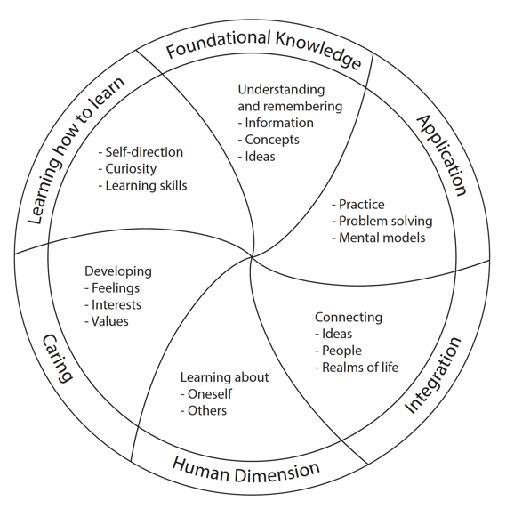
In his excellent book, Designing Significant Learning Experiences (2003), Dee Fink builds and extends the Constructive Alignment (CA) concept and describes the three main components of CA as an inter-dependent triad rather than a sequence of actions. He posits that course learning outcomes, assessment practices, and teaching and learning activities are best represented by an inter-dependent triad that can generate significant synergy when these components are properly aligned, interdependent, and mutually supporting.

What makes Fink’s approach so useful is the taxonomy he created for Significant Learning. His taxonomy includes softer aspects like ‘Human Dimension’ and ‘Caring’. Educators have recently come to realize more and more that these “softer” dimensions are actually the key to significant learning experiences. Bloom’s taxonomy can only get us so far and the Fink taxonomy provides a much more powerful model for designing your instruction. Dee often says “if you aren’t asking how your students will be different 5 years after taking your course, you are aiming too low”. Carefully applying his course design methodology can lead to some extraordinary outcomes.
At first, I didn’t understand the power of this taxonomy. I had been dutifully using Fink’s suggestion of compiling Outcomes – Assessments - Teaching Strategies into what he called the 3-column table. The table helped you map directly from an outcome to an assessment measure, then to teaching and learning activities that gets students ready to achieve the desired outcome. For many years, this pragmatic approach really helped me constructively align pieces in numerous courses. But, the real revelation after a number of years of using the table in this simple way. One day, I approached things a little differently and took the time to map each outcome against each domain of the Significant Learning Taxonomy. It was revolutionary! Suddenly, I could see how to make my typical one-dimensional assessments richer and multidimensional. So many possibilities appeared that would allow me to build a Significant Learning experience just like Dee promotes in his book.
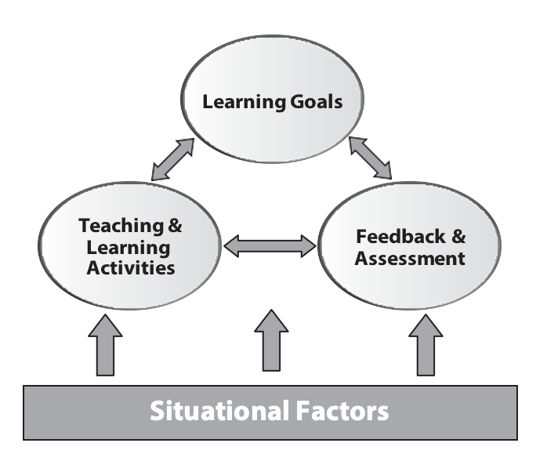
Step 1: Consider Situational Factors. Gather information about the course and its context: the number of students, pre/co-requisites, students’ prior knowledge and experience, the nature of the course, how it fits into the curriculum or program, the nature of the subject, the culture of the discipline, and expectations of the department and institution.
Step 2: Identify Learning Outcomes/Goals. Once you understand your context then you can identify what you want the students to learn. (This may be constrained by co- and pre-requisite requirements and departmental and institutional expectations).
Step 3: Design Assessment Activities. You first need to determine what is worth assessing and what evidence you will collect to determine whether students are achieving each of the course goals. You should also consider how to provide periodic feedback on students’ learning progress in in assessment activities.
Step 4: Design Learning Activities. Once you have clear course goals, and you know how you are going to assess student learning and provide feedback, you can then create instructional materials and design learning activities to help your students achieve these goals.
Step 5: Iterate. Thoughtful course design needs to revisit these steps and fine-tune them with each iteration of moving around the inter-dependent triad of outcomes-assessment-learning activities.

Logistics Advice

Become familiar with Canvas

Canvas is the UBC provided course/learning management system software. Canvas has a wide range of features you can use to easily develop your online course site. Most of the tools are quite intuitive to set up. Remember you can reach out to the Centre for Instructional Support (CIS) at any time for help and training on how to use Canvas. It is worth talking with CIS to learn about best practices and get help with configuring settings within each tool in Canvas. CIS also can provide one-to-one consultations for faculty and training for your TA’s.
Any time you have questions about Canvas you can contact the CIS helpdesk at learning@apsc.ubc.ca. If you have bigger, more complex campus-level questions you can still contact us first and we will escalate it to the Learning Technology Hub (LT Hub) at lt.hub@ubc.ca. Please use your UBC email address when asking for help.
If you get a barrage of emails from students about difficulty accessing something on your Canvas site - check the Canvas settings or contact CIS for help at learning@apsc.ubc.ca If it is a singular student computer issue, have the student contact the IT Services Helpdesk themselves at https://web.it.ubc.ca/forms/isf/

Do not have students contact the CIS
If you want additional training on Canvas - you should check out the offerings from the Centre for Teaching, Learning, and Technology (CTLT) https://ctlt.ubc.ca/ and the Learning Technology Hub (LT Hub) https://lthub.ubc.ca/support/lt-hub/. They offer workshops and drop-in sessions on Canvas and a wide range of other learning technologies - https://events.ctlt.ubc.ca/events/

Working with Teaching Assistants
For larger courses, you will likely be working with a teaching assistant. Teaching assistants are mostly drawn from departmental graduate students but can include both graduate and undergraduate students for other departments, programs, and faculties. Talk with your school or department administrator about the TA assignment process and timelines in your local context.
Teaching assistants are paid to work a maximum of 192 hours of work per semester. TAs are not allowed to work for more than 24 hours in a single week. TAs work can include:
- Teaching classes, tutorials, labs, etc.
- Marking assignments or exams
- Invigilating exams
- Answering emails from students
- Holding office hours
- Tutoring
Be mindful that these smaller jobs can quickly add up, so you should encourage your TA to keep a record of their hours, detailing what kind of work they are doing, and how much time they spend on each task. This will help you understand where your TA is using their time and where you might want to redirect their efforts.
When a TA is assigned and their appointment is processed in WorkDay and the Student Information System (SISC), they are automatically given the TA role in the appropriate Canvas shell. Be aware that the basic TA Canvas role does not have access to many Canvas features including the grade book and settings controls on many tools. You may want to request an upgrade of your TA’s access so they can help manage your entire Canvas shell. Many faculty members give the entire responsibility for managing the Canvas course to their TA. The Centre for Instructional Support can upgrade TA access to Canvas and provide TA training and support.

Find your Support Network
It is helpful to spend some time mapping out the UBC support networks before you need them. This can substantially reduce your stress and anxiety when issues inevitably arise.
For your office and IT help - there are two main support groups - IT Services for your computer issues (https://web.it.ubc.ca/forms/isf/) and Building Operations for issues with your physical space. Building Operations requests are most often handled by an administrator in your school/department's main office.
For your administration needs – for HR, course scheduling, teaching assignments and TA assignments you will have administrators in the main school/department office that can help you. When you have your introductory meeting with your school director or department head, make sure to ask them who you should be asking for the different kinds of help.
For course technology support - there are 2 main support groups. Your primary support is the Centre for Instructional Support (CIS), which can be contacted at learning@apsc.ubc.ca. The other is the LT hub, which focuses primarily on campus level issues with course technologies. They can be contacted at lt.hub@ubc.ca. The LT Hub focuses primarily on campus level issues with course technologies.
For classroom issues - there are two main support groups – For physical space issues contact Classroom Services (known as Learning Spaces) at learning.spaces@ubc.ca and for more day-to-day classroom technology issues contact the AV groups help desk at av.helpdesk@ubc.ca or help number at 604-822-7956. It is worth putting the AV group's phone number in your mobile’s contact list. Although the UBC classroom technology is very robust, you may from time to time encounter issues. The AV help desk can help you over the phone or come quickly to your classroom (they often arrive in less than 10 minutes).

Rhythm of the Academic Year
The academic year has a specific recurring yearly rhythm that you can use to better manage your time. The summer is most often considered time to recharge and perhaps retool some of your course components in preparation for the two main terms that begin in September and January. These terms are typically 13 weeks in length. There are 2 shorter summer terms delivered in a compressed time format, but many instructors won’t be teaching in summer, so it will not be discussed at length here. You can consult the UBC calendar for each year’s specific term dates and total teaching days.
May - Exams were completed in April. Grades have been reviewed and submitted and everyone is taking a collective breath. This is a good month to reflect on the past year's courses and build a prioritized list of things you want to work on over the summer. It is a good time to talk with CIS and get their advice and attention so they can work with you over the summer. CTLT offers a variety of teaching-focused workshops and learning opportunities each May. Summer instructors begin preparing for the two condensed summer sessions (May/June and July/August). Very few courses are offered in Applied Science during the summer sessions.
June - This is the height of academic conference season for many disciplines - it can start to become difficult to schedule meetings with colleagues. Services at the Centre for Instructional Support are available all summer to support summer sessions and help you prepare for the fall and winter semesters.
July – Often make up exams are given for academic concessions. Meeting with colleagues can become even more difficult as many people are now on vacation. Typically, people become more available in mid to late August. This is a good month to be working on updating your course materials and working with CIS to get ready for the fall semester.
August - Preparation for the fall semester really gets underway in earnest. Canvas shells will have been auto-created for every SIS (Student Information System) course section. When you are assigned by your department administrator to a course in WorkDay you will automatically gain CWL (Campus Wide Login) access to the appropriate Canvas shells. These new shells are empty, so if you want to start with last year's content you need to ask CIS to “roll-over last year's course into this year's shell” by sending an email to learning@apsc.ubc.ca. If you are teaching a multi-section course or combined undergraduate/graduate course, you will likely want to ask for the “shells to be merged” (by sending an email to learning@apsc.ubc.ca). In late August, when your Canvas site is ready - you PUBLISH the course and it will become available to enrolled students on the first day of term. The Canvas system draws student enrollments directly from the SIS - so a newly enrolled student will automatically gain access to Canvas and a dropped student will automatically lose access to Canvas.
September - First day of the semester is taken up with UBC’s Imagine Day, so the first real teaching day of the semester is actually the 2nd day of term. As the term progresses, you may have small issues with setting up different Canvas tools and CIS can help you sort those out (learning@apsc.ubc.ca). TAs automatically get access to Canvas when the department/school office completes their appointment - there can often be a delay here if the office is behind on appointments. In an emergency, CIS can temporarily add a TA, but these are temporary additions and only last for 2 weeks with the expectation that the official appointment will be processed by then.
October/November - As the term progresses, you may want help setting up different Canvas tools or want to explore using different Canvas features - CIS can help you with this (learning@apsc.ubc.ca).
December - Instructors will often contact CIS for help formatting grade book and compiling final grades - remember to check local standard procedures for grade reviews and submissions. In very late December, roll-over requests are often made for the January semester Canvas course. Like for September start, auto-created empty Canvas shells have been created for every SIS section.
January to April – This semesters rhythm is very similar to the fall semester. Empty course shells are auto-created mid-semester in the fall to allow preparation for January courses. CIS is typically closed between December 25 and January 1st. With this in mind, you might want to proactively work with CIS in mid-December to get your courses ready.

Campus Supports
Getting Students Help
Both local and campus-level Student Services can help you ensure a struggling student can get the help they need when they need it. They both can help students navigate the different procedures and processes that can help them thrive at UBC. As an instructor you may identify a student who needs help. It is only your job to get the student connected to the resources and services they need. The easiest way to do that is get Student Services involved early.
A good first step if you suspect a student is struggling is to flag your concern using the Early Alert system. This is a campus-wide reporting system that allows faculty, staff, and TAs to confidentially identify and share their concerns about a student. It lets us centrally track concerns so helpful interventions can be timelier and undertaken in a more coordinated way.

Academic Help
The first place students should be encouraged to seek academic help is by attending offices hours with course instructors and TAs. When this type of help is not enough there are typically two routes for seeking more help depending on whether it is a “learning how to learn” issue (approaches to learning, study skills, noting taking, etc.) or specific course content related questions.
When students need help with their learning and study skills you should direct them to the UBC Learning Commons and their helpful in-person and online resources.
When students need help with more fundamental academic skills beyond the normal course related help in office hours, they can be directed to the various tutoring services like AMS tutoring, the Math Learning Centre, the Centre for Writing and Scholarly Communication, etc.

Computer Help
When students are having difficulty with UBC systems (Canvas, SISC, WIFI network) they should be directed to contact the IT Services helpdesk at https://web.it.ubc.ca/forms/isf/

Accommodation Help
Some students will have academic accommodations – the most common is the allowance for more time on examinations and tests. They need to provide you with an official letter from the Centre for Accessibility to receive any accommodation. If the student doesn’t have the letter, direct them to the Centre for Accessibility to get one - no letter - no concession. Once a letter is provided, you can contact the Centre for Accessibility and they will organize the accommodation process.
There are other kinds of accommodations that you might encounter like in-class note takers, ASL interpreters, access to alternative learning materials, need for audio recording of lectures and others.
The Centre for Accessibility is only mandated to work with disability-related accommodations and not temporary health issues.

Counselling Help
UBC Counselling Services provides confidential counselling support for students. The services can be accessed through UBC Student Services. The Counselling Services use a brief, intentional counselling model to quickly begin to address mental health concerns. After a student shares their information, the staff will connect them to the support option most suitable for their situation.

Student in Distress Help
When a student comes to you in crisis you want to ensure there is a continuity of care. You either walk with them over to the Counseling Centre in Brock Hall or you can walk them to your local Student Services. Often the local Student Services will then take over the care of the student and get them to Brock Hall safely.
The process of supporting a student in crisis is outlined in the “green folder” https://facultystaff.students.ubc.ca/health- wellbeing/assisting-students-distress
One of the most difficult situations could be a student confiding in an instructor about something violent or sexually violent. The process for this is different - ask for guidance from Student Services within your school, department or Faculty.

Victim of Sexual Violence
Sexual assault is a difficult and complex experience. The University has a survivor-centered approach that strives to empower a survivor to make their own choices about who they may disclose to, and their decisions to access support services or file a report. Please refer to the Sexual Violence Protection and Response Office - UBC SVPRO for accessing services, university policies, responding to disclosures, and sexual assault prevention resources specific to UBC faculty and staff.

UBC Policies related to Instruction
UBC has many campus-wide policies and regulations for faculty, staff and students. It is worth reviewing the following policies that relate strongly to teaching and learning. You can review all UBC policies and procedures at https://www.calendar.ubc.ca/vancouver/index.cfm?tree=3,0,0,0
- Academic Concessions for Students
- Academic Accommodations for all Students’ Religious Observances and the Cultural Observances of First Nations, Métis, and Inuit Students
- Academic Accommodation for Students with Disabilities
- Academic Honesty and Standards
- Content and Distribution of Course Syllabi
- BC Statement on Respectful Environment for Students, Faculty, and Staff

Frequently Asked Questions
What should I do if classroom AV isn’t working?
You should contact the AV Help Desk. They provide very prompt, real-time support for instructors experiencing technical difficulties in UBC classrooms. You can contact the AV Helpdesk at 604-822-7956 or av.helpdesk@ubc.ca
A student is having trouble with Canvas. What should I do?
If is appears to be a course configuration/setting issue, you can contact CIS for help (learning@apsc.ubc.ca). Do not sent students to CIS! Students should be directed to contact the IT Services helpdesk at https://web.it.ubc.ca/forms/isf/
What do I do if I catch a student cheating?
There is a UBC policy: Academic Honesty and Standards that provides some guidance on procedures. Here are details on the standard UBC procedures - https://academicintegrity.ubc.ca/regulation-process/faculty/. In Applied Science, please contact Carol Jaeger or Sherry Green in the Dean’s office for help navigating the various Academic Integrity procedures.
How do I handle requests for an accommodation - like more time for an exam?
Each student needs to provide you with an official letter from the Centre for Accessibility to receive a disability related accommodation. If the student doesn’t have the letter, direct them to the Centre for Accessibility to get one - no letter - no concession. Once a letter is provided, you can contact the Centre for Accessibility and they will organize the accommodation process. With paper-based exams - students most often complete the exam at the Centre for Accessibility. With online exams these accommodations are often locally managed using the Moderate feature in Canvas quizzes.
How do I handle a request for a concession (non-disability accommodation request) - like taking a final exam at a future date?
Life happens and students will sometimes ask for concessions for some course assessment component. Most often this is missing a final examination for health reasons. There is a UBC policy: Academic Concessions for Students that highlights the standard concessions and procedures. Your local Student Services can advise you and help you deal with these events.
What do I do if a student comes to me in distress?
When a student comes to you in crisis you want to ensure there is a continuity of care. You either walk with them over to the Counseling Centre in Brock Hall or you can walk them to your local Student Services. Often the local Student Services will then take over the care of the student and get them to Brock Hall safely.
Supporting a student in crisis is outlined in the “green folder” https://facultystaff.students.ubc.ca/health-wellbeing/assisting-students-distress
One of the most difficult situations could be a student confiding in an instructor about something violent or sexually violent. The process for this is different - ask for guidance from Student Services within your school, department or Faculty.
Another option if student is not in dire distress is Early Alert - it is a campus-wide reporting system that allows faculty, staff, and TAs to confidentially identify and share their particular concern about a student sooner and in a more coordinated way.
Sexual Assault Reporting - Sexual assault is a unique and complex experience. The University has and continues to implement a survivor-centered approach that strives to empower a survivor to make their own choices about who they may disclose to, and their decisions to access support services or file a report. Please refer to the Sexual Violence Protection and Response Office - UBC SVPRO for accessing services, university policies, responding to disclosures, and sexual assault prevention resources specific to UBC faculty and staff.
What study spaces and technology resources are available to students?
There are many informal study spaces in most buildings around campus. For students looking for additional study space, you can direct them to the Ike Barber Learning Commons. There are both first-come-first-serve and bookable study spaces in the Learning Commons. You can book technology-enabled board rooms to practice presentations, sign out laptops and other pieces of technology, or just find a quiet place to study. Direct your student to learningcommons.ubc.ca to learn more.
Is the classroom WIFI strong enough to handle online exams?
The UBC WIFI network is strong enough to support online exams in most classrooms. It is worth having some test events to both check the WIFI strength and to have students test their personal devices before any high-stake’s events. Students should be directed to connect to the more robust UBCsecure WIFI network and not the weaker UBC visitor network.
I have been sending emails to my students using Canvas and the Faculty Service Centre (FSC) but some students say they are not getting them. What is going on?
You can’t easily get a list of student emails, but can use a variety of campus systems to send emails to your entire class (Canvas and FSC). These campus systems automatically use the email address that students use to access the Student Service Centre (SSC). There can be difficulties when students use one email account to access the SSC (often their official UBC email) and then use a different for their day-to-day email (i.e., Gmail or Hotmail). It is worth asking in class early in the semester if everyone is getting your course emails.

UBC Glossary
Alma Mater Society (AMS) - a student-led, nonprofit organization to improve student academic, social and personal life at UBC.
AV Help Desk - Classroom Services offer real-time support for instructors experiencing technical difficulties in UBC classrooms. You can contact the AV Helpdesk at 604.822.7956 or av.helpdesk@ubc.ca
Canvas - Our Learning Management System is Canvas – canvas.ubc.ca. Canvas course shells are automatically created before each term for every scheduled section in the Student Information System (SIS). Instructors are automatically added to courses, once they are appointed to teach a section. TAs are automatically enrolled once HR has processed their appointment. Students are automatically given access when they enroll in a course (note there is a lag between student enrollment and Canvas access). Students also automatically lose access to the Canvas site if they withdraw from the course.
Campus-Wide Login (CWL) - The CWL system provides single sign-on access to most University systems, such as WorkDay, the Faculty Service Centre, and Canvas
Centre for Accessibility - Some students have a right to disability-related accommodations. They will need to provide you with an official letter from the Centre for Accessibility to receive an accommodation. The Centre for Accessibility will organize the accommodation process. In a pre-COVID world, that might be an extended time for an exam with the student sitting at the Centre for Accessibility. In a COVID world, many of these accommodations are managed using the Moderate feature in Canvas quizzes.
Centre for Instructional Support (CIS) - a dedicated Applied Science faculty teaching support centre. They provide free Canvas help desk services, training, and teaching consultation services. Visit the Centre for Instructional Support website to understand the services available to you and to get advice on a wide range of teaching topics – cis.apsc.ubc.ca
Centre for Teaching, Learning and Technology (CTLT) – provide 1 to 1 consultations and workshops throughout the year on teaching skills, learning technologies, and different aspects of course design - ctlt.ubc.ca
Copyright Office - copyright.ubc.ca has information on how to use copyrighted materials and what fair dealing means. This can help you keep your course materials copyright compliant.
Early Alert - Early Alert is a campus-wide reporting system that allows faculty, staff, and TAs to confidentially identify and share their concerns about students sooner and in a more coordinated way.
FASmail - an enterprise email service for staff, faculty and student employees of the University of British Columbia. https://it.ubc.ca/services/email-voice-internet/ubc-faculty-staff-email-fasmail
Faculty Association (UBCFA) - acts as the bargaining agent of all faculty members employed by the University of British Columbia and regulates relations between the faculty members and the University through collective bargaining. https://www.facultyassociation.ubc.ca
Faculty Service Centre (FSC) is an online system where you can get student photos and class lists, communicate with students, and enter final grades. Grades are submitted in the FSC but check with your school or department about local policies for grade submissions. Your department, program or school admin office arranges your access to this system as part of the onboarding process. https://ssc.adm.ubc.ca/fsc/home
IT Services - provides unified IT support to all campus units. Remember, for Canvas and learning technology support you contact your local instructional support unit or the LT Hub and for all other computer related issues instructors need to contact IT Services. Instructors can contact the IT Services helpdesk at https://web.it.ubc.ca/forms/isf
Key Desk - located in the back of the bookstore. You will need to get a key request form completed and submitted by your department, program, or school admin office rep. The key desk will email you when your keys are ready for pickup. A refundable deposit is required.
Learning Commons - provides excellent online and in-person (located in Ike Barber building) resources to support students and their learning – learningcommons.ubc.ca
Learning Technology Hub (LT Hub) is a campus-level support unit for learning technologies (primarily Canvas). They can be contacted about any issues. Small issues are normally handled locally by the Centre for Instructional Support but larger system-level issues should always be forwarded to LT Hub. The LT Hub has more extended service hours than the local CIS unit. You can contact them by email at lt.hub@ubc.ca, by phone at 604-827-4775, and on the web at https://lthub.ubc.ca
Library - has several important services for faculty and students. LOCR (library online course reserves) provides integration with Canvas so students can directly access copyrighted materials, like journal articles. Each discipline has a subject librarian that can help you use library resources in your courses. https://library.ubc.ca
Sexual Assault Reporting - Sexual assault is a unique and complex experience. The University has a survivor-centered approach that strives to empower a survivor to make their own choices about who they may disclose to, and their decisions to access support services or file a report. Please refer to the Sexual Violence Protection and Response Office and its website UBC SVPRO for accessing services, university policies, responding to disclosures, and sexual assault prevention resources.
Student in Crisis/Green Folder - When a student comes to you in crisis you typically will walk them over to the Counseling Centre in Brock Hall. You can also visit your local Student Services. They can sometimes accelerate getting help. One of the most difficult situations could be a student confiding in an instructor about something violent or sexually violent. The process for this is different and you should ask for guidance from Student Services within your unit. Here are specific directions for helping a student when they are in distress – https://facultystaff.students.ubc.ca/health-wellbeing/assisting-students-distress
Student Experience of Instruction (SEoI) - UBC has recently shifted from “Student Evaluations of Teaching” to “Student Experience of Instruction.” Students are asked to provide feedback near the end of the term on their course experience and the quality of learning. Students access the survey in their Canvas shell and receive reminder emails. You can monitor the survey completion rate on Canvas and will receive results within a few weeks of the end of term (only once your course grades are submitted). https://teacheval.ubc.ca
Student Health - offers a wide range of health assessments and treatments provided by doctors, nurse practitioners, and nurses. https://students.ubc.ca/health/student-health-service
Student Information System (SISC) - receives information from UBC scheduling system known as Scientia and allows users to complete the required registration process
Student Services - student advising, bursaries and awards, well-being services, counselling, sexual assault support services, and academic and learning supports. https://students.ubc.ca
Student Service Centre (SSC) - student self-serve portal for making applications, investigating awards, seeing exam schedules, paying fees, viewing grades, completing registrations, and accessing transcripts. https://ssc.adm.ubc.ca/sscportal
Teaching and Learning Enhancement Fund (TLEF) - an annual grant call, open to all faculty to support teaching innovation at UBCV. Each year, the Office of the Provost invites all UBCV Faculties and Colleges to apply for TLEF funding for initiatives that will improve student learning experiences at the university. You can get more information and helpful advice on the CTLT website, including grant preparation guidance, upcoming calls and deadlines, evaluation criteria, and information on previous recipients
Wireless Network (UBCsecure) - allows faculty, staff and students to connect to the internet anywhere on the UBC campus at high speeds 24x7. UBCsecure provides secure access using WPA2-Enterprise protocols.
WorkDay - enterprise system for self-service administration of HR, payroll, benefits, team management, finance, delegation, absences, and compensation. You will be provided access as part of your onboarding process. https://wd10.myworkday.com/ubc/d/home.htmld#path=
UBC Calendar - a comprehensive guide to all programs, courses, services, and academic policies and procedures at the University of British Columbia. https://www.calendar.ubc.ca/vancouver/
UBC Card - All current UBC Faculty and Staff Appointees are eligible for UBCcards. Physical cards grant you access to UBC Library privileges, building access and access to card-controlled rooms, UBC bookstore e-money purchases, and food Services' dining convenience and discounts

Ask for Help

Invitation from CIS
The Centre for Instructional Support (CIS) is a faculty member support unit that is part of the Dean’s office at the Faculty of Applied Science (APSC). The CIS offices are located in CEME 1214. The CIS Helpdesk can be contacted at learning@apsc.ubc.ca or by visiting the website at cis.apsc.ubc.ca
The Centre provides no-cost teaching support services to faculty in all schools, departments, and programs in Applied Science. The Centre does not provide support for research activities. The Centre does not provide services for students or other UBC Faculties. The Centre’s original mandate was “to promote the pedagogically wise use of technology”. It quickly became apparent that supporting technology was only part of the puzzle, and the pedagogical support and professional development of instructors were essential to not just foster “the wise use of technology” but to help faculty better design student learning experiences. This mandate now reads “we help APSC faculty utilize learning technologies and incorporate pedagogical best practices in their teaching”.

Works Cited
Ambrose, S., Bridges, M., DiPietro, M., Lovett, M., Norman, M. (2010). How Learning Works: 7 Research-Based Principles for Smart Teaching. San Francisco, CA. Jossey-Bass.
Angelo, T, and Cross, P. (1995). Classroom Assessment Techniques. A Handbook for College Teachers. 2nd Ed. San Francisco, CA. Jossey-Bass.
Barrows, H. (1998). The Tutorial Process. 2nd Ed. Southern Illinois University Press.
Barton, L. (2007). Quick flip questions for the revised Bloom’s taxonomy. Madison, WI: Edupress.
Bloom, B., Englehart, M., First, E., Hill, W., Krathwohl, D. (1956). Taxonomy of educational objectives: The classification of educational goals; Handbook 1: Cognitive domain. New York, NY: Longmans, Green and Co.
Biggs, J. (2022, Sept. 28). Constructive Alignment. https://www.johnbiggs.com.au/academic/constructive-alignment/
Biggs, J. (2022, Sept. 28). Solo Taxonomy. https://www.johnbiggs.com.au/academic/solo-taxonomy/
Biggs, J., Tang, C. (2011). Teaching for Quality Learning at University. New York, NY: McGraw-Hill.
Brickell, J., Porter, D., Reynolds, M., Cosgrove, R. (1994). Assigning students to groups in engineering design projects: a comparison of five methods. Journal of Engineering Education, 7, 259-262.
Duch, B., Groh, S., Allen, D. eds. (2001). The Power of Problem-Based Learning Sterling, VA: Stylus.
Dweck, C. (2006). Mindsets: The new psychology of success. New York: Random House.
Erskine, J., Leenders, M., Mauffette-Leenders, L. (2019). Writing cases. 5th Ed. London, Ontario: Ivey Business School.
Erskine, J., Leenders, M., Mauffette-Leenders, L. (2003). Teaching with cases. 3rd Ed. London, Ontario: Ivey Business School.
Erskine, J., Leenders, M., Mauffette-Leenders, L. (2007). Learning with cases. 3rd Ed. London, Ontario: Ivey Business School.
Fink, L. (2003). Creating Significant Learning Experiences: An integrated approach to designing college courses. San Francisco, CA: Jossey-Bass.
Godolphin, W. (2004). Set-Body-Close lesson plan model, personal communication.
Gronlund, N. (2000). Writing Instructional Objectives for Teaching and Assessment. 7th ed. Columbus, OH: Pearson.
Kolb, D. (1984). Experiential Learning: Experience as the Source of Learning and Development. Englewood Cliffs, N.J.: Prentice-Hall.
Lang, J. (2016). Small Teaching: Everyday Lessons from the Science of Learning, San Francisco, CA. Jossey-Bass.
Michael. J. (2004). Mental Models and Meaningful Learning. Journal of Veterinary Medical Education. 31(1).
Michaelsen, L., Bauman Knight, A., Fink, D. (Eds). (2004). Team-Based LearningA Transformative Use of Small Teams in College Teaching. Sterling, VA: Stylus.
New Faculty Orientation Guide - University of British Columbia. (2019, Sept. 28). https://ctlt.ubc.ca/resources/new-faculty-orientation-guide
Nilson, L. (2003): Improving Student Peer Feedback, College Teaching, 51:1, 34-38
Perry, W. (1999). Forms of intellectual and ethical development in the college years: A scheme. San Francisco, CA: Jossey-Bass.
Rice, G. (2018). Hitting Pause: 65 Lecture breaks to Refresh and Reinforce Learning. Sterling, VA. Stylus Publishing.
Roberson, B., Franchini, B. (2014). Effective Task Design for the TBL Classroom. Journal on Excellence in College Teaching, 25, 275-302.
Roberson, B., and Sibley, J. (2019, June 17). Team-Based Learning Revisited. Educause Review. Educause: Boulder, CO.
Russell, I., Hendricson, W., Herbert, R. (1984). Effects of lecture information density on medical student achievement. Journal of Medical Education, 59(11), 881-889
Schwartz D., Bransford, J. (1998). A Time for Telling. Cognition and Instruction, 16(4), 475-52
Sibley, J., Ostafichuk, P. (2014). Getting Started with Team-Based Learning. Sterling, VA: Stylus.
Sibley, J., Roberson, B., O’Dwyer, B. (in press). Constraining choice to enhance learning activities impacts critical thinking and real-world decision-making skills. Educause Review. Educause: Boulder, CO.
Talbert, R. (2017). Flipped Learning: A guide for higher education. Sterling, VA: Stylus.
Thoma, G. (1993). The Perry framework and tactics for teaching critical thinking in economics. Journal of Economic Education, 24(2), 128-136.
Thompson, M., Haidet, P., Borges, N., Carchedi, L., Roman, B., Townsend, M., Butler, P., Swanson, D., Anderson, M., & Levine, R. (2015). Team cohesiveness, team size and team performance in team-based learning teams. Medical education, 49(4), 379-385.
Tuckman, B. (1965). Developmental sequence in small groups. Psychological Bulletin, 63(6), pp.384-399.
Value Rubrics – American Association of Colleges & Universities (2022, October 17) https://www.aacu.org/initiatives/value-initiative/value-rubrics
Wankat, P., Oreovicz, F. (2015). Teaching Engineering. 2nd Ed. West Lafayette, Indiana: Purdue University Press.
Weimer, M. (2002). Learner-Centered Teaching: 5 Key Changes to Practice. San Francisco, CA. Jossey-Bass.
Wiggins, G., McTighe, J. (2005). Understanding by Design. 2nd Ed. Alexandria, VA: ASCD Press.

A
Advanced Pedagogies 25
Assignments 18, 34
B
Best Team Size 29
Bloom’s Taxonomy 15
C
Campus-Wide Login 70
Canvas 28, 51, 66, 69
Case-Based Learning 27
Spaced and Interleaved Practice 42
Centre for Instructional Support 3, 70, 76
Centre for Teaching, Learning, and Technology 3, 71
CIS helpdesk 51
Concrete-to-Concept 12
Constructive Alignment 45
Constructivism 32
Course Design 44
Critical Thinking 40
CTLT 3
E
Examinations 23
Fading 33
First Course Changes 9
Flipped Classroom 26
Frequently Asked Questions 66
G
Great First Day 7
Groups and Teams 28
Guided Inquiry 27
K
Kolb’s Learning Cycle 33
L
Learning Technology Hub 51, 72
Lecture Density 9
Lesson plan 10
M
Marking Workload 20
Mental Models 43
Mindsets 36
N
Naïve task 12
O
Objectives and Outcomes 14
One-minute paper 13
P
Peer Feedback 24
Perry’s Model of Intellectual Development 34
Problem-Based Learning 26
Punctuated Lectures 12
Q
Questioning 7, 11
R
Retrieval Practice 41
Rubrics 20
S
Scaffolding 33
Significant Learning Model 48
SOLO Taxonomy 37
Syllabus 10
T
Teaching and Learning Enhancement Fund 74
Teaching Assistants 53
Teaching your first course 5
Team Formation 28
Team Formation Strategies 28
Team Formation Study 29
Team-Based Learning 27
Tests 23
Think-Pair-Share 14
Tuckman’s team development model 28
U
UBC policies 65
Understanding by Design 46

